

CONFIDENTIAL FILING

July 27, 2018

VIA ELECTRONIC FILING SYSTEM

Mr. Mark L. Johnson, Executive Director and Secretary Washington Utilities and Transportation Commission
1300 South Evergreen Park Drive SW Olympia, WA 98504-7250

RE: 2019 Petition to Receive USF Support

Dear Mr. Johnson:

MASHELL TELECOM, INC. DBA RAINIER CONNECT (“MASHELL”), a privately-held rate of
return carrier receiving high cost support, has electronically submitted a 2017 Petition to Receive USF Support to the Commission with redacted financial data. MASHELL respectfully provides the Commission with its confidential financial data so that all its reporting obligations are satisfied.

MASHELL, by its authorized representative, respectfully submits confidential information in compliance with WAC 480-07-160. MASHELL requests confidential treatment of certain information submitted with its annual reporting requirements as a privately-held rate of return carrier. The confidential information is required by WAC 480-123-110 and includes detailed financial information that is competitively sensitive. Disclosure of this confidential information would have a substantial negative impact on MASHELL. Such information would not normally be made available to the public for inspection because of the financial information and should be afforded confidential treatment under WAC 480-07-160.

As specified in the WAC 480-07-140, copies of the redacted confidential information are being filed simultaneously with the non-redacted confidential information. The redacted information for this filing and each page of the file where confidential information has been omitted is marked “REDACTED - FOR PUBLIC INSPECTION” and the confidential submission is marked “CONFIDENTIAL PER WAC 480-07-160”.

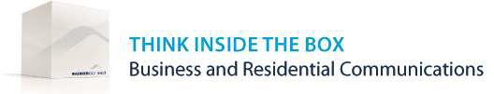

Please feel free to contact me with any questions regarding this particular matter. Sincerely,

Danielle Clausen, Controller
For Mashell Telecom Inc. dba Rainier Connect Enclosures

