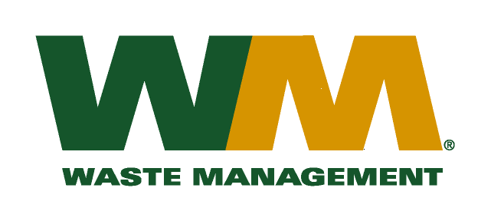
July 30, 2026
Washington Utilities and Transportation Commission
Chandler Plaza Building
1300 S. Evergreen Park Drive SW
P.O. Box 47250
Olympia, WA. 98504-7250

Subject: Waste Management of Ellensburg, a division of Waste Management of Washington, Inc.(G-237); Tariff # 12 – TG-160842
Dear Sirs:
Enclosed herein, please find replacement page 32 to the above-referenced docket. This replacement page is being submitted to correct a clerical error. Please do not re-docket.

Very truly yours,

Michael A. Weinstein
Senior Pricing Manager, Pacific Northwest Market Area

