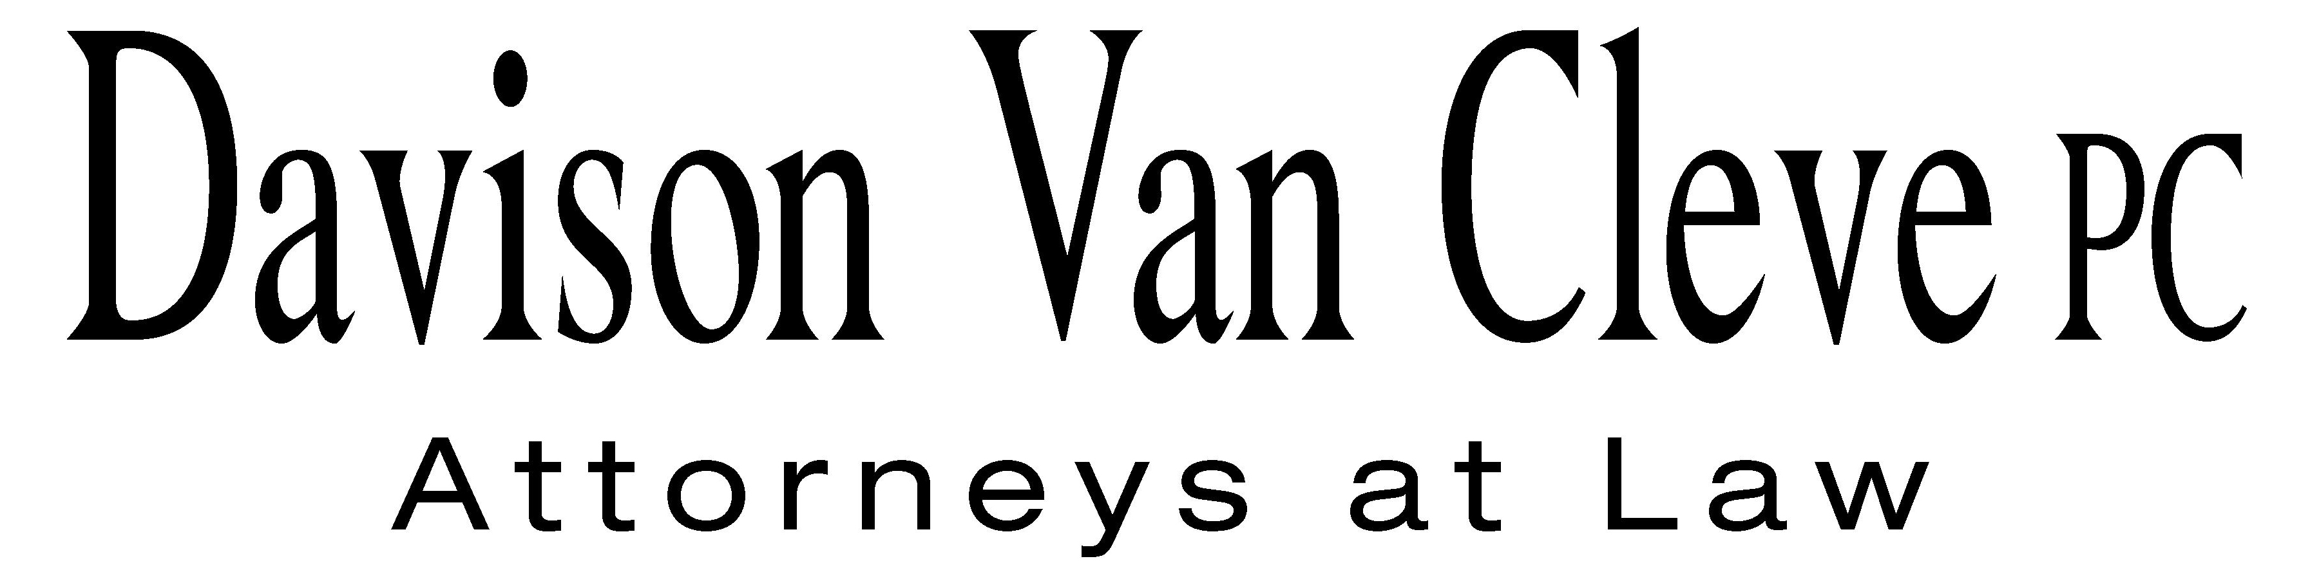
TEL (503) 241-7242 ● FAX (503) 241-8160 ● mail@dvclaw.com
Suite 400
333 SW Taylor
Portland, OR 97204

June 11, 2012

Via Email and Federal Express

Mr. David E. Danner
Secretary
Washington Utilities and Transportation Commission
PO Box 47250
1300 S Evergreen Park Drive SW
Olympia, WA 98504-7250

Re: In the matter of WUTC v. PacifiCorp.
Docket No. UE-120700

Dear Mr. Danner:

Enclosed please find an original and twelve (12) copies of the Petition to Intervene of Boise White Paper, LLC.

Thank you for your assistance. If you have any questions, please do not hesitate to contact our office.

Sincerely yours,

/s/ Sarah A. Kohler
Sarah A. Kohler
Enclosures

cc: Service List

CERTIFICATE OF SERVICE

I hereby certify that I have this day served the foregoing documents upon all parties of record in this proceeding by mailing a copy thereof in a sealed, first-class postage prepaid envelope to each individual’s last-known address, as listed below.
DATED this 11th day of June, 2012.
Davison Van Cleve, P.C.

/s/ Sarah A. Kohler
Sarah A. Kohler

WILLIAM R GRIFFITH  VICE PRESIDENT, REGULATION  PACIFICORP  825 NE MULTNOMAH, SUITE 2000  PORTLAND OR 97232  bill.griffith@pacificorp.com | SIMON FFITCH  OFFICE OF THE ATTORNEY GENERAL  PUBLIC COUNSEL  800 FIFTH AVENUE STE 2000  SEATTLE WA 98104-3188  simonf@atg.wa.gov
SALLY BROWN
ASSISTANT ATTORNEY GENERAL
WUTC
ATTORNEY GENERAL SECTION
STATE MAIL STOP 40128
sbrown@utc.wa.gov

