Agenda Date: April 12, 2012
Item Number: A2

Docket: UE-112226
Company: Pacific Power and Light

Staff: Rick Applegate, Regulatory Analyst
Chris Mickelson, Regulatory Analyst

Recommendation

Take no action, thereby allowing the tariff filing made by Pacific Power and Light (PacifiCorp or company) in Docket UE-112226 to take effect April 13, 2012, by operation of law.

Background

On December 30, 2011, PacifiCorp filed with the Washington Utilities and Transportation Commission (commission) an update to its tariff Schedule 37 – Avoided Cost Purchases from Cogeneration and Small Power Purchases (tariff). On February 24, 2012, PacifiCorp revised at staff’s request the tariff to reflect the results of a recently completed request for proposal (RFP) and to extend the duration of the tariff from 5 years to 10 years. The revised tariff has an effective date of April 13, 2012.

The tariff follows the requirement that utilities buy electricity from qualifying facilities under the Public Utility Regulatory Policy Act (PURPA) at the utility’s avoided cost. In implementing the requirements of PURPA, this commission has adopted related rules including, WAC 480-107-055 that provides in part:

- A utility must file annually a schedule of estimated avoided cost for the energy and capacity associated with the resource block the utility solicited in its most recent RFP filed pursuant to WAC 480-07-025 [sic] Contents of the solicitation.

- Schedules of estimated avoided cost are to be based upon:

- The most recent project proposals received pursuant to an RFP issued under these rules;

- Estimates included in the utility's current integrated resource plan filed pursuant to WAC 480-100-238;

- The results of the utility's most recent bidding process; and

(d) Current projected market prices for power.

Discussion

Results of the Latest RFP

PacifiCorp filed its 2011 Integrated Resource Plan (IRP) on March 31, 2011. In the IRP, PacifiCorp identified a capacity deficit for the Western Control Area (WCA) – service territory consisting of California, Oregon, and Washington – triggering the commission’s RFP rules. After receiving a limited waiver of these rules, PacifiCorp issued an RFP on January 16, 2012. In the RFP, PacifiCorp proposed to meet its capacity deficit through the use of “front office transactions” which it described as “resources, assumed to be firm, that represent procurement activity made on an annual forward basis to help the Company cover short positions.”

On January 31, 2012, PacifiCorp received qualifying bids from several entities and after performing a quick mark-to-market present value evaluation, transacted with the party that submitted the most favorable bid. As part of its review of this filing, staff examined the RFP responses received by PacifiCorp and the market resource that PacifiCorp acquired as a result. Following the acquisition, PacifiCorp then included the new resource in the resource cost model (GRID) that produced the avoided cost results.

Current Market Price for Power

PacifiCorp develops its avoided cost by comparing the results of two GRID model iterations. The first iteration provides the 10-year dispatch cost of the WCA using PacifiCorp’s current resource information. The second iteration adds an additional resource with zero dispatch costs and a 100 percent capacity factor. During this second iteration, GRID redispatches PacifiCorp’s resources allowing the company to calculate the incremental effect of the additional resource. PacifiCorp then uses the results to calculate its avoided cost tariff. This process is consistent with prior practice and produces results that highly correlate with staff’s 10-year market power price forecast developed using the AuroraXMP model. The following graph compares PacifiCorp’s avoided costs with staff’s forecast using AuroraXMP.

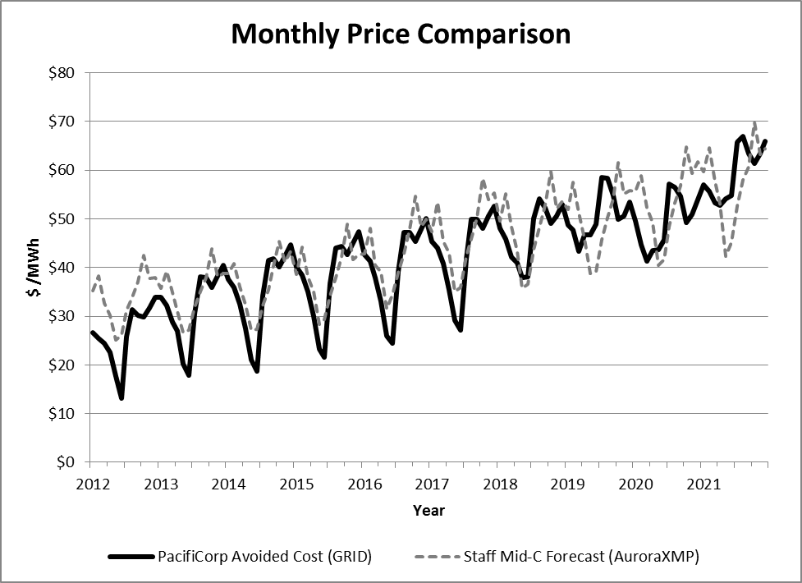

Staff has reviewed PacifiCorp’s filing and accompanying workpapers for consistency with commission rules. In particular, staff focused on the requirements that the avoided cost consider proposals received pursuant to PacifiCorp’s recent RFP and current projected market prices for power. Following its review, staff believes that PacifiCorp developed its avoided cost consistently with the requirements and, therefore, the tariff should be allowed to take effect.

Recommendation

Take no action, thereby allowing the tariff filing made by PacifiCorp in Docket UE-112226 to take effect April 13, 2012, by operation of law.

WAC 480-107-055 (1) should reference WAC 480-107-025.
Docket No. UE-100514
PacifiCorp 2011 IRP, Volume I, p. 150, March 31, 2011.

