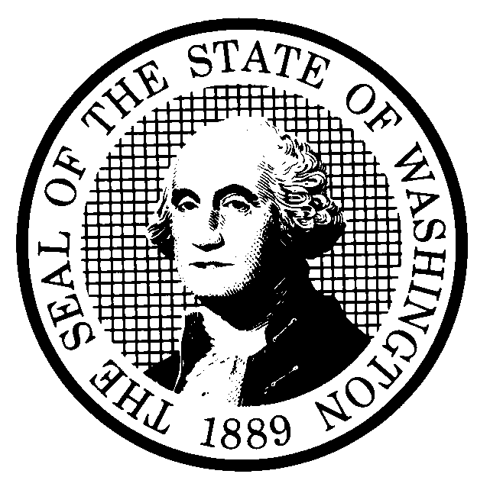 | PREPROPOSAL STATEMENT OF INQUIRY |  | CR-101 (June 2004)  (Implements RCW 34.05.310)  Do NOT use for expedited rule making
Agency: Washington Utilities and Transportation Commission
Subject of possible rule making: On November 7, 2006, Washington voters approved Initiative Measure No. I-937, now codified as RCW 19.285. This new chapter concerns requirements for new energy resources, and requires large utilities to obtain fifteen percent of their electricity from new renewable resources such as solar and wind by the year 2020 and to undertake cost-effective energy conservation. The subject of this inquiry is to consider whether the Utilities and Transportation Commission (UTC) should propose new or modified regulations to implement the provisions of RCW 19.285. This inquiry may lead to proposed amendments to existing rules including, without limitations, WAC 480-100. Docket UE-061895.
Statutes authorizing the agency to adopt rules on this subject: RCW 80.01.040, RCW 80.04.160 and RCW 19.285.080(1).
Reasons why rules on this subject may be needed and what they might accomplish: RCW 19.285.080 provides that the UTC “may adopt rules to ensure the proper implementation and enforcement of this chapter as it applies to investor-owned utilities.” The UTC’s initial review of the new chapter and consultation with several interested parties indicates that the UTC should initiate this inquiry to examine whether new rules should be proposed, whether amendments should be proposed to existing rules, or whether no action respecting rules is necessary.
Identify other federal and state agencies that regulate this subject and the process coordinating the rule with these agencies: Public utilities not jurisdictional to the UTC are required by RCW 19.285 to acquire minimum amounts of conservation and renewable resources. RCW 19.285.080(2) requires The Department of Community, Trade and Economic Development (CTED) to adopt certain rules that will apply to such public utilities. The UTC welcomes CTED’s participation in this inquiry as an interested person. If practical and convenient, the UTC may conduct joint workshops with CTED on certain subjects pertinent to this inquiry.
Process for developing new rule (check all that apply):
Negotiated rule making
Pilot rule making
Agency study
Other (describe) The UTC’s official notice of this inquiry will indicate the date by which the UTC wishes to receive initial written comments and the date, time and location of an initial workshop. The UTC may provide the opportunity for additional written comments and/or for participation in additional workshops, if needed.

How interested parties can participate in the decision to adopt the new rule and formulation of the proposed rule before publication: (List names, addresses, telephone, fax numbers, and e-mail of persons to contact; describe meetings, other exchanges of information, etc.)
Interested persons may file comments with the Executive Secretary, Washington Utilities and Transportation Commission, P.O. Box 47250, 1300 S. Evergreen Park Drive S.W., Olympia, Washington, 98504-7250; Telephone (360) 664-1174; Fax (360) 586-1150, by 5:00 p.m., Monday, February 26, 2007.

For specific information regarding opportunities for written comments and to ensure receipt of further information concerning this rulemaking, including notices of any workshops, please see the attachment to this form.

DATE  January 24, 2007 |  | CODE REVISER USE ONLY
NAME (TYPE OR PRINT)
Carole J. Washburn

SIGNATURE |  | Filed with the Code Reviser’s Office  January 24, 2007, 11:09 a.m.  WSR 07-03-171
TITLE
Executive Secretary

WASHINGTON UTILITIES AND TRANSPORTATION COMMISSION
CR-101 - ATTACHMENT
DOCKET UE-061895

Interested persons may contact the Secretary, Washington Utilities and Transportation Commission, P.O. Box 47250, Olympia, Washington, 98504-7250, 360-664-1174 (Fax: 360-586-1150).

WRITTEN COMMENTS
Written comments may be submitted to the Commission at the address given above and should be filed with the Commission no later than February 26, 2007.
Electronic copies. The commission requests that comments be provided in electronic format to enhance public access, for ease of providing comments, to reduce the need for paper copies, and to facilitate quotations from the comments. Comments may be submitted by e-mail to the commission’s Records Center at records@wutc.wa.gov. Please include:

- The docket number of this proceeding (UE-061895)
- The commenting party’s name
- The title and date of the comment or comments

An alternative method for submitting comments may be by mailing/delivering an electronic copy on a 3 ½ inch, IBM-formatted, high-density disk, in .pdf Adobe Acrobat format or in Word 97 or later. Include all of the information requested above. The commission will post on the commission’s Web site all comments that are provided in electronic format. The Web site is located at www.wutc.wa.gov/061895. If you are unable to file your comments electronically or to submit them on a disk, the commission will always accept a paper document.

Opportunity for further comment is anticipated. Information about the schedule and other aspects of the rulemaking, including comments, will be posted on the commission’s Web site as it becomes available. If you wish to receive further information on this rulemaking you may (1) call the Commission’s Records Center at 360-664-1234, (2) e-mail the commission at <records@wutc.wa.gov>, or (3) mail written comments to the address above to the attention of Carole J. Washburn, Secretary. When contacting the Commission, please refer to Docket UE-061895 to ensure that you are placed on the appropriate service list. Questions may be addressed to Nicolas Garcia (360) 664-1346 or e-mail at ngarcia@wutc.wa.gov.

TO CONTINUE RECEIVING NOTICES AND INFORMATION ABOUT THIS RULEMAKING -- The commission wants to ensure its mailings are sent to persons who are interested in the topic and want to receive that information. ANY PERSON WHO COMMENTS will continue to receive notices and information. If you do not submit comments but wish to remain on the mailing list for this rulemaking, please advise the Records Center by any one of the following methods: (1) send a note with your name, address (or a copy of your mailing label), and telephone and fax numbers referencing Docket UE-061895, and the words "Please keep me on the mailing list"; or (2) e-mail your name, address, telephone and fax numbers, referencing Docket UE-061895, and the words "Please keep me on the mailing list" to <records@wutc.wa.gov>. Please note that all information in the mailings will be accessible through the commission's Internet Web site at http://www.wutc.wa.gov/061895. THOSE PARTIES WHO DO NOT RESPOND MAY NOT RECEIVE FURTHER MAILINGS OR INFORMATION ON THE RULEMAKING.
NOTICE

