WN U-2

Original Sheet No. 1139

PUGET SOUND ENERGY
NATURAL GAS SUPPLEMENTAL SCHEDULE NO. 139
Gas Conservation Savings Adjustment Rate

Section 1: Applicability

This Conservation Savings Adjustment (“CSA”) rate is applicable to sales Customers served under Schedule Nos. 23, 31, 41, 53, 85, 86 and 87.

Section 2: Purpose

This schedule recovers costs that would otherwise go unrecovered by the Company as a result
of the services provided under Gas Conservation Service Schedules numbered between 200 and 299.

Section 3: Definitions

- Annual Conservation Report – The Company’s annual report on conservation results, filed on or before February 15 of each year in accordance with the Commission’s order in Docket No. UE-970686.
- Recovery Year – The calendar year prior to each CSA rate filing.
- Savings Adjustment – The accumulated conservation gas savings reported in the Company’s Annual Conservation Reports that is not reflected in the test year loads used to determine gas service rates in effect during the Recovery Year. The Savings Adjustment will be tracked separately, by month, for each rate group listed in Section 5.
- Fixed Cost Rate (“FCR”) – Is a rate per therm calculated for each rate group listed in Section 5 that is used to calculate the UFCA. The FCR is equal to the applicable proforma test year margin revenue for base rates in effect during each month of the Recovery Year, less any associated basic and minimum charge revenue, divided by the corresponding proforma test year gas sales.
- Unrecovered Fixed Cost Amount (“UFCA”) – The Savings Adjustment for each rate group multiplied by the associated FCR for each month, summed across the months within the Recovery Year.
Section 4: Rate Calculations

- No greater than seventy-five (75) percent of the UFCA for each Recovery Year will be recovered in the first CSA rate year following the Recovery Year, which begins May 1 of each year, subject to true-up in subsequent CSA filings.

(N)
|
|
|
|
|
|
|
|
|
|
|
|
|
|
|
|
|
|
|
|
|
|
|
|
|
|
|
|
|
|
|
|
|
|
|
|
|
|
|
|
|
(N)

Issued: June 13, 2011 Effective: July 14, 2011
Advice No.: 2011-16

Issued By Puget Sound Energy
By: | 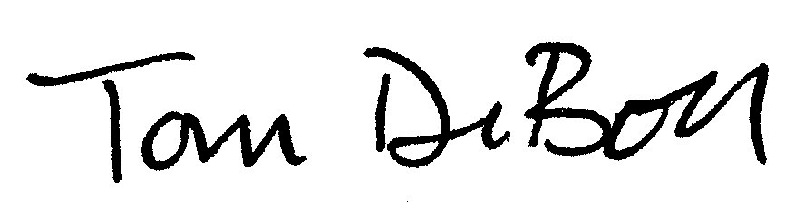 | Tom DeBoer Title: Director, Federal & State Regulatory Affairs

