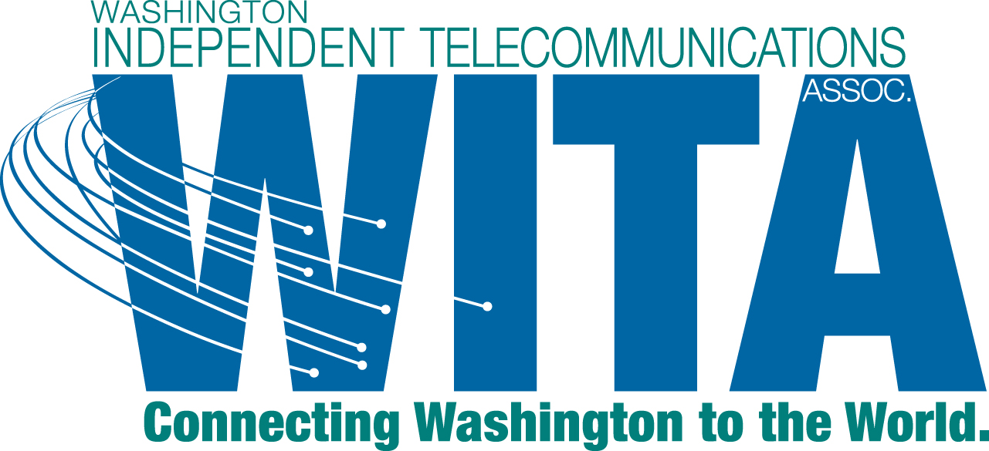

November 14, 2012

David Danner, Executive Director and Secretary
Washington Utilities and Transportation Commission
1300 S. Evergreen Park Drive SW
Olympia, WA 98504-7250

Re: UT-120451 - Response of WITA to Notice of Opportunity to Comment

Dear Mr. Danner:

On October 31, 2012, the Commission issued a Notice of Opportunity to Comment (the Notice) in the above-referenced docket. In the Notice, the Commission is providing interested persons an opportunity to comment on a proposed revision to WAC 480-120-251 Directory Service prior to issuing a new CR-102. This letter constitutes the comments of the Washington Independent Telecommunications Association (WITA).

The Notice is a follow-up to the workshop held in October on the proposed rule. Much of the focus at the workshop was on a recent Ninth Circuit decision holding that directories constitute speech and are entitled to full First Amendment protection.

In its earlier comments, WITA asked that the rule be repealed. Repeal of the rule seems to be the action most consistent with the Ninth Circuit decision. However, the draft rule proposed in the Notice represents a compromise that WITA can support. In making this statement, WITA takes no position on whether the requirement in proposed WAC 480-120-251(2)(a) to provide a printed directory upon customer request can withstand a First Amendment challenge.

Therefore, as a preferred position, WITA respectfully requests that the Commission repeal WAC 480-120-251. As explained in WITA's earlier comments, it should be the business determination of each local exchange company whether it provides a telephone directory to its customers and, if so, in what format.

If the Commission determines that it is going to continue to require that directories to be provided, WITA can support the rule as proposed in the Notice.

Thank you for the opportunity to comment and your attention to these comments.

Sincerely,

CenturyLink will be filing its own comments.

