WN U-60 Original Sheet No. 139-a

PUGET SOUND ENERGY
Electric Tariff G

SCHEDULE 139
ELECTRIC CONSERVATION SAVINGS ADJUSTMENT RATE
(Continued)

b) The remaining UFCA for a given Recovery Year will be recovered in CSA rates no sooner than the second CSA rate year following the Recovery Year, subject to:
    - verification and possible modification by a third-party evaluator of the conservation savings used to determine the applicable Savings Adjustment;
    - the limitation that the UFCA recovered for the given Recovery Year does not result in the Company’s actual rate of return, as derived from the Company’s audited year-end financial statements, exceeding its authorized rate of return in the Recovery Year; and
    - a true-up in subsequent CSA filings.

  - CSA rates for each rate group will be determined by dividing the applicable UFCA by the projected sales for the associated rate group in the CSA rate year.

  - The UFCA in the 2011 Recovery Year will be calculated using the Savings Adjustment resulting from the conservation savings reported in the Company’s 2010 Annual Conservation Report and the conservation savings projected for calendar year 2011 in the Company’s 2011 Annual Conservation Plan (“ACP”). The non-residential conservation savings estimated in the ACP for calendar year 2011 will be allocated between the non-residential rate groups based upon their relative proportion of reported conservation savings in 2010. These estimates will be trued up to actual results in a subsequent CSA filing.

  - New CSA rates shall be filed no later than March 1 of each year.

- RATES –

Schedule 7 0.0311 cents per kWh
Schedules 24, 25, 26, 29, 31, 35, 43 and 57(*) 0.0415 cents per kWh
Schedules 40, 46, 49, 448, 449, 458 and 459 0.0018 cents per kWh

6) ADJUSTMENTS – Rates in this schedule or amounts charged under this schedule are subject to adjustment by such other schedules in this tariff as they may be added or modified from time to time.

- GENERAL RULES AND PROVISIONS – Service under this schedule is subject to the General Rules and Provisions contained in this tariff.

* Rate applies to the schedule(s) as well as equivalent schedules, such as Residential and Farm Schedules.

(N)
|
|
|
|
|
|
|
|
|
|
|
|
|
|
|
|
|
|
|
|
|
|
|
|
|
|
|
|
|
|
|
|
|
|
|
|
|
|
|
|
|
|
|
|
(N)

Issued: June 13, 2011 Effective: July 14, 2011
Advice No.: 2011-15
Issued By Puget Sound Energy
By: | 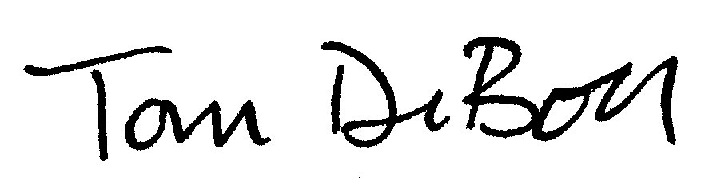 | Tom DeBoer Title: Director, Federal & State Regulatory Affairs

