WN U-60 Original Sheet No. 139

PUGET SOUND ENERGY
Electric Tariff G

SCHEDULE 139
ELECTRIC CONSERVATION SAVINGS ADJUSTMENT RATE

- APPLICABILITY – This Conservation Savings Adjustment (“CSA”) rate is applicable to all bills for electric service calculated under all schedules contained in this tariff and all retail contracts for electric service except where explicitly exempted.

- PURPOSE – This schedule recovers costs that would otherwise go unrecovered by the Company as a result of the services provided under Schedule 83, Schedule 150, schedules numbered between 200 and 215, and between 217 and 299.

- DEFINITIONS –

  - Annual Conservation Report – The Company’s annual report on conservation results, filed on or before February 15 of each year in accordance with the Commission’s order in Docket No. UE-970686.
  - Recovery Year – The calendar year prior to each CSA rate filing.
  - Savings Adjustment – The accumulated conservation Energy savings reported in the Company’s Annual Conservation Reports that is not reflected in the test year loads used to determine Electric Service rates in effect during the Recovery Year. The Savings Adjustment will be tracked separately, by month, for each rate group listed in Section 5. The Savings Adjustment will not include conservation savings associated with the Company’s fuel conversion program.
  - Fixed Cost Rate (“FCR”) – Is a rate per kWh calculated for each rate group listed in Section 5 that is used to calculate the UFCA. The FCR is equal to the applicable proforma test year revenue for base rates in effect during each month of the Recovery Year, less the sum of any associated basic charge revenue and costs related to the Company’s Power Cost Adjustment Clause, divided by the corresponding proforma test year Energy sales.
  - Unrecovered Fixed Cost Amount (“UFCA”) – The Savings Adjustment for each rate group multiplied by the associated FCR for each month, summed across the months within the Recovery Year.

- RATE CALCULATIONS –

  - No greater than seventy-five (75) percent of the UFCA for each Recovery Year will be recovered in the first CSA rate year following the Recovery Year, which begins May 1 of each year, subject to true-up in subsequent CSA filings.

(N)
|
|
|
|
|
|
|
|
|
|
|
|
|
|
|
|
|
|
|
|
|
|
|
|
|
|
|
|
|
|
|
|
|
|
|
|
|
|
|
|
(N)

Issued: June 13, 2011 Effective: July 14, 2011
Advice No.: 2011-15
Issued By Puget Sound Energy
By: | 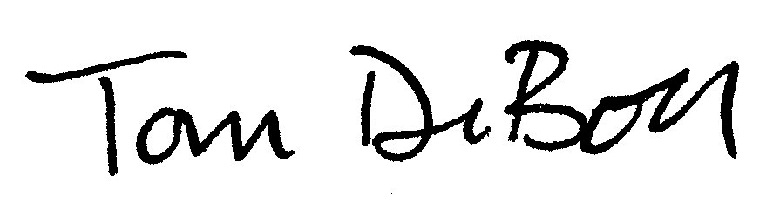 | Tom DeBoer Title: Director, Federal & State Regulatory Affairs

