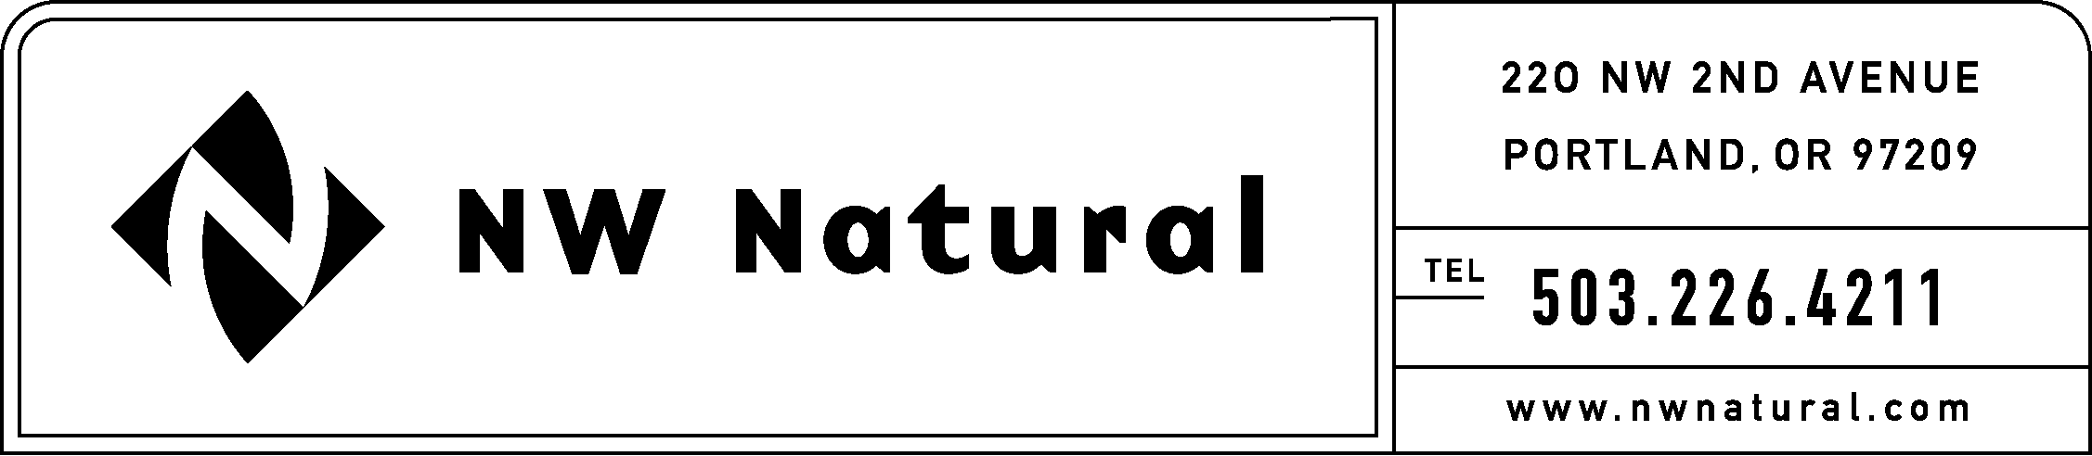
Rates & Regulatory Affairs

July 31, 2026

Secretary
Washington Utilities & Transportation Commission
P.O. Box 47250
Olympia, Washington 98504-7250

Re: Docket Number U-991301

NW Natural appreciates the opportunity to comment in this matter. These comments are directed only to the proposal to move the provisions for gas utilities regarding notice to the public of tariff changes from Chapter 480-80 WAC Utilities General - Tariffs to 480-90 WAC Gas Companies – Operations.

There are at least two features a user wants when they seek to find information from the Washington Administrative Code. They include : (1) that the rules are logically structured and located in a chapter that is best suited to the subject matter; and (2) that the rules are comprehensive and easy to understand. The proposal to re-locate a rule that pertains to noticing the public/customers of rate and tariff changes to a chapter that governs utility operations does not meet the first criteria for a logical structure. As such, the rule at issue should remain within Chapter 480-80.

Thank you for the opportunity to comment.

Sincerely,

Onita King
Tariff Consultant

