
Frontier Communications Northwest Inc.
1800 – 41st Street WA0105RA
P. O. Box 1003
Everett, WA 98201-1003
Fax: 425-261-5262
September 28, 2010

VIA ELECTRONIC MAIL

Mr. David Danner
Executive Director and Secretary
Washington Utilities and Transportation Commission
1300 S. Evergreen Park Drive SW
Olympia, WA 98504

Re: UT-090842 – Joint Application of Verizon Communications Inc. and Frontier Communications Corporation for an Order Declining to Assert Jurisdiction Over, or, in the Alternative, Approving the Indirect Transfer of Control of Verizon Northwest Inc.

Dear Mr. Danner:

The April 16, 2010 Order in the above-referenced matter included a condition requiring Frontier Communications Northwest Inc. to submit an initial broadband deployment plan, and consult with staff, within 90 days of the closing date.

Attached are 2 Highly Confidential documents describing the planned deployment. These documents were reviewed in a meeting with Staff on September 23, 2010.

If you have any questions in regard to this information, please feel free to contact me at 425.261.6380 or linda.fogg@FTR.com.

Sincerely,
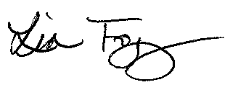
Lin Fogg
State Manager Regulatory/Legislative

Attachments

cc: Kevin L. Saville

