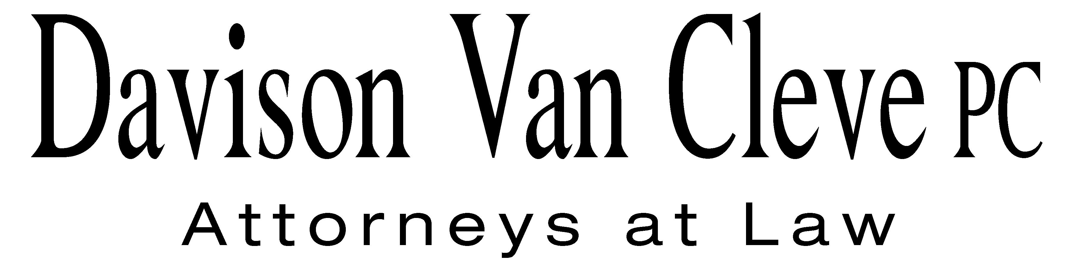
TEL (503) 241-7242 ● FAX (503) 241-8160 ● mail@dvclaw.com
Suite 400
333 SW Taylor
Portland, OR 97204

October 11, 2012

Via Email and Federal Express

Mr. David E. Danner
Washington Utilities and Transportation Commission
PO Box 47250
1300 S Evergreen Park Drive SW
Olympia, WA 98504-7250

Re: In the Matter of PUGET SOUND ENERGY’S Petition for Approval of a Power Purchase Agreement for Acquisition of Coal Transition Power, as Defined in RCW 80.80.010, and the Recovery of Related Acquisition Costs
Docket No. UE 121373

Dear Mr. Danner:

Enclosed please find an original and ten (10) copies of the Confidentiality Agreement of Joshua D. Weber on behalf of the Industrial Customers of Northwest Utilities.

Thank you for your assistance.

Sincerely yours,

/s/ Sarah A. Kohler
Sarah A. Kohler
Enclosures

cc: Service List

CERTIFICATE OF SERVICE

I hereby certify that I have this day served the foregoing Confidentiality Agreement of Joshua D. Weber upon all parties of record in this proceeding by mailing a copy thereof in a sealed, first-class postage prepaid envelope to each individual’s last-known address, as listed below.
DATED this 11th day of October, 2012.
Davison Van Cleve, P.C.

/s/ Sarah A. Kohler
Sarah A. Kohler

PUGET SOUND ENERGY  TOM DEBOER  PO BOX 97034 PSE-08N  BELLEVUE WA 98009-9734  tom.deboer@pse.com | PERKINS COIE  SHEREE CARSON  Donna Barnett  JASON KUZMA  10885 N.E. FOURTH STREET STE 700 BELLEVUE WA 98004-5579  scarson@perkinscoie.com  dbarnett@perkinscoie.com  jkuzma@perkinscoie.com
WASHINGTON UTILITIES & TRANSPORTATION COMMISSION  SALLY BROWN  PO BOX 40128  OLYMPIA, WA 98504  sbrown@utc.wa.gov | PUBLIC COUNSEL  SIMON FFITCH  LISA GAFKEN  800 FIFTH AVENUE STE 2000  SEATTLE, WA 98104-3188  simonf@atg.wa.gov  lisa.gafken@atg.wa.gov
NW ENERGY COALITION
NANCY HIRSH
DANIELLE DIXON
811 1st Ave # 305
Seattle, WA 98104-2599
nancy@nwenergy.org
danielle@nwenergy.org

