BEFORE THE WASHINGTON UTILITIES AND TRANSPORTATION COMMISSION
In re Application of  SHUTTLE EXPRESS, INC.,  For Extension of Certificate No. C-975,  Shuttle Express, Inc. d/b/a Shuttle Express | Docket No. TC-091931  Permit No. C-975  DECLARATION OF BROOKS E. HARLOW IN SUPPORT OF MOTION TO STRIKE PROTEST, CANCEL PREHEARING CONFERENCE, AND TERMINATE ADJUDICATIVE PROCEEDING

  - I, Brooks E. Harlow, hereby declare as follows:
  - I am one of the attorneys for Shuttle Express, Inc. d/b/a Shuttle Express ("Shuttle") and I make this declaration in support of the Motion To Strike Protest, Cancel Prehearing Conference And Terminate Adjudicative Proceeding.
  - Yesterday (February 2, 2010), I personally reviewed the Commission's original file in this matter at the Commission's Record Center. Attached hereto as Exhibit A is the only copy of the Protest that was on file with the Commission at that time. The notation on the copy reflects that it was filed via the web portal, but not filed by mail or hand delivery. The Protest in the file appears to be a printout, not an original document, and was unsigned.
  - Attached hereto as Exhibit B is a "screen shot" showing the online list of documents filed in this docket as of yesterday. The online list of documents also reflected that the Protest was only submitted via the web portal on January 20, 2010, but not filed in hard copy until January 27, 2010. Attached as Exhibit C is a copy of the protest the Records Center e-mailed to me yesterday afternoon. According to the date stamp, the hard copy was filed on January 27, 2010.
  - Attached hereto as Exhibit D is a copy of the Protest that Shuttle received in the mail along with a another document styled as a "Complaint," together with the envelope that contained the Protest and Complaint, showing the postmark date. Exhibit D was provided to me by Shuttle Express. The Complaint is dated January 25, 2010, and the postmark shows that the Protest and Complaint were also mailed on January 25, 2010.
  - I was unable to find a certificate of service of the protest anywhere in the Commission's official file.
  - I declare under penalty of perjury under the laws of the State of Washington that the foregoing is true and correct.

Executed this 3rd day of February, 2010, in Seattle, Washington.
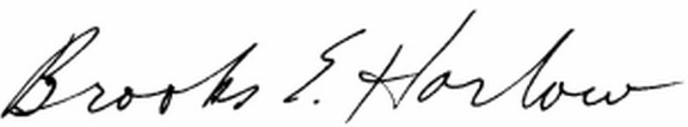
Brooks E. Harlow

CERTIFICATE OF SERVICE
Docket No. Docket No. TC-091931
I hereby certify that a true and correct copy of the foregoing was forwarded via electronic mail and first class mail, postage fully prepaid, in a sealed envelope, to the following:

John Solin
Mike Lauver
SeaTac Shuttle, LLC
d/b/a Whidbey Seatac Shuttle
P.O. Box 2895
Oak Harbor, WA 98277
E-mail: mike@seatacshuttle.com

John Rowley
General Manager
Shuttle Express, Inc.
800 SW 16th Street
Renton, WA 98055
jrowley@shuttleexpress.net

Dated at Seattle, Washington, this 3rd day of February, 2010.
/s/______________________________
Carol Munnerlyn, Secretary

