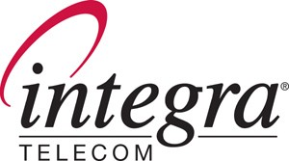

730 Second Avenue South - Suite 900 - Minneapolis – Minnesota 55402

October 8, 2008

David Danner
Secretary & Executive Director
WA Utilities & Transportation Commission
1400 S. Evergreen Park Drive S.W.
P.O. Box 40128 Via Email to: records@utc.wa.gov
Olympia, WA 98504-0128 and Overnight Delivery

Re: SUPPLEMENTAL FILING – Docket No. UT-080864
AUGUST 2008 Combined Class A Report of INTEGRA TELECOM OF WASHINGTON, INC. & ITS WASHINGTON AFFILIATES

Dear Mr. Danner:

Enclosed for filing, information only, is the August 2008 Sample Combined Class A Report of Integra Telecom of Washington, Inc. and its Washington affiliates (Integra). Please accept this as a supplement to Integra’s pending Petition for Alternative Measurement and Reporting under WAC 480-120-439(12). I have enclosed an original and 12 copies of this filing and have also submitted it electronically via email to the Commission’s Records Center. Please contact the undersigned with any questions or concerns.

Sincerely,

Cathy Murray
Manager, Regulatory Affairs
Integra Telecom
730 2nd Avenue South, Suite 900
Minneapolis, MN 55402-2456
(612) 436-1632 (direct)
(612) 436-6816 (department fax)
camurray@integratelecom.com

Email Enclosures
Cc: Kristin Russell, WUTC

