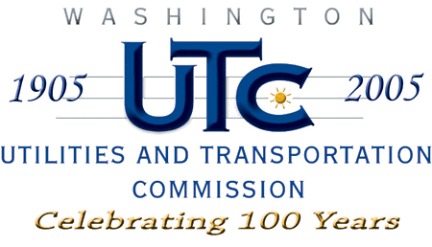

Memorandum
July 9, 2009

To: TR-072010 - File

From: Kathy Hunter, Deputy Assistant Director, Transportation Safety

Subject: TR-072010 – Grade Crossing Protective Fund (GCPF) Application from Washington State Department of Transportation (WSDOT)

On October 10, 2007, WSDOT filed a GCPF application to pay for a project to upgrade incandescent to LED lights at the crossing located at the intersection of SR-124 and Union Pacific Railroad’s (UP) tracks in Walla Walla county. The crossing is identified as USDOT#844397U.

On November 7, 2007, the Commission issued an order approving the $20,000 request for disbursement. The order required that the upgrade and request for reimbursement be completed by June 30, 2008. On August 21, 2008, WSDOT submitted a request for an extension of time to June 30, 2009, to complete the LED upgrade. The Commission granted the request on August 22, 2008.

Staff received notice from WSDOT on June 29, 2009, that WSDOT and UP had not completed the upgrades. Staff will continue to work with WSDOT and UP to seek additional grant opportunities to upgrade the crossing.

Staff recommends that the docket be closed because the conditions of the order were not met.

Cc: Financial Services

