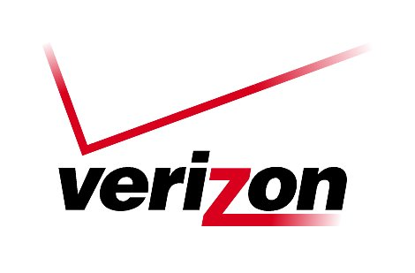 Verizon Northwest Inc.

1800 – 41st Street, WA0105RA
P. O. Box 1003
Everett, WA 98206-1003
Fax: 425-261-5262

July 15, 2010

Advice No. 3299

Washington Utilities and Transportation Commission
1300 S. Evergreen Park Drive, S. W.
Olympia, Washington 98504-7250

To whom it may concern:

Please substitute the enclosed Attachment A and Sheet 474.1 for the ones previously filed, and add the enclosed Sheet 21.1 to the filing package.

Very truly yours,

Richard E. Potter
Director
Public Affairs, Policy & Communications

