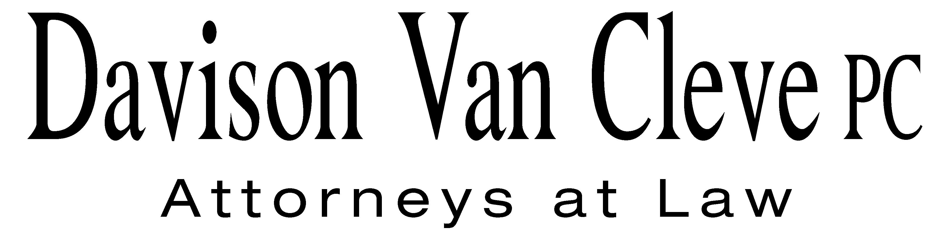
TEL (503) 241-7242 ● FAX (503) 241-8160 ● mail@dvclaw.com
Suite 400
333 S.W. Taylor
Portland, OR 97204

November 18, 2011

Via Email and Federal Express

David E. Danner
Executive Director and Secretary
Washington Utilities and Transportation Commission
PO Box 47250
1300 S Evergreen Park Drive, SW
Olympia WA 98504-7250

Re: In the matter of the PacifiCorp’s general rate increase.

Docket No. UE-100749, Phase II

Dear Mr. Danner:

Enclosed please find the original and seventeen (17) copies of the Phase II Reply Brief on behalf of the Industrial Customers of Northwest Utilities in the above-referenced matter.

If you have any questions or concerns, please do not hesitate to contact our office. Thank you for your assistance.

Sincerely yours,

/s/ Sarah A. Kohler
Sarah A. Kohler

Enclosures

cc: Service List

CERTIFICATE OF SERVICE
I hereby certify that I have this day served the foregoing documents upon all parties of record in this proceeding by mailing a copy thereof in a sealed, first-class postage prepaid envelope to each individual’s last-known address, as listed below.
DATED this 18th day of November, 2011.
Davison Van Cleve, P.C.

/s/ Sarah A. Kohler
Sarah A. Kohler

Katherine McDowell  McDowell Rackner & Gibson PC  419 SW 11th Avenue  Portland, OR 97205 | Walmart Stores, Inc.  2001 SE 10th Street  Bentonville, AR 72716-0550
Mary Wiencke,  PacifiCorp  825 NE Multnomah St STE 1800  Portland, OR 97232 | The Energy Project  3406 Redwood Ave.  Bellingham, WA 98225
Don Trotter  Assistant Attorney General  WUTC  PO Box 40128  Olympia, WA 98504-0128 | Arthur Butler  Ater Wynne LLP  601 Union Street  Seattle, WA 98101-3981
Simon ffitch  Office of the Attorney General  800 Fifth Avenue  Seattle, WA 98104-3188 | Sarah A Shifley  Office of the Attorney General  800 5th Ave  Seattle, WA 98104-3188
Brad M Purdy  Attorney at Law  2019 N. 17th St.  Boise, ID 83702 | Amie Jamieson  McDowell Rackner & Gibson PC  419 SW 11th Avenue  Portland, OR 97205
Andrea Kelly
PacifiCorp
825 NE Multnomah St STE 800
Portland, OR 97232

