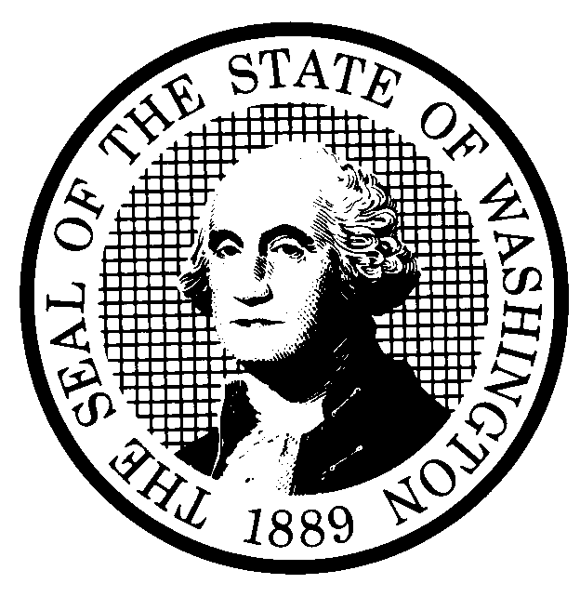 | PROPOSED RULE MAKING  (RCW 34.05.320) |  |  |  |  |  |  |  |  | CR-102 (7/22/01)  Do NOT use for expedited  rule making
Agency: WASHINGTON UTILITIES AND TRANSPORTATION COMMISSION |  |  |  |  |  |  |  |  |  | Original Notice
Preproposal Statement of Inquiry was filed as WSR 00-17-134 ; or  Expedited Rule Making -- Proposed notice was filed as WSR ; or  Proposal is exempt under RCW 34.05.310(4). |  |  |  |  |  |  |  |  |  | Supplemental Notice  to WSR  Continuance of WSR
(a) Title of rule: (Describe Subject) Chapter 480-75 WAC, Hazardous Liquid, Gas, Oil and Petroleum Pipeline Companies – Safety. The proposed rules would establish minimum safety standards and reporting requirements for the transportation of hazardous liquids by pipeline.

Purpose: This proposal would implement the requirements of chapter 81.88 RCW which requires the Commission to develop a comprehensive program of hazardous liquid pipeline safety. In addition, the proposal would implement the Governor’s Executive Order 97-02 by reviewing the rules for need, effectiveness and efficiency, clarity, intent and statutory authority, and cost and fairness.

Other identifying information: Docket No. TO-000712

(b) Statutory authority for adoption: RCW 80.01.040 and RCW 80.04.160 |  |  |  |  |  |  |  |  | Statute being implemented: chapter 8l.88 RCW
(c) Summary: See Section (j) below.

Reasons supporting proposal:
(d) Name of Agency Personnel Responsible for: |  |  |  |  | Office Location |  |  |  |  |  | Telephone
1. Drafting.....Sondra Walsh, Senior Policy Strategist |  |  |  |  | 1300 S. Evergreen Park Dr. S.W., Olympia, WA 98504-7250 |  |  |  |  |  | 360-664-1286
2. Implementation.... Carole J. Washburn, Secretary |  |  |  |  | 1300 S. Evergreen Park Dr. S.W., Olympia, WA 98504-7250 |  |  |  |  |  | 360-664-1174
3. Enforcement.......... Carole J. Washburn, Secretary |  |  |  |  | 1300 S. Evergreen Park Dr. S.W., Olympia, WA 98504-7250 |  |  |  |  |  | 360-664-1174
(e) Name of proponent (person or organization):  Washington Utilities and Transportation Commission |  |  |  |  |  |  |  |  |  |  | Private  Public  X Governmental
(f) Agency comments or recommendations, if any, as to statutory language, implementation, enforcement and fiscal matters:
None

(g) Is rule necessary because of:  Federal Law?  Federal Court Decision?  State Court Decision? |  | Yes  Yes  Yes |  | X No  X No  X No |  | If yes, ATTACH COPY OF TEXT  Citation:
(h) HEARING LOCATION: |  |  |  |  |  |  | Submit written comments to:
Commission Hearing Room  Second Floor, Chandler Plaza Building  1300 S. Evergreen Park Drive S.W.  Olympia, WA 98504-7250 |  |  |  |  |  |  | Secretary, Docket No. TO-000712  Washington Utilities and Transportation Commission  1300 S. Evergreen Park Dr. S.W., P.O. Box 47250,  Olympia, Washington 98504-7250  FAX (360) 586-1150 By (date) June 26, 2002
Date: July 10, 2002 Time: 9:30 a.m. |  |  |  |  |  |  | DATE OF INTENDED ADOPTION: July 10, 2002
Assistance for persons with disabilities: Contact  Mary DeYoung by July 8, 2002 |  |  |  |  |  |  | CODE REVISER USE ONLY
TDD (360) 586-8203 or (360) 664-1133
NAME (TYPE OR PRINT)
CAROLE J. WASHBURN

SIGNATURE

TITLE  SECRETARY |  |  | DATE  6/5/02
(COMPLETE REVERSE SIDE)
(j) Short explanation of rule, its purpose, and anticipated effects:

The proposed rules would establish a comprehensive program of hazardous liquid pipeline safety consistent with chapter 8l.88.RCW, by establishing safety standards for the transportation of hazardous liquids by pipeline, by establishing requirements for the design, construction, maintenance, and repair of hazardous liquids pipeline facilities, and by establishing safety plans and reporting requirements. The purpose of the rules is to provide minimum safety standards and reporting requirements for the transportation of hazardous liquids by pipeline. The proposal would protect the health and safety of the public and the environment by implementing safety measures applicable to persons transporting hazardous liquids by pipeline within the state of Washington.

Does proposal change existing rules? | X YES NO | If yes, describe changes:
The proposal would change the title of chapter 480-75 WAC to Hazardous Liquid, Gas, Oil and Petroleum Pipeline Companies – Safety.

The proposal repeals five out of seven existing rules in chapter 480-75 WAC, creates thirty-six new rules, and amends one existing rule.
Organization of the Chapter. The proposal would organize chapter 480-75 WAC into six parts (General Rules, Design and Construction Rules, Operation
and Maintenance Rules, Reporting Rules, and Adoption by Reference Rule) to improve ease of use.

General Rules. This section includes common rules that the Commission applies to all regulated industries. Placement of general rules in this
Chapter would eliminate searching other WACs for applicable rules. Two new rules have been proposed for inclusion in this section:
WAC 480-75-210, Additional requirements, and WAC 480-75-220, Severability.

Design. This section includes ten new rules that incorporate the requirements of chapter 81.88 RCW.

Construction and Repair. This section also includes seven new rules based on the requirements of chapter 81.88 RCW .

Operation and Maintenance. This section includes six new rules that reflect the requirements of chapter 81.88 RCW.

Reporting Rules. WAC 480-75-650, Annual reports, has been redrafted for clarity and to reflect the requirements of chapter 81.88 RCW.
This section also includes six new rules: WAC 480-75-600, Maps, drawings, and records of hazardous liquid facilities, WAC 480-75-610, Reporting
requirements for proposed construction, WAC 480-75-620 Pressure testing reporting requirements, WAC 480-75-630, Incident reporting,
WAC 480-75-640, Depth of cover survey, and WAC 480-75-660 Operations safety plan requirements..
Adoption by Reference. WAC 480-75-999 is amended to update references.

(k) Has a small business economic impact statement been prepared under chapter 19.85 RCW?
X Yes. Attach copy of small business economic impact statement.
A copy of the statement may be obtained by writing to:
Washington Utilities and Transportation Commission
Records Center, Docket No. TO-000712
1300 S. Evergreen Park Dr. S.W.
P.O. Box 47250
Olympia, WA. 98504-7250

telephoning: (360) 664-1234
faxing: (360) 664-1150
No. Explain why no statement was prepared

(l) Does RCW 34.05.328 apply to this rule adoption? Yes X No
Please explain:
The Commission is not an agency to which RCW 34.05.328 applies. The proposed rules are not significant legislative rules as referenced in RCW 34.05.328.

