Updated APPENDIX 1 to Exhibit J of Docket Nos. UE-011570 and UG-011571 (Consolidated)

In Compliance with Order 17 of Docket Nos. UE-072300 and UG-072301 (Consolidated)

PSE’S SERVICE QUALITY PROGRAM

Service Guarantee

Electric Tariff Schedule 130 Customer Service Guarantee
Electric Tariff Schedule 131 Restoration Service Guarantee
Natural Gas Tariff Schedule 130 Customer Service Guarantee
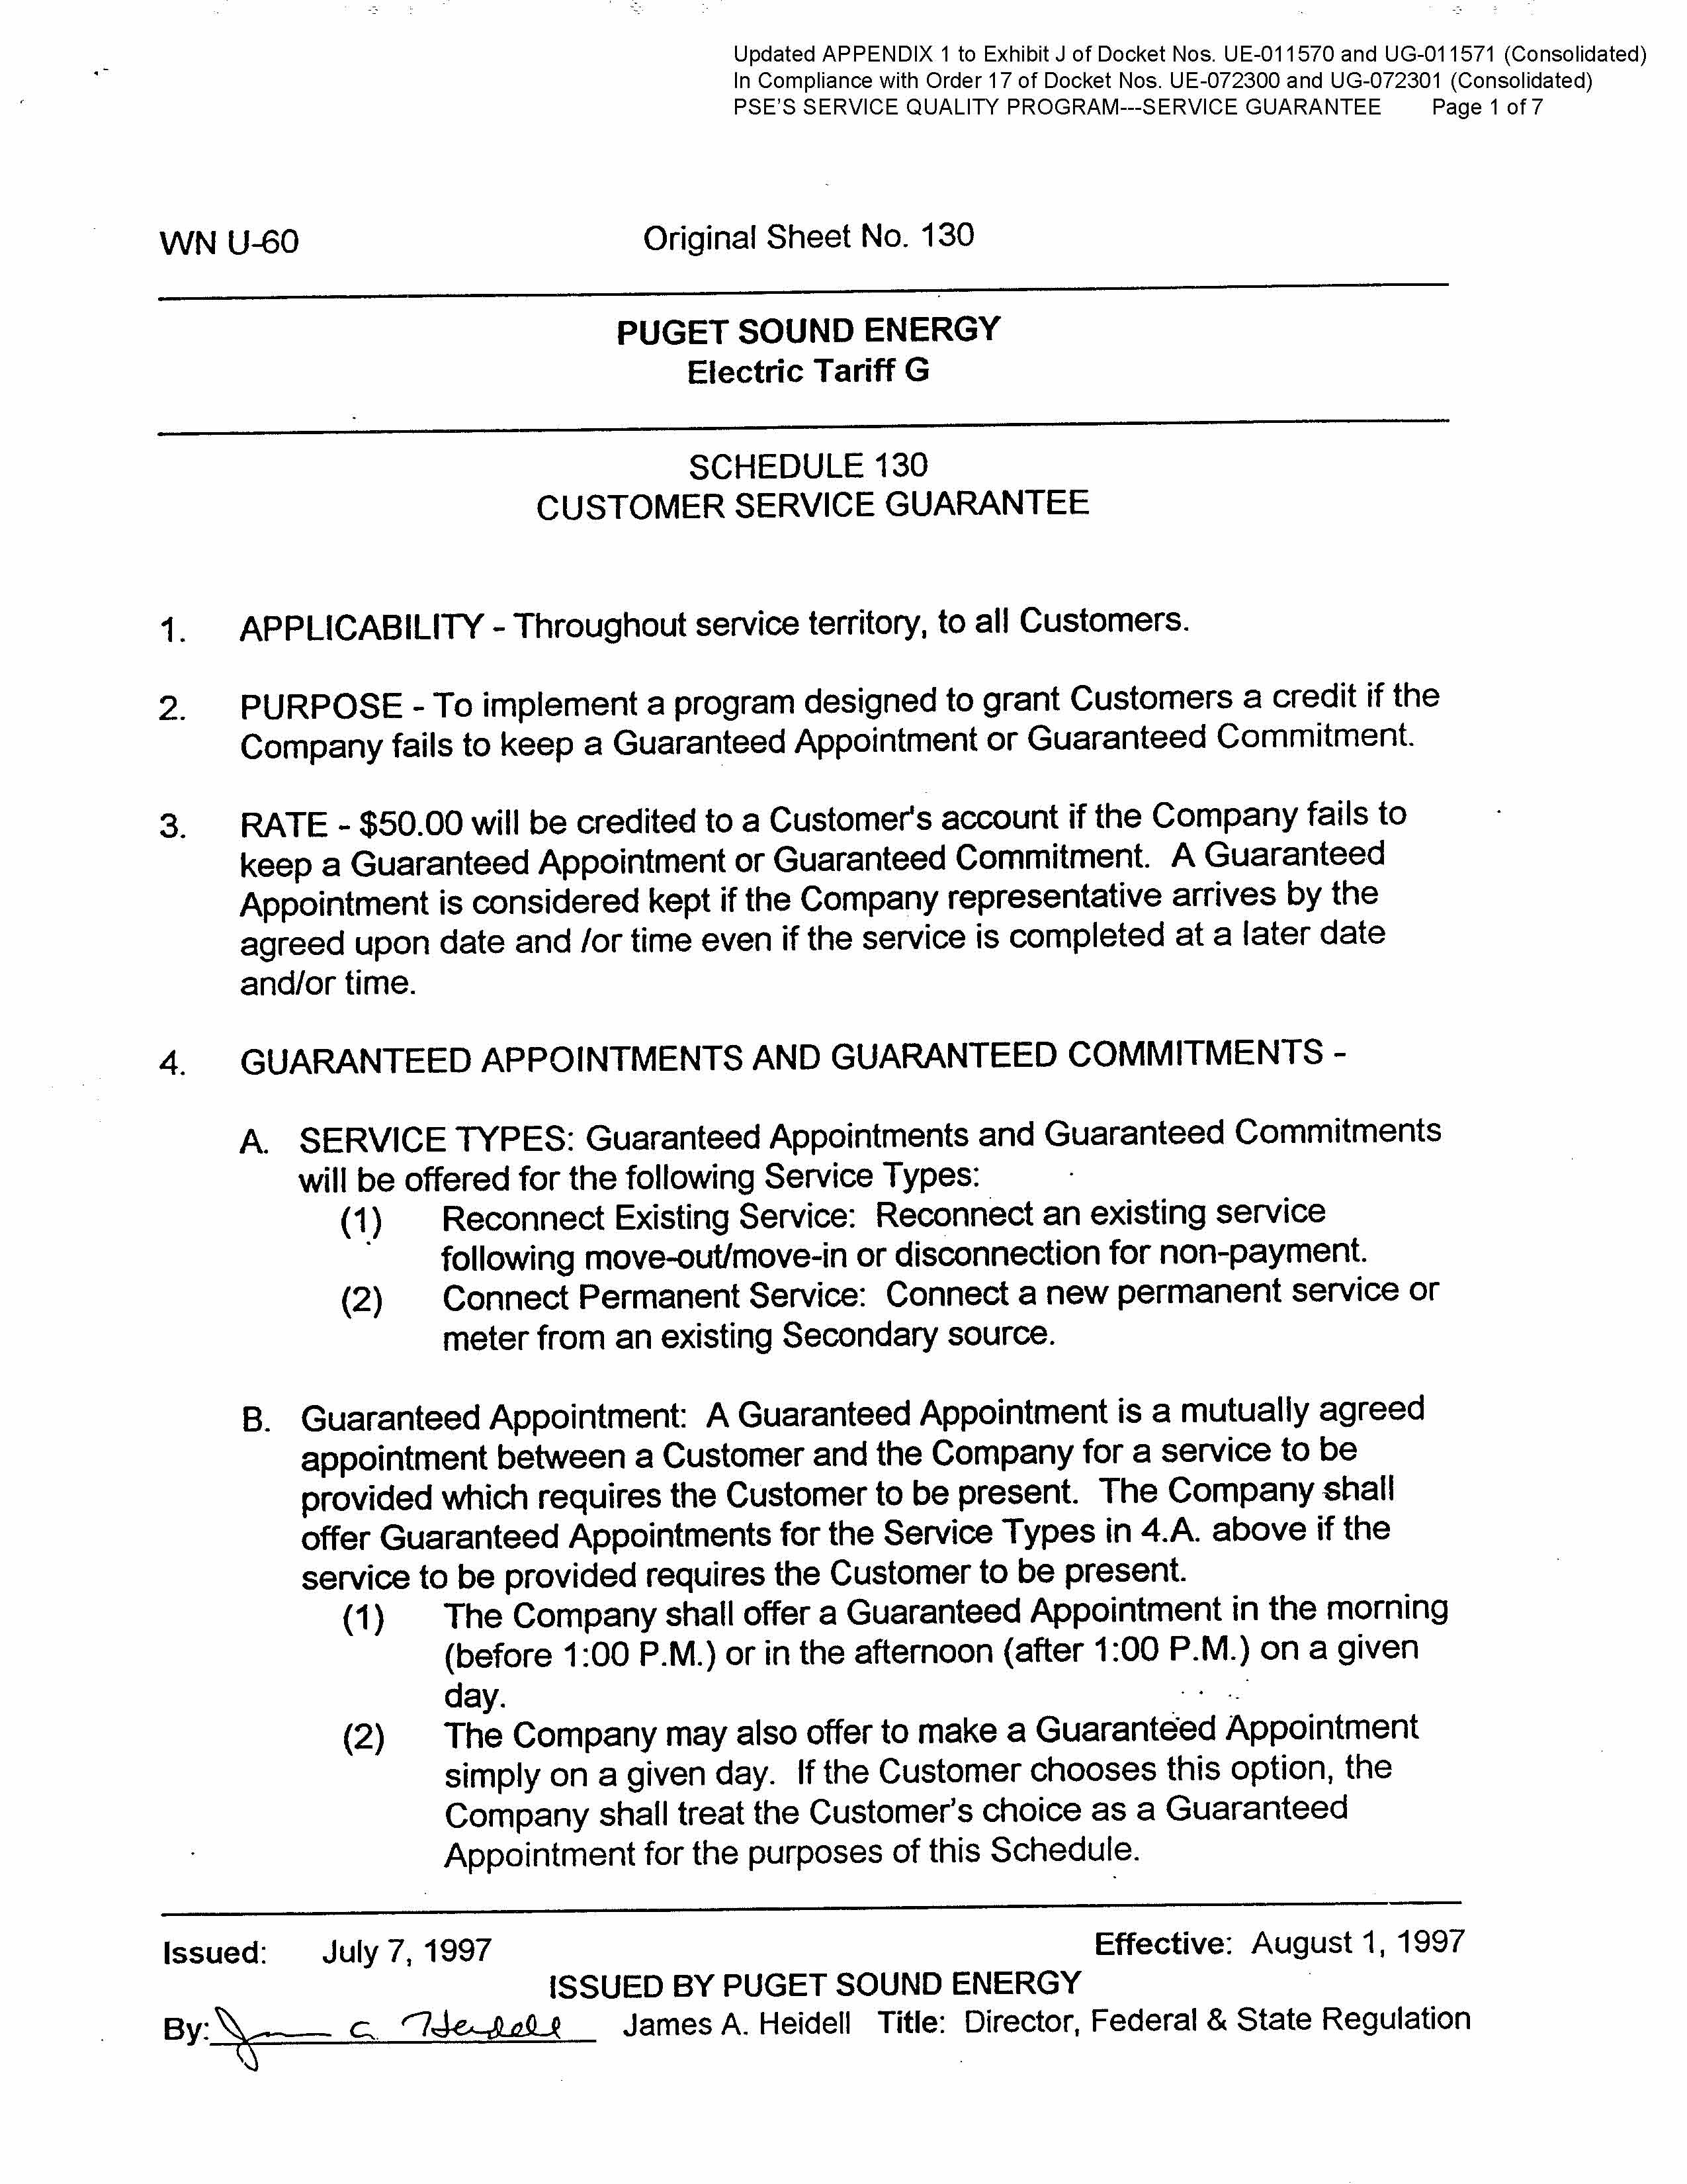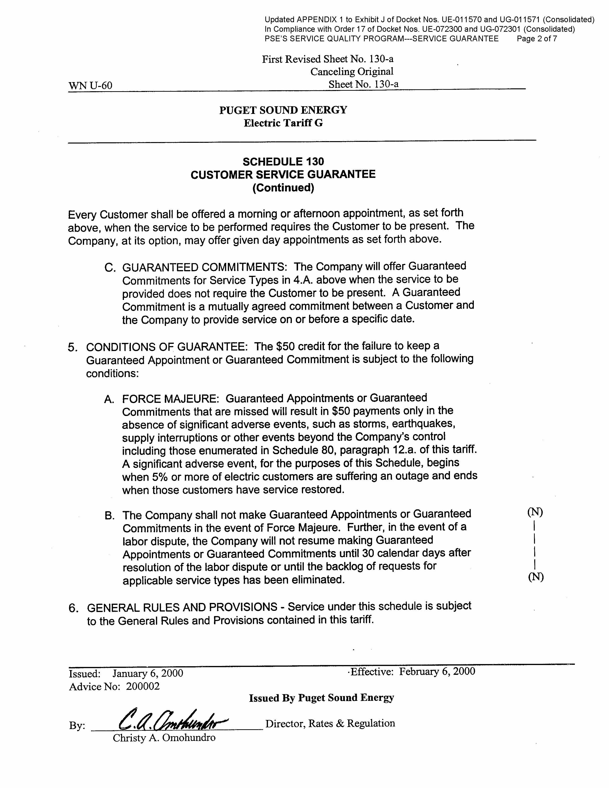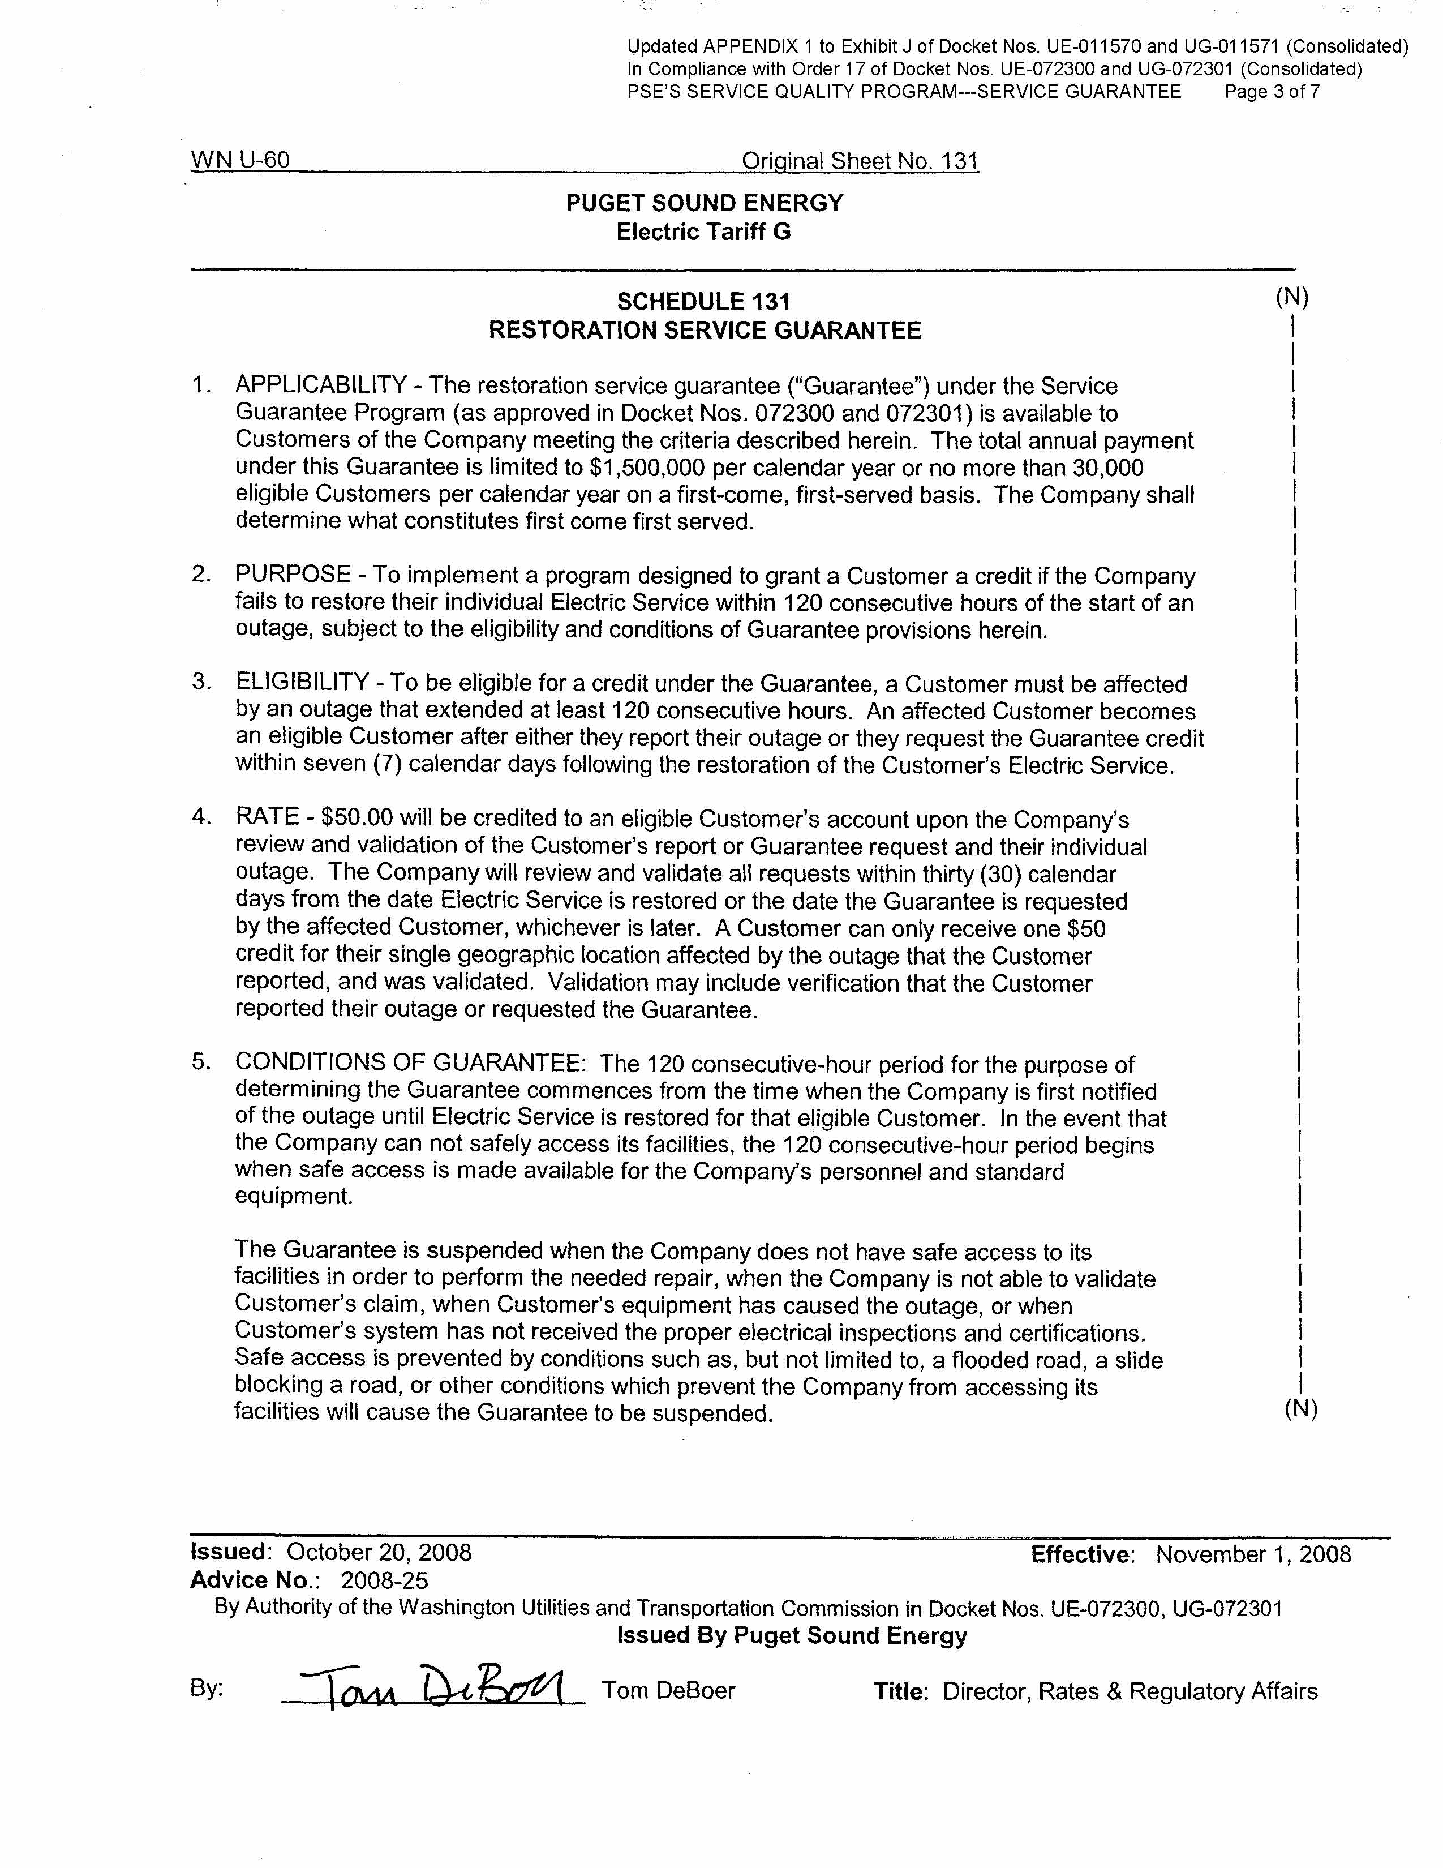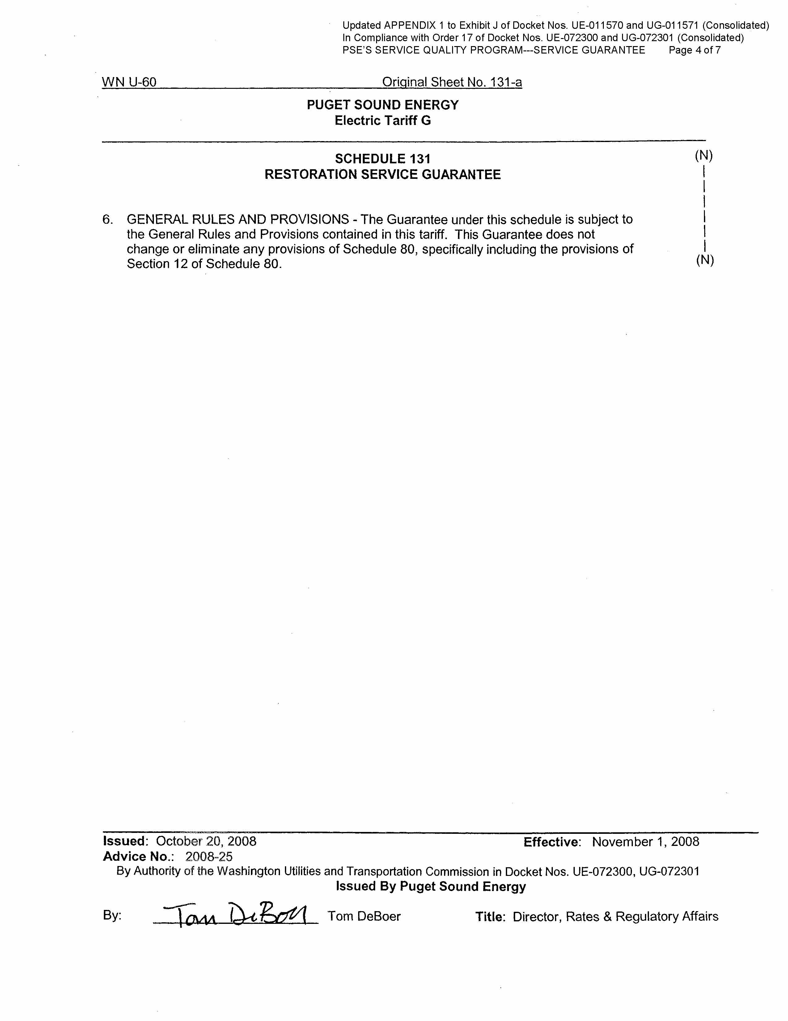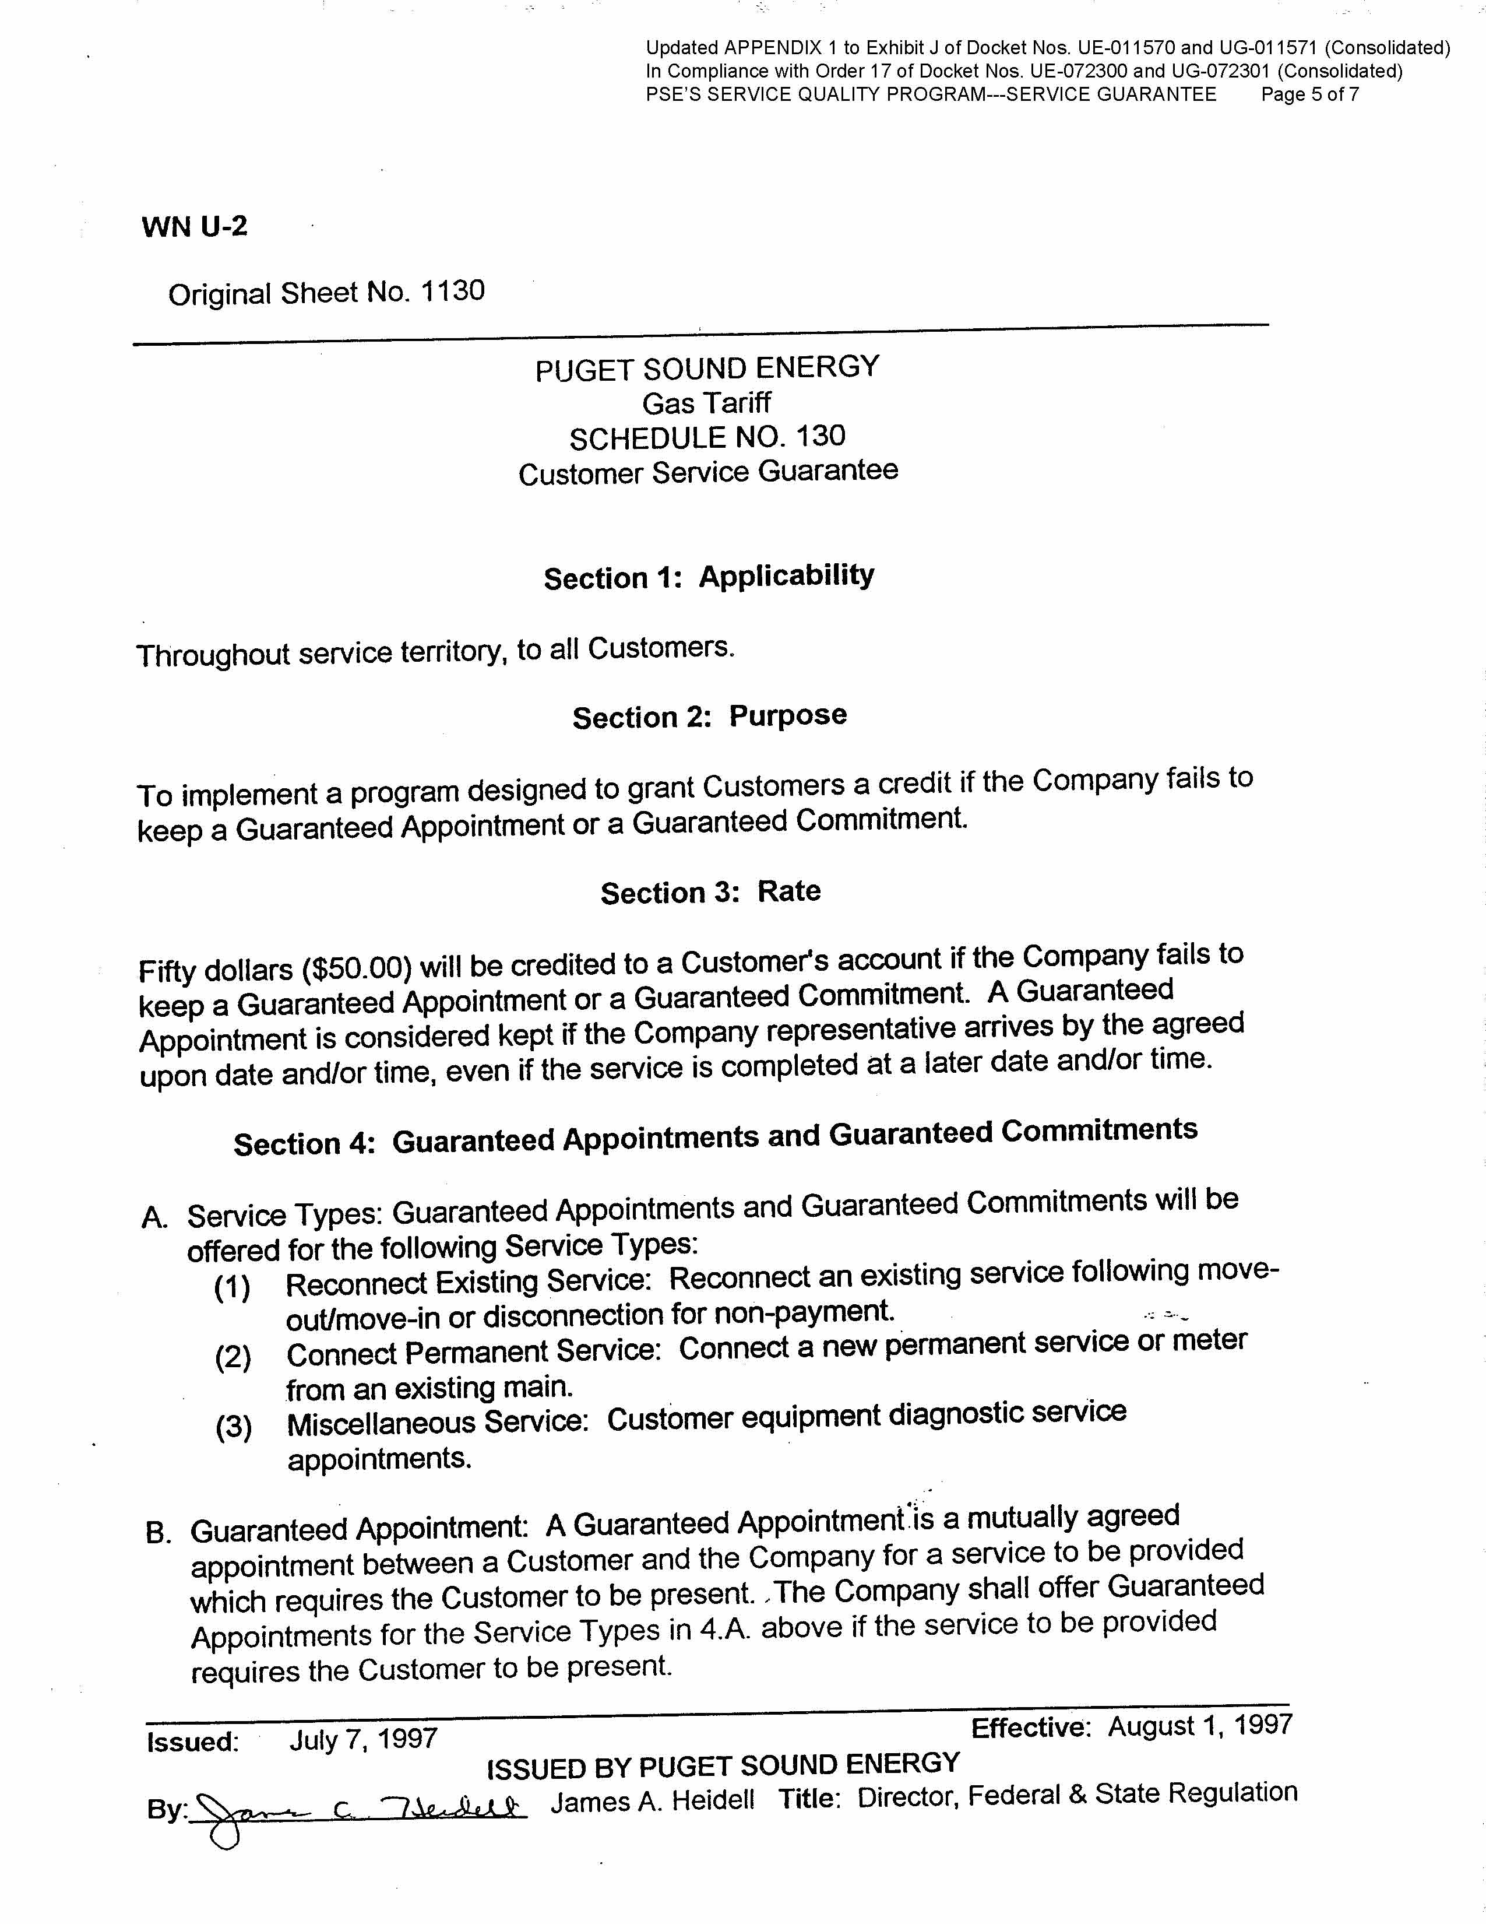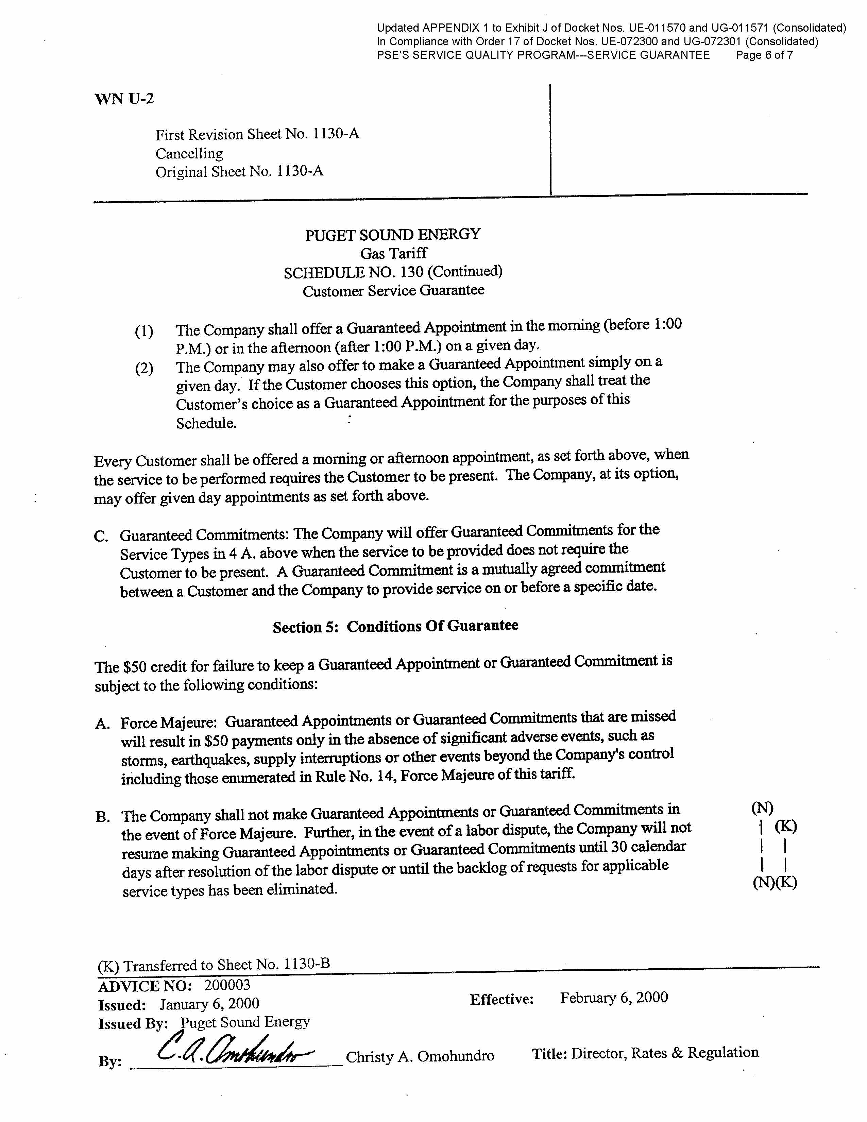
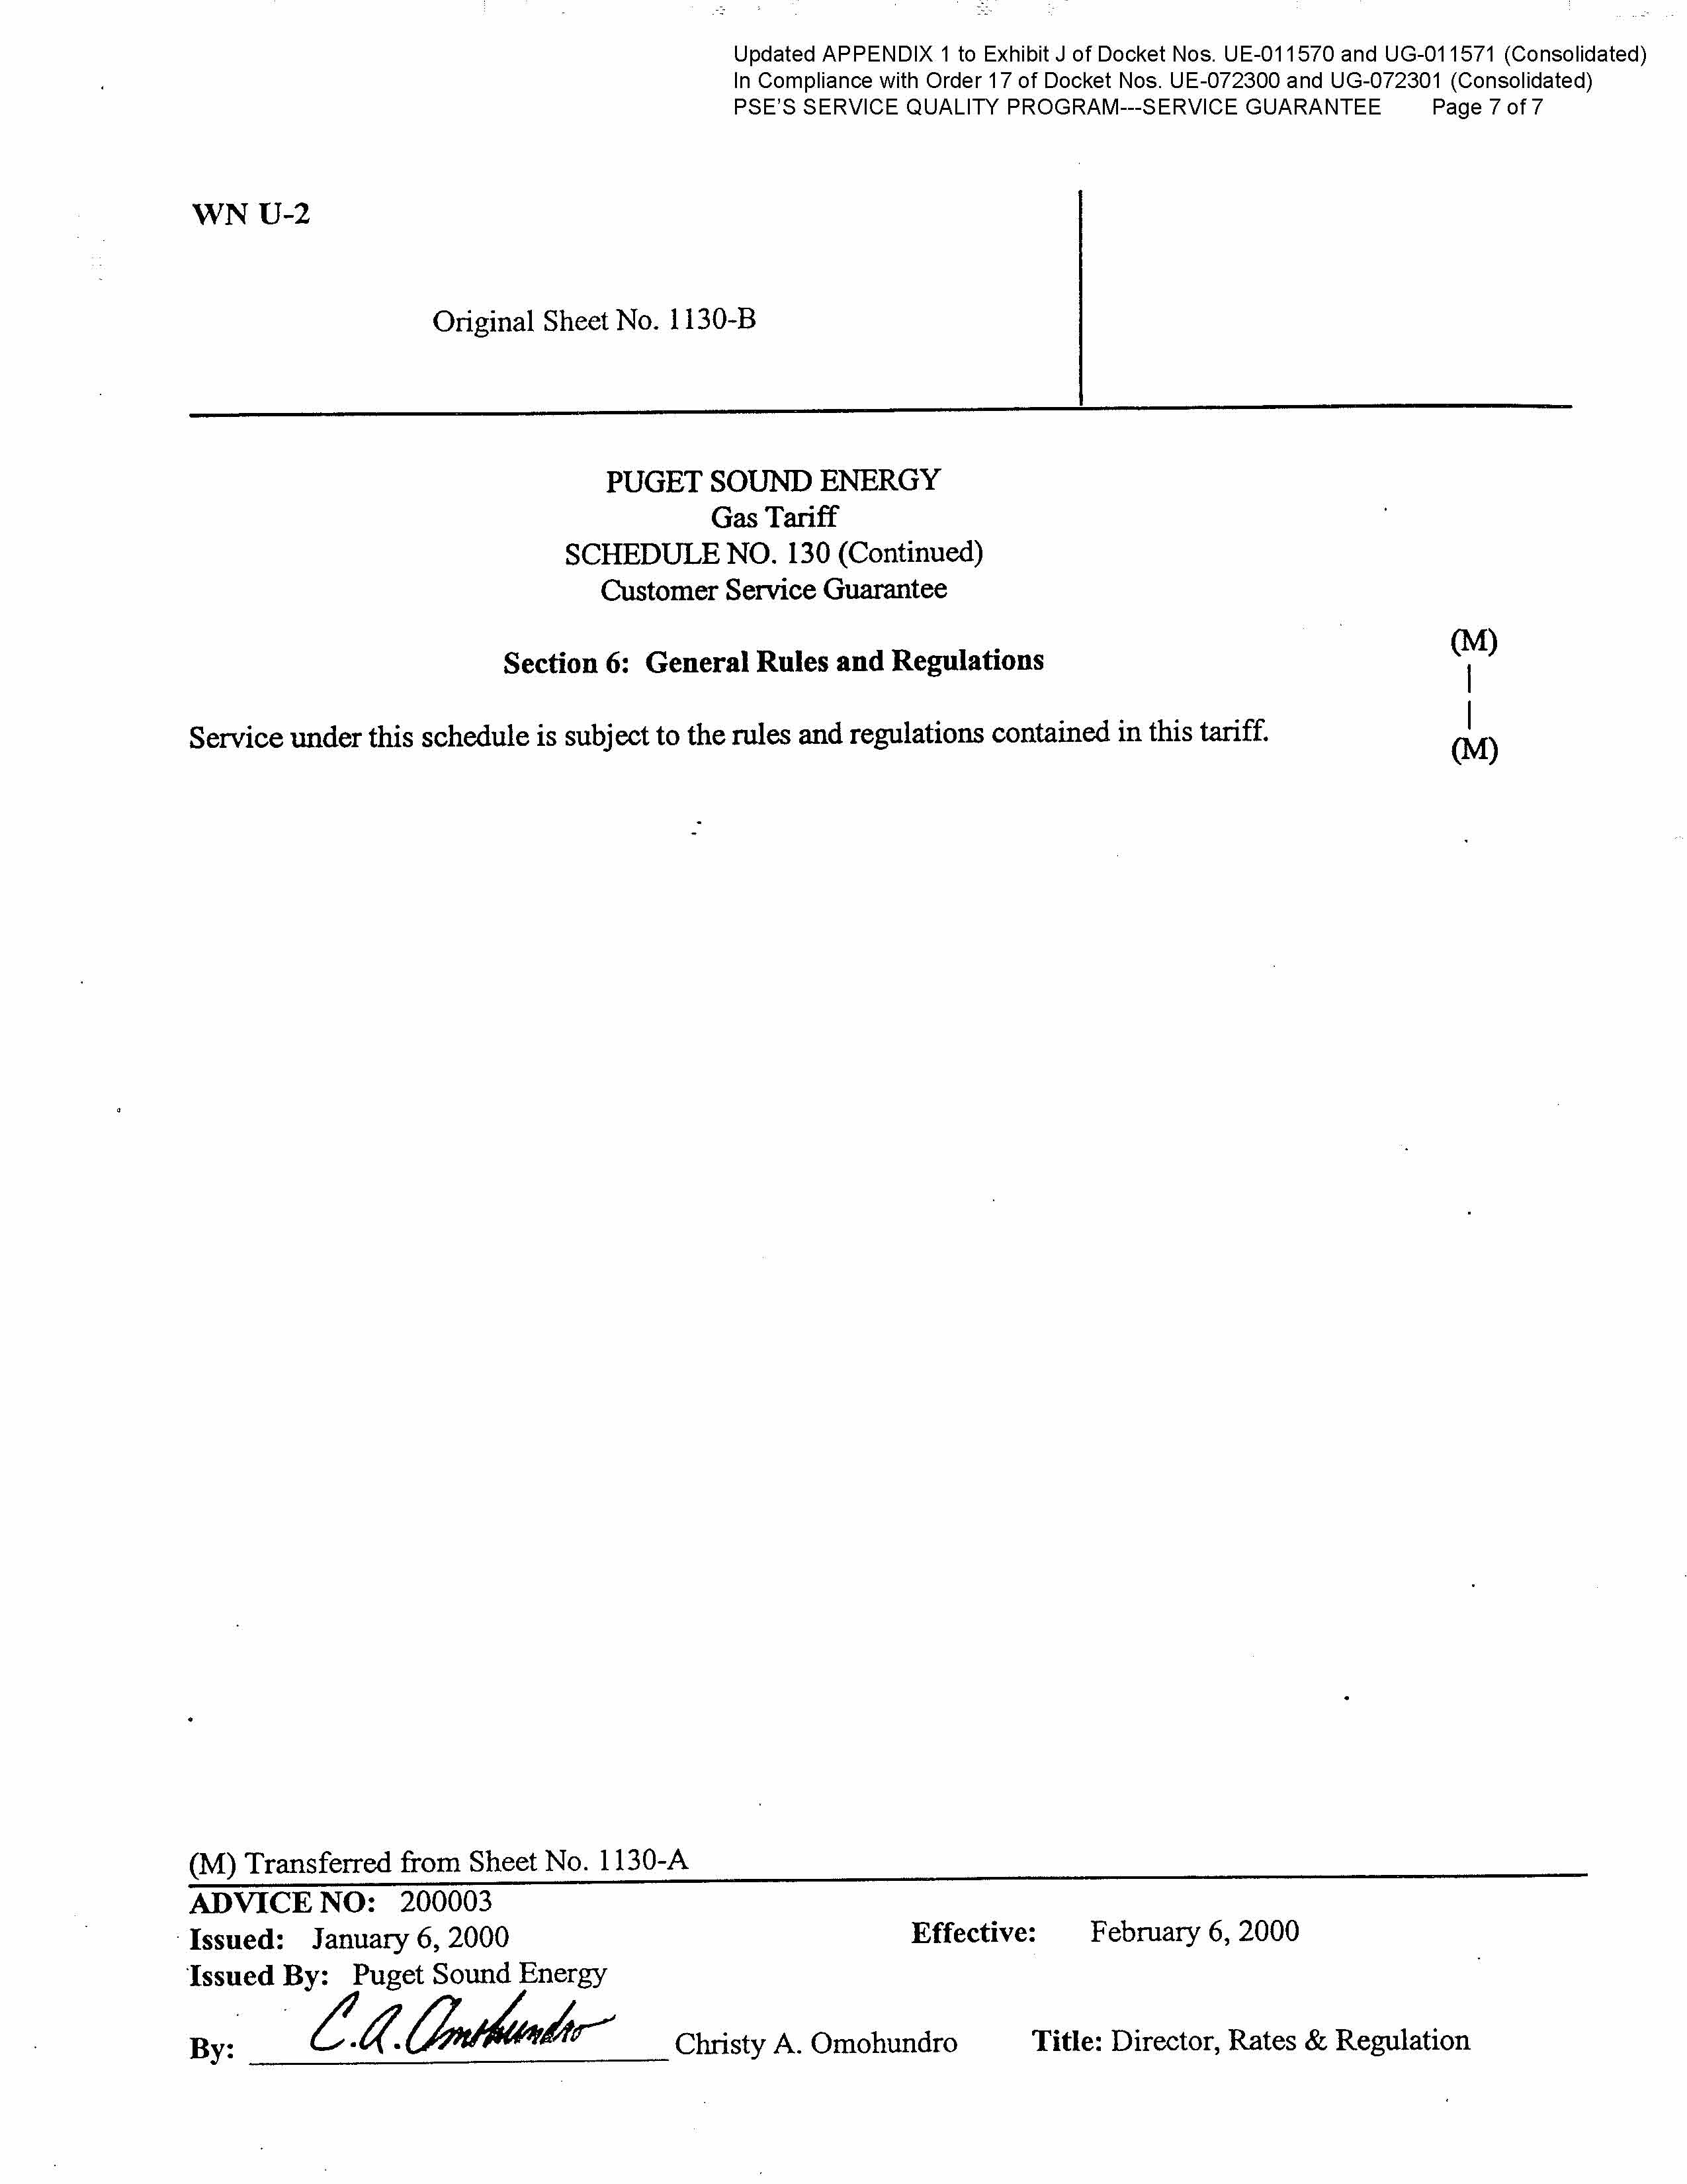
Updated APPENDIX 2 to Exhibit J of Docket Nos. UE-011570 and UG-011571 (Consolidated)

In Compliance with Order 17 of Docket Nos. UE-072300 and UG-072301 (Consolidated)

PSE’s Service Quality Program

SERVICE QUALITY PROGRAM MECHANICS

TABLE OF CONTENTS

TABLE OF CONTENTS 1
A. CONTINUATION OF PROGRAM 2
B. BENCHMARKS 3
C. PERIODIC REVIEW OF PROGRAM 4
D. FINANCIAL PENALTIES 4
1. Allocation 4
2. Penalty Per Point 5
3. Doubling of Penalty Amounts 5
E. CALCULATIONS 5
1. Overall Customer Satisfaction 5
2. WUTC Complaint Ratio 6
3. SAIDI (System Average Interruption Duration Index) 7
4. SAIFI (System Average Interruption Frequency Index) 8
5. Customer Access Center Telephone Answering Performance 9
6. Customer Access Center Telephone Transactions Customer Satisfaction 10
7. Gas Safety Response Time 11
8. Field Service Operations Transactions Customer Satisfaction 12
9. Disconnection Ratio 12
10. Kept Appointments 13
11. Electric Safety Response Time 15
F. PAYMENT OF PENALTIES, IF ANY, TO CUSTOMERS 17
G. COMMISSION REPORTS 17
H. CUSTOMER NOTICE (CUSTOMER REPORT CARD) 19
I. MITIGATION PETITION, IF APPLICABLE 20
J. CUSTOMER AWARENESS OF CUSTOMER SERVICE GUARANTEE 20
K. CUSTOMER AWARENESS OF RESTORATION SERVICE GUARANTEE 21
Attachment A- Major Event and Localized Emergency Event Days (Affected Local Areas Only) 22
Attachment B-Major Event and Localized Emergency Event Days (Non-Affected Local Areas Only) 24

CONTINUATION OF PROGRAM

The parties have agreed to the continuation of the service quality program implemented under Docket No. UE-960195 (the merger docket) until such time as directed otherwise by the Commission. Any party may bring a request to terminate the service quality program to the Commission at any time, but no sooner than 5 years from the implementation date directed under Docket Nos. UE-011570 and UG-011571. The service quality program has been further extended by the Commission in Docket Nos. UE-072300 and UG-072301 with various modifications.

The service quality program includes a Customer Service Guarantee, a Restoration Service Guarantee, and a Service Quality Index (“SQI”). This document addresses, primarily, the mechanics of the latter, the Service Quality Index. All modifications regarding SQI mechanics outlined in Orders 12, 14, 16, and 17 of the 2007 dockets and Orders 1 and 2 of UE-031946 have been incorporated into this updated Appendix 2 (“Appendix”). The Customer Service Guarantee, which provides for a $50 missed appointment credit, is outlined in the company’s tariff (Schedule 130) for both natural gas and electric service. Electric Schedule 131, Restoration Service Guarantee, details the terms and the application of $50 electric outage restoration credit to a qualified customer.

BENCHMARKS
The following table summarizes the benchmarks to be used in Service Quality Index program.
Index | Benchmark
- Overall Customer Satisfaction | 90% satisfied (rating of 5 or higher on a 7-point scale)
- WUTC Complaint Ratio | 0.40 complaints per 1000 customers, including all complaints filed with WUTC
- SAIDI | 320 all-inclusive outage minutes per customer per year
- SAIFI | 1.30 non-major-event interruptions per year per customer
- Customer Access Center Answering Performance | 75% of calls answered by a live representative within 30 seconds of request to speak with live operator
- Customer Access Center Transaction Satisfaction | 90% satisfied (rating of 5 or higher on a 7-point scale)
- Gas Safety Response Time | Average of 55 minutes from customer call to arrival of field technician
- Field Service Operations Transactions Customer Satisfaction | 90% satisfied (rating of 5 or higher on a 7-point scale)
- Disconnection Ratio | 0.030 disconnections / customer for non-payment of amounts due when WUTC disconnection policy would permit service curtailment
- Kept Appointments | 92% of appointments kept
- Electric Safety Response Time | Average of 55 minutes from customer call to arrival of field technician

PERIODIC REVIEW OF PROGRAM

The benchmarks and methods presented in this document shall be reviewed from time to time and at least every 5 years for appropriateness. The Company or any party may propose changes to a benchmark at the time of the filing of the annual report. Changes to a benchmark may not be retroactive.

FINANCIAL PENALTIES

PSE shall be assessed a financial penalty if any service quality index, other than SQI No. 1, Overall Satisfaction and SQI No. 9, Disconnection Ratio (See Footnote No. 5), falls below its benchmark. The maximum annual aggregate penalty for which the company is at risk is $15 million. The allocation of the $1.5 million to each SQI, with related notes, follows:

Allocation
Maximum Penalty Per SQI =
(Total maximum penalty) / (number of SQIs with penalty)
Maximum Penalty Per SQI =
($15,000,000)/ (11 – 1)
Maximum Penalty Per SQI = $1,500,000

Note: There is no penalty associated with the SQI No. 1, Overall Customer Satisfaction, (see Footnote No. 1) and SQI No. 9, Disconnection Ratio, has been eliminated at this time (see Footnote No. 5).

Penalty Per Point
Index | Penalty Per Point
- Overall Customer Satisfaction | N/A
- WUTC Complaint Ratio | $337,500
- SAIDI | $337,500
- SAIFI | $337,500
- Customer Access Center Telephone Answering Performance | $54,000
- Customer Access Center Telephone Transactions Customer Satisfaction | $85,500
- Gas Safety Response Time | $337,500
- Field Service Operations Transactions Customer Satisfaction | $85,500
- Disconnection Ratio | $337,500
- Kept Appointments | $7,050
- Electric Safety Response Time | $337,500

Doubling of Penalty Amounts
The parties have agree that doubling the otherwise applicable SQI penalty amount will take place when the Company fails to meet an SQI performance metric in two or more consecutive years, for SQI performance years 2009 and later. As is laid out in Item I of this Appendix, the Company can seek relief from any penalty, which it believes in good faith meets the mitigation standard. If an SQI penalty is determined by the Commission to have been successfully mitigated, then that SQI violation for that year would not be considered as a basis for any doubling of penalties.

CALCULATIONS

Actual performance results for each individual SQI shall be calculated as set forth below based on 12-month calendar reporting periods from January 1 through December 31. Performance results will be reported to an accuracy of the decimal place noted for each benchmark and standard rules of rounding will apply. The specific calculations for each SQI with related notes, follow:

Overall Customer Satisfaction
- Performance Calculation
Overall Customer Satisfaction = semi-annual weighted average of residential and non-residential customers

Percent of Satisfied Customers = aggregate number of survey responses of 5, 6, or 7 divided by aggregate number of survey responses of 1, 2, 3, 4, 5, 6, or 7

- Performance Level At Which Maximum Penalties Would Be Imposed
Penalty calculations are not applicable to SQI No. 1.

- Sample Performance Calculation
Applying the calculation methodology set forth in Section 1.a above, the independent survey firm reports that for the annual reporting period the monthly average of Percent of Satisfied Customers is 91%.

- Penalty Calculation
There is no penalty associated with the SQI. The benchmark of 90% is shown for comparison purposes only.

- Sample Penalty Calculation
Penalty calculations are not applicable to SQI No. 1.

- Notes
The source of the data will be semi-annual reports prepared by The Gilmore Research Group. The actual question for purposes of this benchmark is “Now, please think about all aspects of Puget Sound Energy service. I would like your overall opinion of the company - 7 means you are completely satisfied, 1 means you are not at all satisfied. How would you rate your satisfaction with Puget Sound Energy overall?”

WUTC Complaint Ratio
- Performance Calculation
WUTC Complaint Ratio = ((electric complaints recorded by WUTC during reporting period + natural gas complaints recorded by WUTC during reporting period) / average monthly electric customer count during reporting period + average monthly natural gas customer count during reporting period)) * 1000

- Performance Level At Which Maximum Penalties Would Be Imposed
Complaints Per 1000 = 0.58

- Sample Performance Calculation
Assume the following PSE complaints were recorded by the WUTC for the year ending December:
Period | Electric Complaints | Natural gas Complaints
Year Ending 200X | 406 | 299

Assume the following average annual customer counts are reported by PSE for the year ending December:
Period | Average Annual Electric Customers | Average Annual Natural gas Customers
Year Ending 200X | 1,031,831 | 626,124

Complaints Per 1000 = ((406 + 299) / (1,031,831 + 626,124)) * 1000
Complaints Per 1000 = 0.43

- Penalty Calculation
Penalty = ((Complaints Per 1000 - benchmark) / benchmark) * 10 * penalty per point
Benchmark = 0.40 complaints Per 1,000 Customers
Penalty Per Point = $337,500
The maximum penalty is $1,500,000

- Sample Penalty Calculation
Based on the sample performance calculation:
Penalty = ((0.43 - 0.40) / 0.40) * 10 * $337,500
Penalty = $253,125

- Notes
The average monthly customer count is the average of the total number of PSE customers, per month, during the reporting period. Any penalty imposed shall be applied to both the natural gas and electric low income bill assistance programs.
The source of the data will be (a) the monthly WUTC report sent to the Company from Consumer Affairs and (b) customer counts as reported in the Company’s monthly financial reporting package.

SAIDI (System Average Interruption Duration Index)
- Performance Calculation
SQI SAIDI = Rolling 5-year average of current year Annual Total SAIDI and prior four years Annual Total SAIDI results, excluding Annual Total SAIDI for 2006 or any subsequent exclusion approved by the Commission. Exclusions will be replaced by preceding Annual Total SAIDI performance results until there are 5 years included in the calculation of current year SQI SAIDI.

Annual Total SAIDI = (Total Customer Outage Minutes) / (Average Annual Electric Customer Count)

- Performance Level At Which Maximum Penalties Would Be Imposed
SAIDI = 462

- Sample Performance Calculation
Assume the following DATA for the year ending December:
Period | Customer Outage Minutes
Year Ending 200X | 250,000,000

Assume the following average annual customer counts are reported by PSE for the year ending December:
Period | Average Annual Electric Customers
Year Ending 200X | 1,031,831

Annual Total SAIDI = (250,000,000) / (1,031,831)
= 242
Period | Annual Total SAIDI | Note
Year 200X-5 | 302
Year 200X-4 | 192
Year 200X-3 | 2,636 | Excluded per Commission order
Year 200X-2 | 312
Year 200X-1 | 202
Year 200X | 242

SQI SAIDI for Year 200X = Average of (242, 202, 312, 192, 302)
= 250

- Penalty Calculation
Penalty = ((SQI SAIDI - benchmark) / benchmark) * 10 * penalty per point
Definitions:
SQI SAIDI = Rolling 5-year average of current year Total SAIDI and prior four years Annual Total SAIDI results, excluding Annual Total SAIDI for 2006 or any subsequent exclusion approved by the Commission
Annual Total SAIDI Period = January - December
Benchmark = 320 minutes / customer
Penalty Per Point = $337,500
The maximum penalty is $1,500,000

- Sample Penalty Calculation
Based on the sample performance calculation:
Penalty = ((250 - 320) / 320) * 10 * $337,500
Penalty = $0 (The actual calculation is –$738,281)

- Notes
Any penalty imposed shall be applied to the electric low income bill assistance program. The source of the data will be the outage reporting system that is a part of SAP, the Company’s Work Management and Financial Information System. The data is computed in program ZIRSAIDI and transaction ZIO1. SAIDI will be calculated in conformance with the Company’s Electric Reliability and Reporting Plan in compliance with WAC 480-100-393.

SAIFI (System Average Interruption Frequency Index)
- Performance Calculation
SAIFI = (Total Customer Interruptions Excluding Major Events) /
(Average Annual Electric Customer Count)
Definitions:
Major Events = Days when more than 5% of PSE’s customers are out and associated carry-forward days
Carry-forward days end when those customers have service restored.

- Performance Level At Which Maximum Penalties Would Be Imposed
SAIFI = 1.88

- Sample Performance Calculation
Assume the following DATA for the year ending December:
Period | Customer Interruptions
Year Ending 200X | 1,265,543

Assume the following average annual customer counts are reported by PSE for the year ending December:
Period | Average Annual Electric Customers
Year Ending 200X | 1,031,831

SAIFI = (1,265,543) / (1,031,831)
SAIFI = 1.23

- Penalty Calculation
Penalty = ((Annual SAIFI - benchmark) / benchmark) * 10 * penalty per point
Definitions:
Annual SAIFI = January - December
Benchmark = 1.30 outages / customer
Penalty Per Point = $337,500
The maximum penalty is $1,500,000

- Sample Penalty Calculation
Based on the sample performance calculation:
Penalty = ((1.23 – 1.30) / 1.30) * 10 * $337,500
Penalty = $0 (The actual calculation is –$181,731)

- Notes
Any penalty imposed shall be applied to electric low-income customers.
The source of the data will be the outage reporting system that is a part of SAP, the Company’s Work Management and Financial Information System. The data is computed in program ZIRSAIDI and transaction ZIO1. SAIFI will be calculated in conformance with the Company’s Electric Reliability and Reporting Plan in compliance with WAC 480-100-393.

Customer Access Center Telephone Answering Performance
- Performance Calculation
Call Performance = average of ((monthly aggregate number of calls answered by a company representative within 30 seconds of a request to talk to a live operator) / (monthly aggregate number of calls received) * 100)

Customer calls abandoned within 30 seconds of waiting for an operator should be excluded from the performance calculation and not counted as part of this index.

- Performance Level At Which Maximum Penalties Would Be Imposed
54% of the calls answered within 30 seconds

- Sample Performance Calculation
Customer Access Center statistics report 71% of the calls answered within 30 seconds for the entire one year reporting period ending December.

- Penalty Calculation
Penalty = ((benchmark - Call Performance) / benchmark) * 100 * penalty per point
Benchmark = 75% of calls answered live by company representative within 30 seconds of request to speak to live operator
Penalty Per Point = $54,000
The maximum penalty is $1,500,000

- Sample Penalty Calculation
Based on the sample performance calculation:
Penalty = ((75% - 71%) / 75%) * 100 * $54,000
Penalty = $288,000

- Notes
Any penalty imposed shall be applied to both the electric and natural gas low income bill assistance programs.
The actual call center statistics will be taken from the Company’s Call Center Performance Report, worksheet Access Center Stats MMYY.xls and Y-T-Dmon1.xls, which uses data provided by the VRU.

Customer Access Center Telephone Transactions Customer Satisfaction
- Performance Calculation
Access Center Telephone Transactions Customer Satisfaction = Monthly Average Of Percent Of Satisfied Customers

Percent of Satisfied Customers = aggregate number of survey responses of 5, 6, or 7 divided by aggregate number of survey responses of 1, 2, 3, 4, 5, 6, or 7

- Performance Level At Which Maximum Penalties Would Be Imposed
74% of Customers Satisfied

- Sample Performance Calculation
The independent survey firm reports that for the annual reporting period the following monthly average of Percent of Satisfied Customers: 91.5%.

- Penalty Calculation
Penalty = ((benchmark - monthly average of Percent of Satisfied Customers) / benchmark) * 100 * penalty per point
Benchmark = 90% rating of 5 or higher on 7 point scale
Penalty Per Point = $85,500
The maximum penalty is $1,500,000

- Sample Penalty Calculation
Based on the sample performance calculation:
Penalty = ((90% - 92%) / 90%) * 100 * $85,500
Penalty = $0 (The actual calculation is –$190,000)

- Notes
Any penalty imposed shall be applied to both the natural gas and electric low income bill assistance programs.
The source of the data will be monthly and semi-annual reports prepared by The Gilmore Research Group. The actual question for purposes of this benchmark is “Overall, how would you rate your satisfaction with this call to Puget Sound Energy - would you say 7- completely satisfied, 1- not at all satisfied, or some number in between?”

Gas Safety Response Time
- Performance Calculation
Average number of minutes from customer call to arrival of gas field technician.

- Performance Level At Which Maximum Penalties Would Be Imposed
79 minutes average response time

- Sample Performance Calculation
PSE reports average response time of 58 minutes.

- Penalty Calculation
Penalty =((Average Response Time – benchmark) / benchmark) * 10 * penalty per point
Benchmark = 55 minutes from customer call to arrival of field technician
Penalty Per Point = $337,500
The maximum penalty is $1,500,000

- Sample Penalty Calculation
Based on the sample performance calculation:
Penalty = ((58 - 55) / 55) * 10 * $337,500
Penalty = $184,091

- Notes
Any penalty imposed shall be applied to the natural gas low income bill assistance program. The source of the data will be CLX, the customer billing system for PSE. This data is recorded in report PXPW01A-R03 and program PXPW01A. This data is then summarized in filename YYYY Response Times.xls

Field Service Operations Transactions Customer Satisfaction
- Performance Calculation
Field Service Operations Transactions Customer Satisfaction = Monthly Average Of Percent Of Satisfied Customers

Percent of Satisfied Customers = aggregate number of survey responses of 5, 6, or 7 divided by aggregate number of survey responses of 1, 2, 3, 4, 5, 6, or 7

- Performance Level At Which Maximum Penalties Would Be Imposed
74% of Customers Satisfied

- Sample Performance Calculation
The independent survey firm reports that for the annual reporting period the following monthly average of Percent of Satisfied Customers: 87%.

- Penalty Calculation
Penalty = ((benchmark - monthly average of Percent of Satisfied Customers) / benchmark) * 100 * penalty per point
Benchmark = 90% rating of 5 or higher on 7 point scale
Penalty Per Point = $85,500
The maximum penalty is $1,500,000

- Sample Penalty Calculation
Based on the sample performance calculation:
Penalty = ((90% - 87%) / 90%) * 100 * $85,500
Penalty = $285,000

- Notes
To date, only natural gas customers have been surveyed therefore any penalty imposed shall be applied to the natural gas low income bill assistance program. In the future, electric customers will be included in the survey but only for those electric services that require the customer to be present to provide the service.
The source of the data will be monthly and semi-annual reports prepared by The Gilmore Research Group. The actual question for purposes of this benchmark is: “Thinking about the entire service, from the time you first made the call until the work was completed, how would you rate your satisfaction with Puget Sound Energy - would you say 7- completely satisfied, 1- not at all satisfied, or some number in between?”

Disconnection Ratio
- Performance Calculation
Disconnection Ratio = (Number of Electric Customers Disconnected + Number of Natural gas Customers Disconnected) / (Average Annual Electric Customers + Average Annual Natural gas Customers)

- Performance Level At Which Maximum Penalties Would Be Imposed
Disconnection Ratio = 0.043

- Sample Performance Calculation
Assume the following data for the year ending December:
Period | Number of Electric Customers Disconnected | Number of Natural gas Customers Disconnected
Year Ending 200X | 27,523 | 13,165

Assume the following average annual customer counts are reported by PSE for the year ending December:
Period | Average Annual Electric Customers | Average Annual Natural gas Customers
Year Ending 200X | 1,031,831 | 626,124

Disconnection Ratio = ((27,523 + 13,165) / (1,031,831 + 626,124))
Disconnection Ratio = 0.025

- Penalty Calculation
Penalty = ((Disconnection Ratio - benchmark) / benchmark) * 10 * penalty per point
Benchmark = 0.030 Disconnection / customer
Penalty Per Point = $225,000
The maximum penalty is $1,000,000

- Sample Penalty Calculation
Based on the sample performance calculation:
Penalty = ((0.025 - 0.030) / 0.030) * 10 * $225,000
Penalty = $0 (The actual calculation is –$375,000)

- Notes
Any penalty imposed shall be applied to both natural gas and electric customers.
The source of the data will be CLX, the customer billing systems for PSE. The worksheet for the disconnection results is in endofthe monthYY.xls

Kept Appointments
- Performance Calculation
Kept Appointments = Annual Appointments Kept / (Annual Appointments Missed + Annual Appointments Kept)

For purposes of this index, an appointment refers to either a guaranteed appointment (“a.m.”, “p.m”. or “given day”) or a guaranteed commitments (“on or before a given day”) as defined in the company’s tariff (Schedule 130) for both natural gas and electric service.

Appointments will be considered “missed” when the Company does not meet the time period (i.e., a.m., p.m. or given day ) agreed upon when the appointment was initially set or subsequently rescheduled (through mutual agreement with the customer). Appointments scheduled for a.m., p.m. or given day are considered “missed” if the Company does not meet the a.m., p.m. or given day time frame. Missed appointments exclude appointments that are “excused”.

“Excused” appointments are appointments that meet any of the following criteria: the customer fails to keep the appointment; the customer requests that the appointment be rescheduled; the Company reschedules the appointment because the Company reasonably determines that conditions at the customer site make it impracticable to perform the service; or the appointment falls on a day that 5% or more of electric customers are experiencing an electric outage and subsequent days when the service to those customers is being restored.

Appointments that have been canceled by the customer, regardless of customer’s reason, will be considered “canceled” appointments and will not be counted as missed appointments.

The service does not have to be completed for the appointment to be considered “kept”; any additional appointment to complete a job shall be considered a new appointment and shall be tracked and measured just as any other appointment.

- Performance Level At Which Maximum Penalties Would Be Imposed
Kept Appointments = 75%

- Sample Performance Calculation
Assume the following data for the year ending December:
Total number of electric and natural gas appointments kept = 175,000
Total number of electric and natural gas appointments missed = 17,000
Total number of electric and natural gas appointments excused = 500
Total number of electric and natural gas appointments canceled = 10,000

Kept Appointments = 175,000 / (175,000 + 17,000) = 91%

- Penalty Calculation
Penalty = (((1 - Kept Appointments) (1 - Benchmark)) / (1 - Benchmark)) *100 * penalty per point
Benchmark = 92% of electric and natural gas appointments kept
Penalty Per Point = $7,050
The maximum penalty is $1,500,000

- Sample Penalty Calculation
Based on the sample performance calculation:
Penalty = (((1 - 91%) - (1 - 92%)) / (1 - 92%)) *100 * $$7,050
Penalty = $ 88,125

- Notes
Any penalty imposed shall be applied to both the natural gas and electric low income bill assistance programs. Any amounts paid by PSE under the Customer Service Guarantee shall reduce any financial penalties imposed and otherwise payable for this SQI.

The missed appointment calculation excludes “excused” and “canceled” appointments as defined in the UE-960195 Supplemental Stipulation. For the purposes of reporting to customers on the annual report card, PSE may choose to report "Appointments Kept" with a corresponding benchmark of 92% of appointments kept. The penalty is the same amount as if reported as "Appointments Missed".
The data to be used to determine and evaluate the appropriate benchmark for missed appointments will be retrieved from the following sources:
Service Type | Service Description | Source
Permanent Service | Permanent secondary voltage electric service from existing secondary lines or permanent natural gas service from an existing main | SAP program ZQRCSG01 and transaction ZTC1
Reconnect Existing Service | Reconnection following move-out/move-in; or disconnection for non-payment | CLX report PXPWMM1-V01 and program PXPWMM1
Diagnostic Service Request | For water heater, checkup, heatout, other appliance repair, or follow-up appointment | CLX report PXPWMM1-V01 and program PXPWMM1

This data is then summarized in filename MissedAppointments.xls.

Electric Safety Response Time
- Performance Calculation
Average number of minutes from customer call to arrival of electric first responder. Performance measurement of this index shall be suspended on: 1) days that 5% or more of electric customers are experiencing an electric outage and subsequent days when the service to those customers is being restored; and 2) days that are determined by the Company to be “localized emergency event day” as defined by the dispatch and utilization of all available electric first responders to the affected Local Area to respond to service outages. Local Areas are defined as one of five electric first-responder operating basis throughout the PSE service territory. The Local Areas are shown in the following table
﻿
Local Area | County(s) | Number of Electric  First Responders as  of October 2003
North | Skagit, Whatcom,  Island | 13
West | Kitsap, Jefferson | 14
South | Thurston, Pierce | 15
North Central | King – North of  Cedar River | 19
South Central | King – South of  Cedar River | 12

On days during which performance measurement of this index is suspended, PSE will account for and report the number of outage events and the number of customers affected in a tabular format as shown on Attachment A to this appendix. Further, the Company will report similar information by Local Area, for those Local Areas not affected by the localized emergency event, as shown on Attachment B to this appendix. This supplemental reporting shall begin for data as of January 1, 2003 and shall continue for a period of at least three calendar years. This supplemental reporting shall be included with both the annual and semi-annual service quality performance reports filed during the supplemental reporting period. One of the primary goals for this supplemental reporting is to develop an objective criterion for defining localized emergency event days. At the end of the initial three year supplemental reporting period, the Company or any party may propose modifications to take effect January 1, 2006, if needed, to the performance measurement of this index, based on these supplemental reports. Such modifications, if needed, may include the benchmark of this index. As stated elsewhere in this document, changes to the benchmark may not be retroactive. In the event that no modifications are made to the measurement of this index, PSE will continue to include the supplemental reports in the semiannual and annual service quality reports, unless another arrangement has been agreed to by the parties.
- Performance Level At Which Maximum Penalties Would Be Imposed
79 minutes average response time

- Sample Performance Calculation
PSE reports average response time of 50 minutes.

- Penalty Calculation
Penalty =((Average Response Time – benchmark) / benchmark) * 10 * penalty per point
Benchmark = 55 minutes from customer call to arrival of field technician
Penalty Per Point = $337,500
The maximum penalty is $1,500,000

- Sample Penalty Calculation
Based on the sample performance calculation:
Penalty = ((50 - 55) / 55) * 10 * $337,500
Penalty = $0 (The actual calculation is –$306,819)

- Notes
Any penalty imposed shall be applied to electric customers.
The source of the data will be CLX, the customer billing system for PSE. This data is recorded in Electric Emergency Response Time Access Database.mdb.

PAYMENT OF PENALTIES, IF ANY, TO CUSTOMERS
The Parties agree that when annual penalty dollars are less than the equivalent of $12 per customer, the annual penalty will be allocated to PSE's low income bill assistance program, the Home Energy Lifeline Program (“HELP”). If the annual penalty amount exceeds $12 per customer, the Company will place an SQI credit on each customer’s bill, rather than allocating the penalty dollars to HELP.

COMMISSION REPORTS
Twice yearly, on or about July 30 (for semi annual report of performance for January through June) and on or before March 31 (for annual reports of performance for January through December), the Company shall file a report with the Commission that includes the following information:
- Monthly data (as available) for the applicable reporting period for each of the SQIs;
- Calculated performance with respect to each of the Service Quality Indices, together with a comparison of calculated performance to the benchmark for each of the SQIs;
- A description of any unusual events that had a significant effect on service quality performance (whether or not a mitigation petition is included with the report);
- A description of any data gathering or reporting difficulties incurred by the Company and any request by the Company to alter its data gathering or reporting methods for future periods if the effect of the change will impact the performance categories or their results in any way;
- The number of missed appointments and missed commitments and payments to customers, by appointment and commitment category, under the Service Guarantee;
- The progress of the Company’s development of gas emergency response plans for outlying areas and the Company’s consultation with the affected communities (city councils and first responder agencies) for such emergency response plans; and
- The performance of PSE’s contractors tracked against relevant service quality benchmarks.
In addition, the annual report to be filed on or before March 31, with the combined reporting of SQI, electric service reliability, and service provider SQI performance results, shall include the following additional information:
- The penalty calculation, if applicable, for each SQI;
- A certification by the independent survey company that the surveys were completed in conformance with applicable procedures and guidelines and that the reported results are unbiased and valid;
- Workpapers that explain the effect, if any, of the penalty on rates for each customer class for both natural gas and electric customers;
- Annual statistics for the time duration from first arrival to control of gas emergencies, for incidents subject to reporting under WAC 480-93-200 and WAC 480-93-210;
- A draft of the proposed customer notice (customer report card) that complies with Section H below;
- Mitigation petition, if applicable;
- New customer construction-related penalties paid by its two predominant service provider contractors and the actions the Company or its service providers have taken to improve customer satisfaction with the new customer construction process;
- Annual supplemental reporting for each day in the annual reporting period on which SQI No. 11 Electric Emergency Response time was suspended in the format prescribed in Attachments A and B;
- A description how PSE uses customer complaint information in its circuit reliability evaluations;
- Supplemental information on the percentage of responses to gas emergencies that are met within 60 minutes and, with the SQI filing for the 2010 SQI performance year, a report stating its position regarding whether the current SQI metric for Gas Response Time should be changed to a performance standard requiring PSE to respond to a minimum of 95 percent of gas emergencies within 60 minutes;
- Supplemental information on the monthly percentage of calls answered by PSE's call centers within 30 seconds of SQI No. 5, Customer Access Center Answering Performance and, with the SQI filing for the 2009 SQI performance year, a report stating its position regarding changing the current SQI No. 5 measurement and penalty to a two-part (annual and monthly thresholds) SQI;
- Supplemental information on the call abandonment and busy calls;
- Supplemental information on the disconnection information in the appendix section of the annual report regarding customer non-payment of amounts due when WUTC disconnection policy would permit service curtailment.

CUSTOMER NOTICE (CUSTOMER REPORT CARD)
At least once per year, PSE will report the annual results for each item in the SQI to all of its customers. The SQI results in the annual SQI report card to customers will be organized by category of service, i.e., customer satisfaction, customer services, and operations services. The customer notice will be distributed to customers only after adequate consultation with Staff and Public Counsel, but no later than 90 days after the Company files its annual report. The proposed customer notice (see Item 12, above) shall contain the following information, at a minimum:
- Total amount of service guarantee paid and total number of appointments for which the service guarantee was paid.
- Total amount of penalty at risk, the total amount of penalties imposed for the current reporting period (both in total and by SQI number). For example, “For this reporting period, the Company was at risk for a total of $10,000,000 in penalties and was assessed a total of $328,087 in penalties, including SQI No. 4 - $40,814, SQI No. 5 - $160,000, and SQI No. 7 - $127,273.”
- A brief description of each benchmark and an indication as to whether the Company met the benchmark.

MITIGATION PETITION, IF APPLICABLE
In the annual report, the Company may include a mitigation petition for relief from penalty, if it believes, in good faith, that it meets the mitigation standard. The standard to be applied for such a petition is that the penalty is due to unusual or exceptional circumstances for which PSE’s level of preparedness and response was reasonable. PSE will not file a mitigation petition unless it believes, in good faith, that it meets this mitigation standard. The parties contemplate that, following a procedure to be established by the Commission, a Commission order will be issued assessing any penalties and resolving any mitigation petition.

CUSTOMER AWARENESS OF CUSTOMER SERVICE GUARANTEE

The Company agrees to take the following actions to promote customer awareness of the customer service guarantee (Schedule 130) for both electric and natural gas service:

- A promotion of the customer service guarantee will be included in the customer newsletter, “EnergyWise,” at least three times per year.
- The text of the customer service guarantee will appear on the back of the bill-stock beginning Fall 2002.
- The “rights and responsibilities” brochures will be updated and will include a description of the customer service guarantee. The rights and responsibilities brochures will be distributed to all new customers and will be made available to all customers at least once per year. Commission Staff and Public Counsel will be consulted as to form and content of this brochure.
- Before the end of any telephone call with a customer which results in an eligible appointment being scheduled, the agent will give a short statement regarding the availability of the $50 missed appointment credit should the agreed to time-frame for the appointment not be met by the company.

In addition, PSE will continue to include questions in customer surveys regarding customer awareness of the service guarantee, as outlined in the Twenty Second Supplemental Order Approving Second Supplemental Stipulation in Docket UE-960195.

CUSTOMER AWARENESS OF RESTORATION SERVICE GUARANTEE

The Company agrees to take the following actions to promote customer awareness of the restoration service guarantee (Electric Schedule 131) for electric service:

- The Company will, at minimum, place information regarding the availability of the restoration service guarantee in the customer newsletter each fall (as part of storm/emergency preparation information) and include this information on its website with other information concerning PSE’s customer service guarantee program.
- The Company will, at a minimum, place a recording regarding the availability of the restoration service guarantee on PSE's IVRU system (which provides customer messaging when a customer is on hold) with either the Company’s declaration of a storm for SQI purposes (5% or more of the Company’s customers are without power) or when the Company opens its Emergency Operations Center.

Attachment A- Major Event and Localized Emergency Event Days (Affected Local Areas Only)
Attachment A

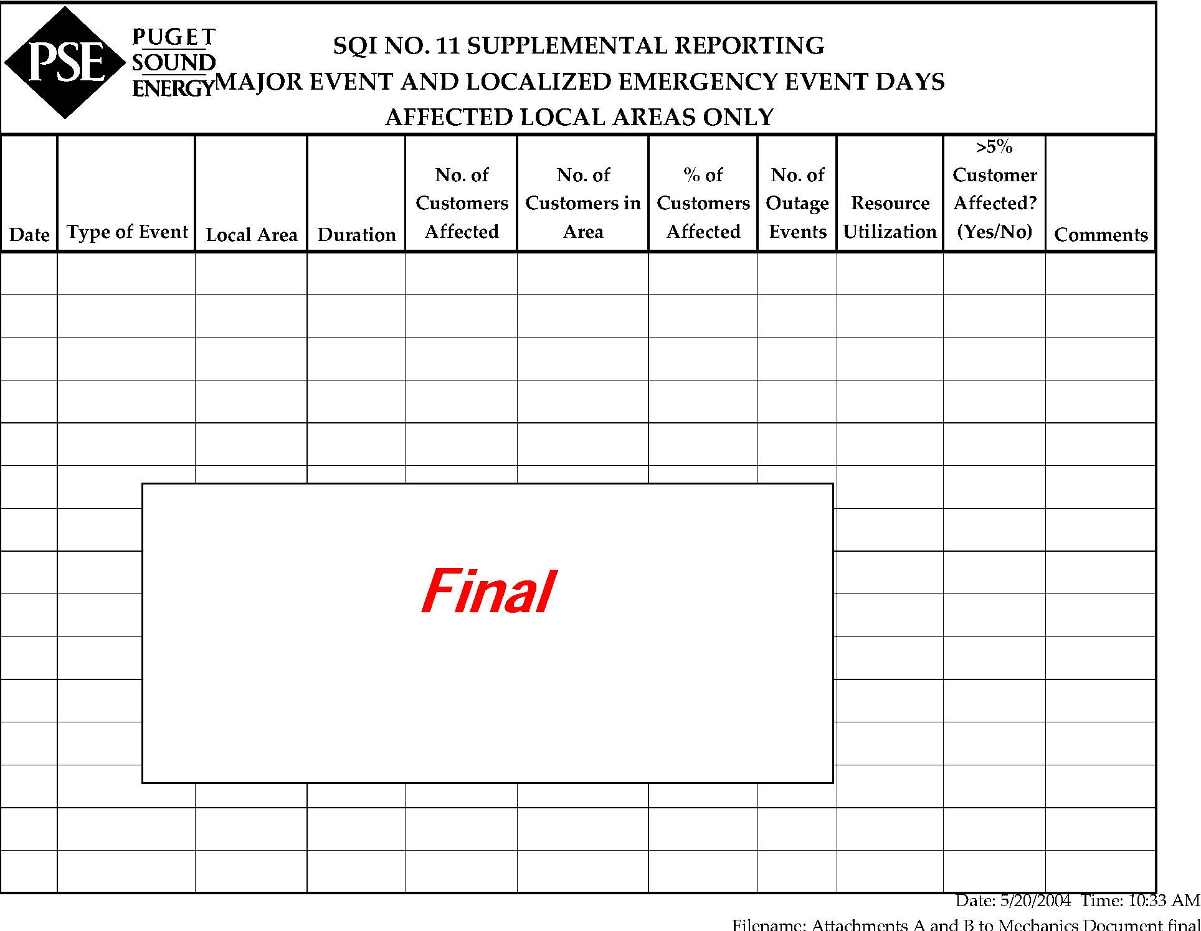

Attachment B-Major Event and Localized Emergency Event Days (Non-Affected Local Areas Only)
Attachment B

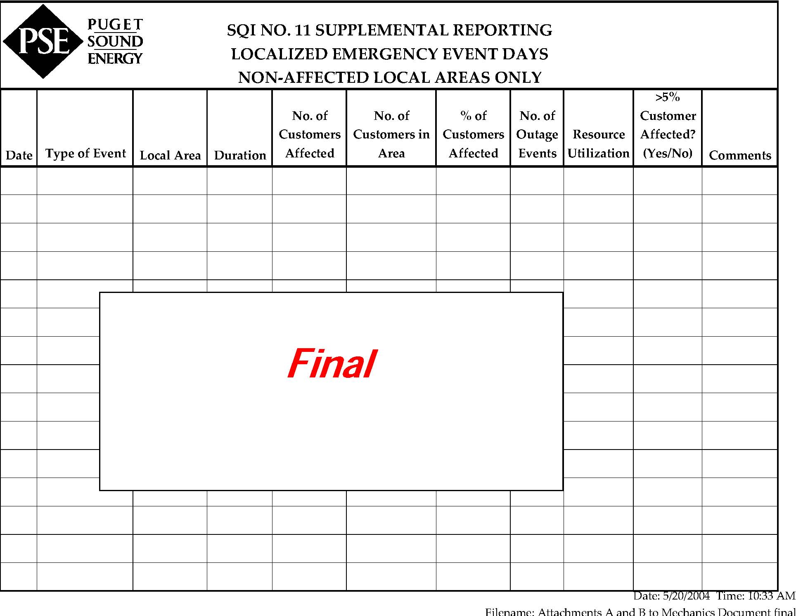

SQI No. 1, Overall Customer Satisfaction, was eliminated in Order 12 of consolidated Docket Nos. UE-072300 and UG-072301, Appendix D, Partial Settlement re: Service Quality, Meter and Billing Performance, and Low Income Bill Assistance, page 10, section M
Id. section L, revised SQI No. 2 benchmark from 0.50 to 0.40
Order 17 of consolidated Docket Nos. UE-072300 and UG-072301, page 10, section 26, granted temporarily amendment of SQI No. 3 calculation and associated benchmark
Descriptions added to distinguish the measurement different between SQI SAIDI and SAIFI. The SQI SAIDI measures all outages, including major events where more than 5% of customers are out of electric service, whereas SQI SAIFI excluded these major event outages.
Order 14 of consolidated Dockets UE-072300 and UG-072301 granted benchmark change from 0.030 to 0.038 for the reporting period starting 2010. In Order 16 of the same dockets, SQI No. 9 is eliminated on an interim basis until further reviewed by the Commission in a PSE GRC.
Order 12 of consolidated Docket Nos. UE-072300 and UG-072301, Appendix D, pages 8 and 9, section H, revised the title of SQI No. 10 from “Missed Appointments” to “Kept Appointments” and reversed the benchmark from 8% to 92% accordingly.
Order 12 of consolidated Docket Nos. UE-072300 and UG-072301, Appendix D, page 5, section B, increased the maximum annual penalty payout from $10 million to $15 million or $1.5 million per metric
Number of SQI with penalty was 11 per Order 12 of the 2007 dockets but SQI No. 9, Disconnection Ratio, along with it potential penalty, was eliminated temporally (see Footnote No. 5). However, the number remains at 11 in the calculation of Maximum Penalty per SQI as there is no change to the $1.5 million per metric maximum penalty.
Order 12 of consolidated Docket Nos. UE-072300 and UG-072301, Appendix D, page 6, section D
Order 12 of consolidated Docket Nos. UE-072300 and UG-072301, Appendix D, pages 5 and 6, section C
Order 17 of consolidated Docket Nos. UE-072300 and UG-072301, page 10, section 27
The change was proposed in PSE’s 2009 SQI Annual Report per Section C of this appendix. The change was agreed to by WUTC staff and Public Counsel via their e-mails to PSE on April 1, 2010. It was also clarified during the March-April 2010 communication among the parties that each transfer of a call within Customer Access Center should be counted as a new request to talk to a live operator in SQI No. 5 performance calculation. The treatment of the transferred calls is consistent with all PSE’s reporting of SQI No. 5 results since the inception of the SQI program in 1997 and will be continued for the future SQI reporting.
Order 17 of consolidated Docket Nos. UE-072300 and UG-072301, page 10, section 27
Order 17 of consolidated Docket Nos. 072300 and 072301, page 10, section 26, granted the housekeeping change to the first condition of days that are subject to the suspension of SQI No. 11. Other changes to the index stem from UE-031946, Order Nos. 01 and 02.
Order 12 of consolidated Docket Nos. UE-072300 and UG-072301, Appendix D, pages 5 and 6, section C
Order 17 of consolidated Docket Nos. UE-072300 and UG-072301, page 10, section 26
For the three-month period ending December 2002, the company shall file a report of its performance on February 15, 2003. Benchmarks have not been established for this interim period and there will be no penalty calculation or customer notice (customer report card) required for this period.
A copy of all service quality reports will also be sent, contemporaneously, to Public Counsel.
Consolidated Docket Nos. UE-011570 and UG-011571, Twelfth Supplemental Order, Exhibit J, page 4, section G
Order 17 of consolidated Docket Nos. UE-072300 and UG-072301, page 10, section 26
Order 12 of Consolidated Docket Nos. UE-072300 and UG-072301, Appendix D, page 9, section I
Docket No. UE-031946, Order Nos. 01 and 02
Order 12 of Consolidated Docket Nos. UE-072300 and UG-072301, Appendix D, page 8, section F. The Company also agrees to invite Public Counsel to participate in meetings to discuss the format and content of the Company’s annual electric service reliability reporting.
Order 12 of Consolidated Docket Nos. UE-072300 and UG-072301, Appendix D, page 8, section G. The Company’s report will include an analysis of the costs, customer impacts and safety implications of making any change to the existing Gas Response Time performance standard (average response time within 55 minutes) and recommend whether the current standard should be changed, and if so, how. The Company will informally consult with the Parties on the analysis prior to the completion of the report.
Order 12 of Consolidated Docket Nos. UE-072300 and UG-072301, Appendix D, page 9, section J. The Company’s report will include an analysis of the costs and customer impacts associated with adopting a quarterly or monthly minimum performance standard, as well as information to the Parties concerning the key variables that impact customer call volume and the Company’s call answering performance. The Company will informally consult with the Parties on the analysis prior to the completion of the report.
Order 12 of Consolidated Docket Nos. UE-072300 and UG-072301, Appendix D, page 10, section K
Order 16 of Consolidated Docket Nos. UE-072300 and UG-072301
Requirement regarding the performance of PSE’s contractors tracked against relevant service quality benchmarks is moved as Item 6 in this section.
Order 12 of Consolidated Docket Nos. UE-072300 and UG-072301, Appendix D, page 5, section A
Ordinarily the annual report will be filed on or before March 31 for the preceding 12-month period ending December 31. In that case, the customer notice (customer report card) would be provided to the customers no later than June 30th of that same year.
In future orders of bill-stock, the headline of the service guarantee on the back of the bill-stock will be in boldface type.
Per WAC 480-90-103 and WAC 480-100-103 Information to Consumers, PSE is required to provide this brochure to each new customer, and on an annual basis advise all customers as to how to obtain this brochure.
As defined in the Company’s tariffs regarding the missed appointment credit; Customer Service Guarantee Schedule 130 for both natural gas and electric service.
As defined in the Company’s tariffs regarding the missed appointment credit; Customer Service Guarantee Schedule 130 for both natural gas and electric service.

