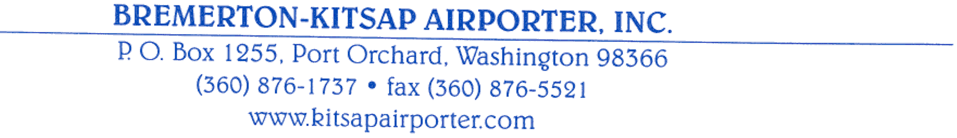
August 24, 2002

Washington Utilities & Transportation Commission 1300 S. Evergreen Park Dr. SW Olympia, W A 98504

Re: Bremerton-Kitsap Airporter, Inc. Tariff, TC-OO1846

Dear Ms. Washburn,

Subject Order requires tariff sheets submitted by this company to be effective on August 24,2002. Are we to understand that the thirty days notice to the public required by WAC 480-30-050 is waived in this case? Our Pierce rates were raised overnight for the military passengers served on that route with no notice to the public.

Pierce rates are for military personnel and their dependents only, since for security reasons, they are the only passengers admitted to the military installations that we serve on that route.

Please advise.

Sincerely,
&--.t ~'t::.c..{ ;'
Richard E. Asche
President

