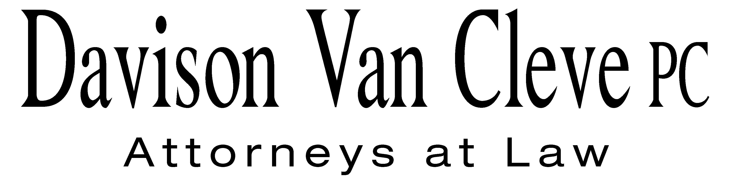
TEL (503) 241-7242 ● FAX (503) 241-8160 ● mail@dvclaw.com
Suite 400
333 SW Taylor
Portland, OR 97204

June 10, 2011

Via Federal Express and Electronic Mail

Carole J. Washburn
Secretary
Washington Utilities & Transportation Commission
1300 S. Evergreen Park Drive S.W.
Olympia, WA 98504

Re: In the Matter of WUTC v. Avista Corporation

Docket Nos. UE-110876

Dear Ms. Washburn:

Enclosed please find an original and twelve (12) copies of the Notice of Appearance on behalf of the Industrial Customers of Northwest Utilities in the above-referenced matter.

Thank you for your assistance. If you have any questions, please do not hesitate to give me a call.
Sincerely yours,

/s/ Sarah A. Kohler
Sarah A. Kohler

Enclosures
cc: Service List
CERTIFICATE OF SERVICE

I hereby certify that I have this day served a copy of the foregoing Notice of Appearance of the Industrial Customers of Northwest Utilities upon the parties, shown below, listed on the official service list in Docket No. UE-110876 by causing the same to be mailed, postage-prepaid, via U.S. Mail.
DATED at Portland, Oregon, this 10th day of June, 2011.
Davison Van Cleve, P.C.

/s/ Sarah A. Kohler
Sarah A. Kohler

Chad M Stokes  Cable Huston Benedick Haagensen & Lloyd, LLP  1001 SW 5th Avenue STE 2000  Portland, OR 97204  cstokes@cablehuston.com | Don Trotter  Assistant Attorney General  WUTC  PO Box 40128  Olympia, WA 98504-0128  dtrotter@utc.wa.gov
Tommy A Brooks  Cable Huston Benedick Haagensen & Lloyd, LLP  1001 SW 5th Avenue STE 2000  Portland, OR 97204-1136  tbrooks@cablehuston.com | Paula E Pyron  NORTHWEST INDUSTRIAL GAS USERS  4113 Wolf Berry Court  Lake Oswego, OR 97035-1827  ppyron@nwigu.org
Kelly Norwood, Vice President  Avista Corporation, d/b/a Avista Utilities  1411 E. Mission  Spokane, WA 99220  kelly.norwood@avistacorp.com | David Meyer  Avista Corporation, d/b/a Avista Utilities  PO BOX 3727  Spokane, WA 99220-3727  dmeyer@avistacorp.com
Sarah A Shifley
Office of the Attorney General
800 5th Ave STE 2000
Seattle, WA 98104-3188
Sarah.Shifley@atg.wa.gov

