June 27, 2016

Mr. David W. Danner
Washington Utilities & Transportation Commission
1300 So. Evergreen Park Drive S.W.
P.O. Box 47250
Olympia, WA 98504-7250

Re: UT-160029 - 2016 Local Urban Rate Floor Data submitted electronically

Dear Mr. Danner:

Enclosed you will find Mashell Telecom, Inc.’s 2016 local urban rate floor data previously submitted to USAC. If you have any questions regarding this information feel free to call me at 360-832-4130.

Sincerely,
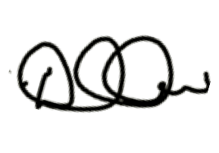
Danielle Clausen
Controller

Enclosures

