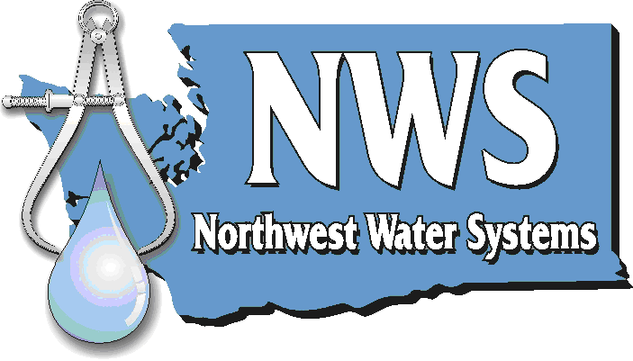 | Planning ● Management ● Engineering  P.O. Box 123 ● Port Orchard, WA 98366 ● 1-888-881-0958

January 13th, 2011

Mr. David Danner, Executive Director and Secretary
Washington Utilities and Transportation Commission
P.O. Box 47250
Olympia, WA 98504-7250

Subject: Copalis Rocks revised pages

Dear Mr. Danner:

You will find the updated pages for the Tariff filing for the Copalis Rocks Mutual Benefit Association with this submission. These pages are similar to what was submitted this past December, however we have updated the page numbers (which were incorrect) and made other minor corrections. Two non-trivial corrections to draw your attention to are that we have extended the effective date to February 10th and the facilities charge has been corrected (there is not one at this time).

Thank you for your time and attention to this, please feel free to contact me with any questions.

Sincerely

Jester Purtteman, E.I.T.
Northwest Water Systems

