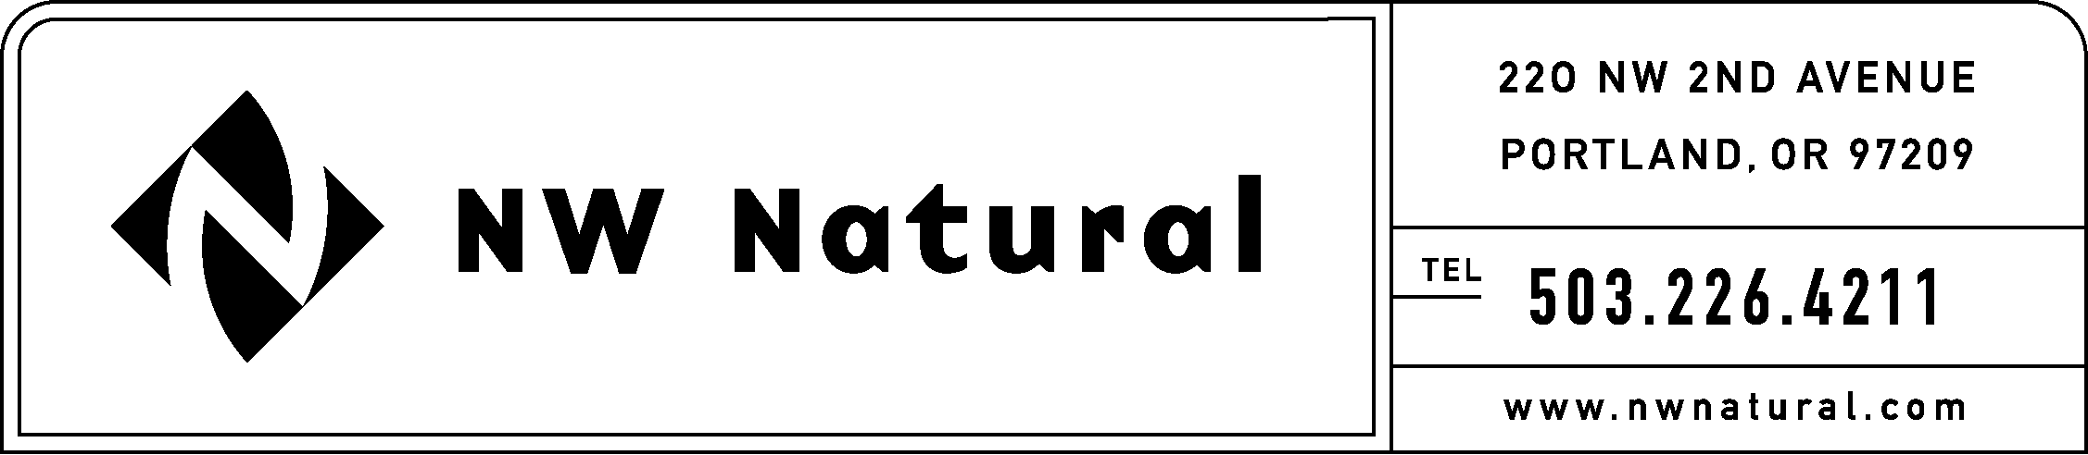

Rates and Regulatory Affairs
Facsimile: 503.721.2516

April 23, 2010

VIA ELECTRONIC FILING

Dave Danner, Executive Director & Secretary
Washington Utilities and Transportation Commission
1300 S Evergreen Park Drive SW
Post Office Box 47250
Olympia, Washington 98504-7250

Re: U-100522, NW Natural’s Statement of Issues

Dear Mr. Danner:

Northwest Natural Gas Company, dba NW Natural (“NW Natural” or the “Company”), hereby submits its statements of issues in the subject docket established for investigating conservation incentive mechanisms and declines in revenues due to various reasons, including conservation programs.

NW Natural believes this investigation begins a worthwhile and timely conversation. The Company identifies the following issues other than conservation that it believes should be considered:

- Weather – Customers use less gas when weather is unseasonably warm. Conversely, a utility collects more revenue when weather is unusually cold and customers are using more gas to heat their homes.
- Elasticity – Customers use less as gas prices increase.
- General trend of reduced natural gas usage – The AGA reports, “Natural Gas use per customer has decreased by about 1 percent per year for the last 38 years, which means that the average residential customer today uses 39 percent less than they did 38 years ago.” This trend, which is not clearly attributable to any one reason identified above, requires regulatory consideration.

NW Natural appreciates the Commission’s consideration of our issues and we look forward to participating in this investigation. Please contact me if you have questions.

Sincerely,

NW NATURAL

/s/ Jennifer Gross

Jennifer Gross

Rates & Regulatory Affairs

See http://www.aga.org/Legislative/RatesRegulatoryIssues/ratesregpolicy/Issues/energyefficiency/ NaturalGasUtilitiesandTheirCustomers.htm

