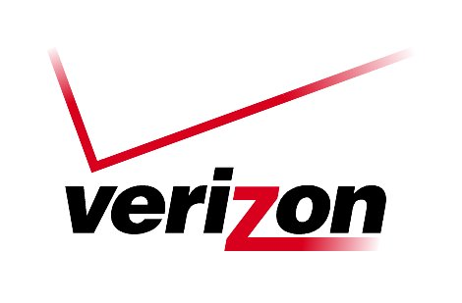 Verizon Northwest Inc.

1800 – 41st Street, WA0105RA
P. O. Box 1003
Everett, WA 98206-1003
Fax: 425-261-5262

January 4, 2007

Ms. Carole J. Washburn, Executive Secretary
Washington Utilities and
Transportation Commission
Chandler Plaza Building
1300 S. Evergreen Park Drive SW
P. O. Box 47250
Olympia, Washington 98504

Dear Ms. Washburn:

Subject: CONTRACT NO. 1333ICB (Docket No. UT-060023)

Verizon Northwest Inc. submits Contract No. 1333ICB, a renewal of a customer specific agreement for 2-1-1 Routing Service filed under Amendment No. 2. The purpose of this Amendment is to extend the term of the agreement on a month-to-month basis for thirty-six (36) months. The customer is currently receiving this service under Contract No. 1316ICB, effective February 5, 2006 in Docket No. UT-060023 and Contract No. 1317ICB, Amendment No. 1, effective February 22, 2006 in the same docket.

2-1-1 Routing Service utilizes a three digit local dialing arrangement to permit voice access to non-emergency and social service agencies. The service will be provided using an Advanced Intelligent Network (AIN) solution, which Verizon companies are employing across the country, uses the most current switch technology, and provides the most accuracy in call completion.

The Company is utilizing a contract because this service is not offered under tariff, and there is limited demand for the service.

The pricing in this contract is the same as in Contract No. 1259ICB for 5-1-1 Routing Service, approved by the Commission in UT-031039. Therefore, no new cost support is being filed. Please refer to the cost support filed in that prior matter. The rates are not the Company’s preferred pricing but are, in agreement with Commission Staff, comparable to Qwest’s current
Ms. Carole J. Washburn
January 4, 2007
Page 2

tariff rates for N11 Service. This filing does not constitute agreement by the Company that its’ preferred pricing (which was originally filed with the 5-1-1 contract) would be improper.

The Company requests approval of this filing with an effective date of February 4, 2007.

Please contact Lin Fogg at (425) 261-6380, if you have questions regarding this filing.

Very truly yours,
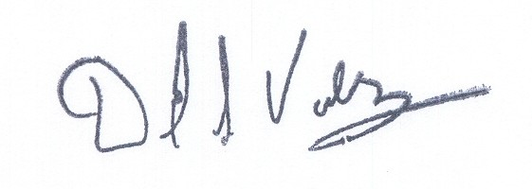

David S. Valdez

Sr. Vice President West

Public Policy, Affairs and Communications

DSV/lf

Attachments
(WA6392533)

ESSENTIAL TERMS AND CONDITIONS

Contract No. 1333ICB New ______ Renewal _____ Amendment ___X___

Effective Date: February 4, 2007

Expiration Date: February 3, 2010

Duration of Contract: Thirty-six (36) months

Renewal Options: None are automatic per terms of the agreement, however, if the customer wishes to continue service and notifies the company prior to the expiration date of the agreement, the company will negotiate a renewal.

Description of Service: 2-1-1 Service utilizes a three digit local dialing arrangement to permit voice access to non-emergency and social service agencies. 2-1-1 Service is provisioned primarily through the Advanced Intelligent Network (AIN).

Termination Charges: None

Number of Units: 80 AIN Capable Host Offices
21 Pseudo AIN Capable Offices
13 Non-AIN Capable Host Offices

Monthly Recurring Charge: None

Non-Recurring Charge(s): $199.99 for 2-1-1 Routing Service Establishment
$ 22.25 Central Office Switch Activation Charge per
Central Office Switch translated

ESSENTIAL TERMS AND CONDITIONS

Contract No. 1333ICB New ______ Renewal _____ Amendment __X____

Locations: In WA: Acme, Alger, Anacortes, Arlington, Benton City, Big Lake, Birch Bay, Blaine, Bothell, Brewster, Bridgeport, Burlington, Camano Island, Camas,
Cashmere, Chelan, Clearview, Concrete, Conway, Coupeville, Curlew, Custer, Darrington, Deming, Duvall, East Wenatchee, Edison, Entiat, Everett, Everson, Fairfield, Farmington, Ferndale, Garfield, George, Granite Falls, Grayland, Halls Lake, Juanita, Kennewick, Kirkland, LaConner, Lake Goodwin, Lake Stevens, Lake Wenatchee, Latah, Laurel, Leavenworth, Loomis, Lyman, Lynden, Malden, Manor Way, Mansfield, Manson, Maple Falls, Marblemount, Marysville, Molson, Monroe, Mount Vernon, Naches, Newport, Nile, North Richland, Oak Harbor, Oakesdale, Palouse, Post Falls, Pullman, Quincy, Redmond, Republic, Richmond Beach, Rockford, Rosalia, Sammamish, Seattle, Sedro Woolley, Silver Lake, Skykomish, Snohomish, Soap Lake, Stanwood, Stevens Pass, Sultan, Sumas, Tekoa, Thornton, Tonasket, Washougal, Washougal River, Waterville, Wenatchee, West Richland, Westport and Woodland as well as Clatskanie, OR and Coeur D’Alene, ID.

Contract No. 1333ICB New ______ Renewal ______ Amendment ___X___

7(b)(iv) A statement summarizing the basis of the rate or charge proposed in the contact and an explanation of the derivation of the proposed rate or charge.

Nonrecurring Charges

The Nonrecurring Charges associated with this agreement are as follows: 2-1-1 Routing Service Establishment Charge of $199.00 which will apply per point-to number in addition to the Central Office Switch Activation Charge per central office translated to the point-to number. The Service Establishment Charge will apply for any change to the point-to number after the initial deployment. The Service Establishment charge is intended to address the one-time service development and the initial provisioning of AIN. There is also a nonrecurring Central Office Switch Activation Charge per Central Office Switch translated of $22.25.

Termination Liability

None.

Monthly Charges

None.
Contract No. 1333ICB New ______ Renewal ______ Amendment __X____

7(b)(iv) Summarize the basis of the charge(s) proposed in the contract and explain the derivation of the proposed charge(s) including all cost computations involved.

Since the Company and Staff have agreed to the terms for providing this service,
no cost support documentation is included with this filing. Cost support
documentation for 5-1-1 Service was filed under Contract No. 1259ICB, effective
July 10, 2003 in Docket No. UT-031039. Verizon agrees to provide 2-1-1 service
under this contract (not to set a precedent) to Washington Information Network 2-1-1 at rates comparable to Qwest’s current tariff rates and no monthly recurring charges for 2-1-1 service in Washington.

Contract No. 1333ICB New ______ Renewal ______ Amendment ___X___

7 (b) (v) Indicate the basis for using a contract rather than a filed tariff for the specific service involved. If the basis for using a contract is the availability of an alternative service provider, identify that provider.

Service is provided under a contract because it is not offered under tariff and there is limited demand for the service.

Contract No. 1333ICB New ______ Renewal ______ Amendment __X____

- Duration of contract. All contracts shall be for a stated time period.

The term shall run on a month-to-month basis for thirty-six (36) months.

