ATTACHMENT B

Geographic Distribution of Recommended GCPF Disbursements
(2003-2005 Biennium)

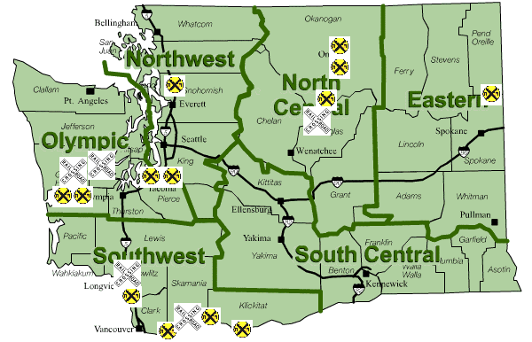

 Indicates general vicinity of projects recommended for GCPF disbursement

Indicates general vicinity of projects not recommended for GCPF disbursement

