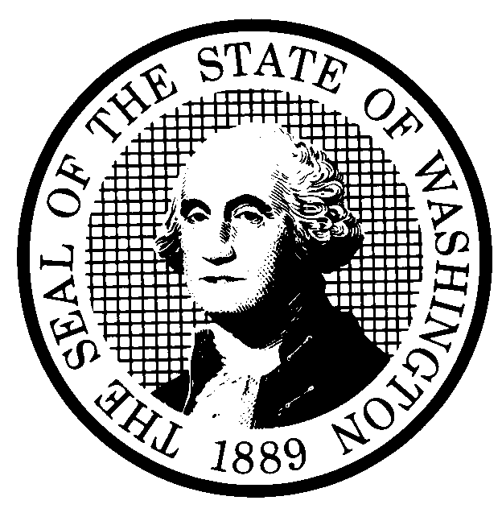 | PROPOSED RULE MAKING  (RCW 34.05.320) |  |  |  |  |  |  |  |  | CR-102 (7/22/01)  Do NOT use for expedited  rule making
Agency: Washington Utilities and Transportation Commission |  |  |  |  |  |  |  |  |  | X Original Notice
Preproposal Statement of Inquiry was filed as WSR ; or  Expedited Rule Making -- Proposed notice was filed as WSR ; or  X Proposal is exempt under RCW 34.05.330(1)(b). |  |  |  |  |  |  |  |  |  | Supplemental Notice  to WSR  Continuance of WSR
(a) Title of rule: (Describe Subject) WAC 480-120-146, Changing service providers from one local exchange (LEC) company to another. The current rule requires telecommunications companies to continue service when a customer migrates from one LEC to another until confirmation of activation of new service is received from the new service provider. On June 17, 2003, Qwest Corporation filed a petition to amend this section to require the LEC providing existing service to the customer to wait until 11:59 of the next business day following the scheduled port before disconnecting the customer.
Purpose: The proposal would amend WAC 480-120-146 to clarify the process to be followed when a customer migrates from one LEC to another LEC, and the customer retains his/her telephone number via Local Number Portability (LNP).

Other identifying information:
Docket No.: UT-030964
(b) Statutory authority for adoption: RCW 80.01.040, RCW 80.04.160, and RCW 34.05.330. |  |  |  |  |  |  |  |  | Statute being implemented:
(c) Summary: See (j) below.

Reasons supporting proposal:
(d) Name of Agency Personnel Responsible for: |  |  |  |  |  | Office Location |  |  |  |  | Telephone
1. Drafting...............Tom Wilson, Regulatory Analyst |  |  |  |  |  | 1300 S. Evergreen Park Drive S.W., Olympia, WA. 98504 |  |  |  |  | 360-664-1282
2. Implementation... Carole J. Washburn, Secretary |  |  |  |  |  | 1300 S. Evergreen Park Drive S.W., Olympia, WA 98504 |  |  |  |  | 360-664-1174
3. Enforcement.......Carole J. Washburn, Secretary |  |  |  |  |  | 1300 S. Evergreen Park Drive S.W., Olympia, WA 98504 |  |  |  |  | 360-664-1174
(e) Name of proponent (person or organization):  Qwest Corporation |  |  |  |  |  |  |  |  |  |  | X Private  Public  Governmental
(f) Agency comments or recommendations, if any, as to statutory language, implementation, enforcement and fiscal matters:
None

(g) Is rule necessary because of:  Federal Law?  Federal Court Decision?  State Court Decision? |  | Yes  Yes  Yes |  |  | x No  x No  x No |  | If yes, ATTACH COPY OF TEXT  Citation:
(h) HEARING LOCATION: |  |  |  |  |  |  |  | Submit written comments to:
Commission Hearing Room  Second Floor, Chandler Plaza Building  1300 S. Evergreen Park Drive S.W.  Olympia, WA 98504 |  |  |  |  |  |  |  | Carole J. Washburn, Secretary, P. O. Box 47250  Olympia, WA 98504 or  E-mail to records@wutc.wa.gov. Please include  Docket No. UT-030964 in your communication.  FAX (360) 586-1150 By: August 27, 2003  See attached form for more information.  FAX ( ) By (date)
Date: October 22, 2003 Time: 9:30 a.m. |  |  |  |  |  |  |  | DATE OF INTENDED ADOPTION: October 22, 2003
Assistance for persons with disabilities: Contact  Mary DeYoung by October 17, 2003 |  |  |  |  |  |  |  | CODE REVISER USE ONLY
TDD (360) 586-8203 or (360) 664-1133
NAME (TYPE OR PRINT)  CAROLE J. WASHBURN |  |  |  |  |  |  |  | Filed with the Code Reviser's Office  August 1, 2003
SIGNATURE |  |  |  |  |  |  |  | WSR# 03-16-063
TITLE  SECRETARY |  |  | DATE  AUGUST 1, 2003
(COMPLETE REVERSE SIDE)
(j) Short explanation of rule, its purpose, and anticipated effects:

The proposed rule revision clarifies the situation where a customer migrates from one LEC to another LEC, and the customer retains his/her telephone number via LNP.

When the customer migrates from one LEC to another using LNP, the proposed amendments to WAC 480-120-146 would replace the manual system of confirmation of activation of new service with the LNP practices ordered in Docket Nos. UT-003022/UT-003040 (Fifteenth Supplemental Order dated August 17, 2001). Specifically, the proposed procedure would require the LEC providing existing service to the customer must wait until 11:59 p.m. of the next business day following the scheduled port before disconnecting a customer’s previous service.

The proposal would provide a more efficient and reliable process that would minimize service interruptions for customers who wish to retain their numbers when changing local exchange carriers.

Does proposal change existing rules? | X YES NO | If yes, describe changes:
See (j) above.
(k) Has a small business economic impact statement been prepared under chapter 19.85 RCW?
Yes. Attach copy of small business economic impact statement.
A copy of the statement may be obtained by writing to:

telephoning: ( )
faxing: ( )
X No. Explain why no statement was prepared

The proposed rule streamlines the process for confirming migrations from LEC to LEC using LNP, and utilizes resources more efficiently. Because there will not be any increase in cost resulting from the proposed rule, an SBEIS is not required.

(l) Does RCW 34.05.328 apply to this rule adoption? Yes X No
Please explain:
The commission is not an agency to which RCW 34.05.328 applies. The proposed rule is not a significant legislative rule of the sort referenced in RCW 34.05.328(5).

WASHINGTON UTILITIES AND TRANSPORTATION COMMISSION
CR-102 - ATTACHMENT
DOCKET NO. UT-030964

(h) Interested persons may contact the Secretary, Washington Utilities and Transportation Commission, P. O. Box 47250, Olympia, Washington, 98504-7250, 360-664-1174 (Fax: 360-586-1150).

WRITTEN COMMENTS

Written comments may be submitted to the Commission at the address given above and should be filed with the Commission no later than Wednesday, August 27, 2003.
Electronic copies. The Commission requests that comments be provided in electronic format to enhance public access, for ease of providing comments, to reduce the need for paper copies, and to facilitate quotations from the comments. Comments may be submitted by electronic mail to the Commission’s Records Center at records@wutc.wa.gov. Please include:

- The docket number of this proceeding (UT-030964)
- The commenting party’s name
- The title and date of the comment or comments

An alternative method for submitting comments may be by mailing/delivering an electronic copy on a 3 ½ inch, IBM-formatted, high-density disk, in .pdf Adobe Acrobat format or in Word 97 or later. Include all of the information requested above. The Commission will post on the Commission’s web site all comments that are provided in electronic format. The web site is located at http://www.wutc.wa.gov/030964. If you are unable to file your comments electronically or to submit them on a disk, the Commission will always accept a paper document.

NOTICE OF STAKEHOLDER DISCUSSION

The Commission has scheduled a stakeholder discussion to provide interested persons the opportunity to discuss the rule proposal in an informal setting. The stakeholder discussion is planned for October 2, 2003, beginning at 2:00 p.m. in the Commission’s Hearing Room, Second Floor, Chandler Plaza, 1300 Evergreen Park Drive S.W., Olympia, Washington.

Information about the schedule and other aspects of the rulemaking, including comments, will be posted on the Commission’s web site as it becomes available. If you wish to receive further information on this rulemaking you may (1) call the Commission’s Records Center at 360-664-1234, (2) e-mail the Commission at <records@wutc.wa.gov>, or (3) mail written comments to the address above to the attention of Carole J. Washburn, Secretary. When contacting the Commission, please refer to Docket No. UT-030964 to ensure that you are placed on the appropriate service list. Questions may be addressed to Tom Wilson (360) 664-1282 or e-mail at twilson@wutc.wa.gov.

