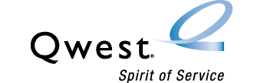

Qwest Corporation

1600 7th Avenue, Room 3206

Seattle, Washington 98191

(206) 345-1568

Facsimile (206) 343-4040

Mark S. Reynolds

Senior Director – Regulatory

Policy and Law

November 28, 2005

Ms. Carole Washburn
Executive Secretary
Washington Utilities and Transportation Commission
1300 S. Evergreen Park Drive SW
PO Box 47250
Olympia, WA 98504-7250

Dear Ms. Washburn:

Pursuant to Qwest Corporation's (Qwest) Performance Assurance Plan at Section 14.2, Qwest herein provides the November 25th, 2005, report of aggregate CLEC performance results for Washington for the period of November, 2004 - October, 2005.

Pursuant to Docket UT-043007, Order #13 revising the filing of Exhibit K to an electronic filing as approved by Washington Utilities and Transportation Commission a paper copy is no longer required. This cover letter and the attached documents in the electronic transmission meet these revised requirements.

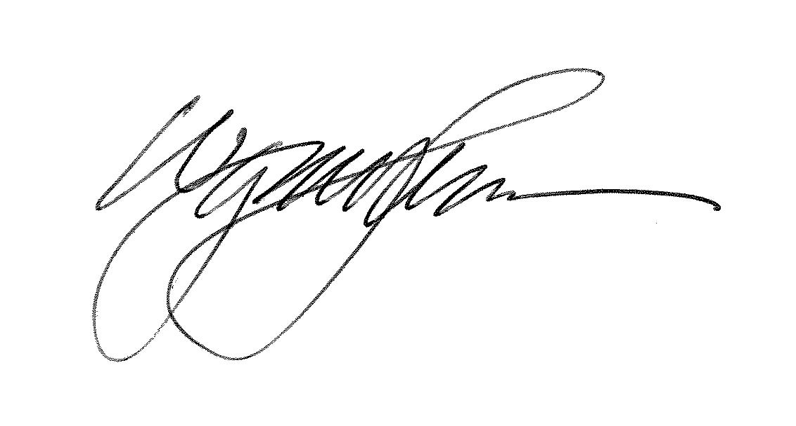
Please contact Wayne Johnson on 515 286 2462 if you have any questions regarding this report.

Sincerely,

For Mark S. Reynolds
Senior Director - Regulatory

