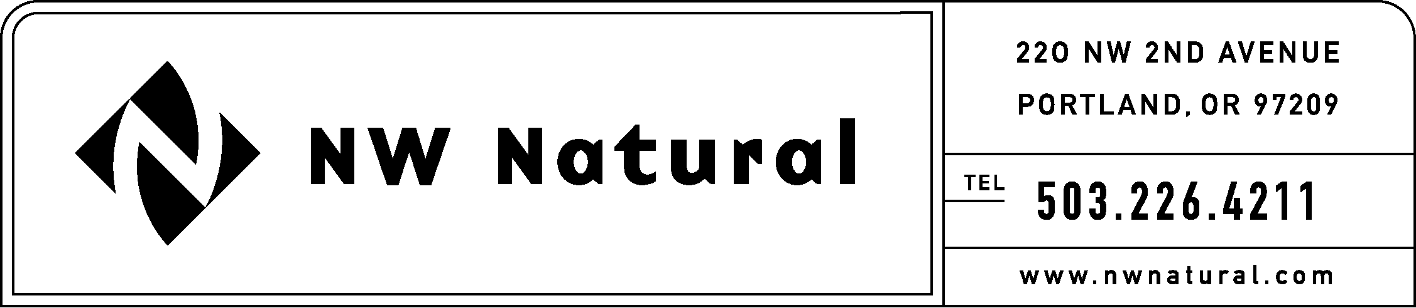

Rates and Regulatory Affairs
Facsimile: 503.721.2532

September 30, 2005

Carole Washburn, Executive Secretary
Washington Utilities and Transportation Commission
P.O. Box 47250
1300 S. Evergreen Park Drive S.W.
Olympia, WA 98504-7250

Re: Docket No. UE-030311; Least Cost Planning Rulemaking, WAC 480-100-238

Docket No. UG-030312; Least Cost Planning Rulemaking, WAC 480-90-238

Replacement Follow-Up Comments of NW Natural

Enclosed for filing are NW Natural’s replacement Follow-up Comments in the above-referenced docket. Follow-up Comments electronically filed yesterday are hereby withdrawn in their entirety.

Please contact me if you have any questions.

Sincerely,

/s/ J. Ross

Joseph M. Ross
Rate Economist/Planning Analyst

JMR/kcm
enclosure

