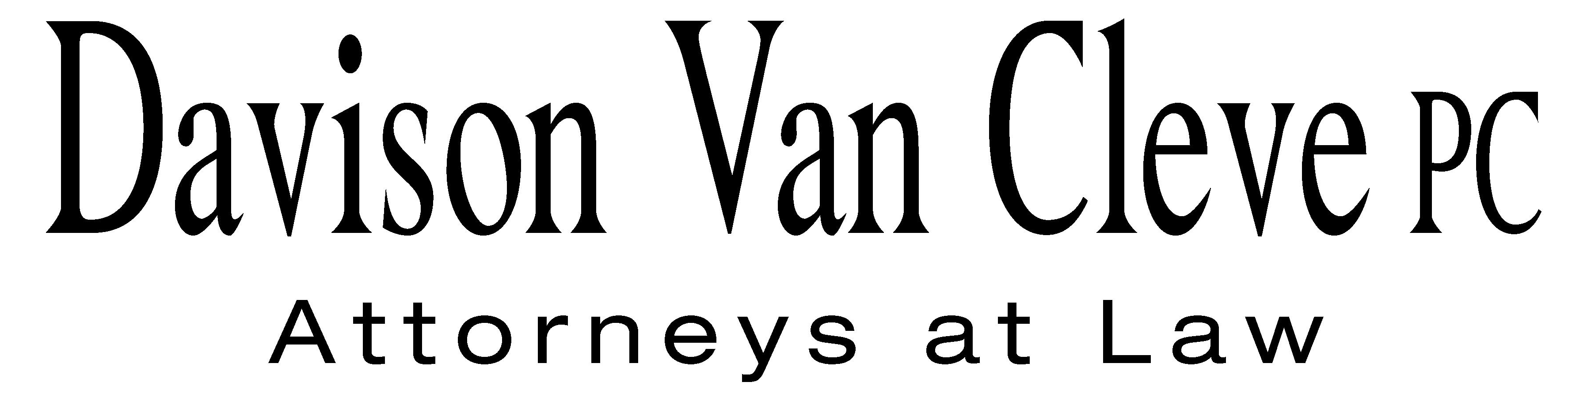
TEL (503) 241-7242 ● FAX (503) 241-8160 ● mail@dvclaw.com
Suite 400
333 SW Taylor
Portland, OR 97204

March 17, 2008

Via Federal Express and Electronic Mail

Carole J. Washburn
Secretary
Washington Utilities & Transportation Commission
1300 S. Evergreen Park Drive S.W.
Olympia, WA 98504

Re: In the Matter of WUTC v. Avista Corporation

Docket Nos. UE-080416

Dear Ms. Washburn:

Enclosed please find the original and 12 copies each of the Petition to Intervene and the Notice of Appearance of the Industrial Customers of Northwest Utilities for filing in the above-referenced docket.
Electronic copies were emailed to the Records Center today, March 17, 2008. Thank you for your assistance.
Sincerely yours,

/s/ Brendan E. Levenick
Brendan E. Levenick

Enclosures
cc: Service List
CERTIFICATE OF SERVICE

I hereby certify that I have this day served a copy of the foregoing Petition to Intervene and Notice of Appearance of the Industrial Customers of Northwest Utilities upon the parties, shown below, listed on the official service list in Docket No. UE-080416 by causing the same to be mailed, postage-prepaid, via U.S. Mail.
DATED at Portland, Oregon, this 17th day of March, 2008.
Davison Van Cleve, P.C.

/s/ Brendan E. Levenick
Brendan E. Levenick

Kelly Norwood  Vice President  Avista Corporation  1411 E. Mission  Spokane, WA 99220 | David Meyer  Attorney  Avista Corporation  PO Box 3727  Spokane, WA 99220
Greg Trautman  Washington Utilities & Trans. Comm'n Attorney General Section  PO Box 40128  Olympia, WA 98504 | Simon ffitch  Office of the Attorney General  Public Counsel Section  800 5th Avenue, Suite 2000  Seattle, WA 98104

