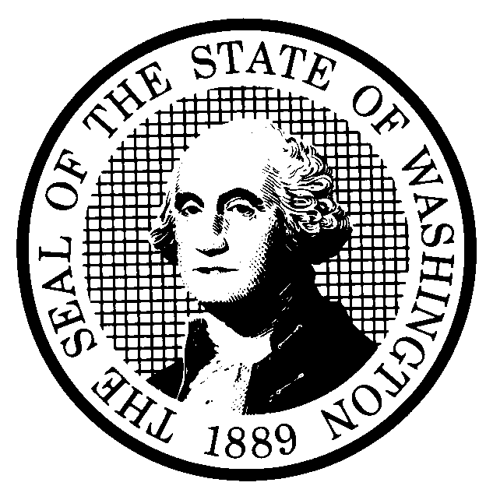 | PROPOSED RULE MAKING |  |  |  |  | CR-102 (June 2004)  (Implements RCW 34.05.320)  Do NOT use for expedited rule making
Agency: Washington Utilities & Transportation Commission
X Preproposal Statement of Inquiry was filed as WSR #04-03-118 &  #04-04-021 ; or  Expedited Rule Making--Proposed notice was filed as WSR ; or  Proposal is exempt under RCW 34.05.310(4). |  |  |  |  |  |  | Original Notice  Supplemental Notice to WSR _____  X Continuance of WSR #04-22-072
Title of rule and other identifying information:

Telco Tune-up Supplemental CR-102 relating to WAC 480-120-147, WAC 480-120-322, and WAC 480-120-349
Docket No. UT-040015
Hearing location(s):  Commission Hearing Room 206  Second Floor, Chandler Plaza Building  1300 S. Evergreen Park Drive S.W.  Olympia, WA 98504 |  |  |  | Submit written comments to:  Name: Carole J. Washburn, Secretary  Address: P. O. Box 47250, Olympia, WA 98504  e-mail records@wutc.wa.gov Please include  Docket No. UT-040015 in your communication.  fax (360) 586-1150 by (date) November 23, 2004
Date: December 10, 2004 Time: 1:30 P.M. |  |  |  | Assistance for persons with disabilities: Contact  Mary DeYoung by Monday, December 6, 2004  TTY (360) 586-8203 or (360) 664-1133
Date of intended adoption: December 10, 2004
(Note: This is NOT the effective date)
Purpose of the proposal and its anticipated effects, including any changes in existing rules:
This supplemental proposal would revise WAC 480-120-147, Changes in local exchange and intrastate toll services, to be consistent with the federal rule, to establish a time limit for local exchange companies to lift freeze, and to submit a change order, to change the term ‘customer’ to ‘subscriber’ throughout section to parallel FCC term, and to make grammar changes. It would repeal WAC 480-120-322, Retaining and preserving records and reports, and adopt WAC 480-120-349, Retaining and preserving records and reports, thus changing the section number to parallel the reorganization of rule sections in Docket A-021178.

The purpose of the continuance of WSR #04-22-072 is to provide notice of a change in the time of the hearing to receive public comment regarding adoption of the rules that are the subject of the Supplemental CR-102. The hearing time has been changed from 9:30 a.m. on December 10, 2004 to 1:30 p.m. on December 10, 2004.
Statutory authority for adoption: |  |  |  | Statute being implemented:
Is rule necessary because of a:  Federal Law?  Federal Court Decision?  State Court Decision?  If yes, CITATION: |  | Yes  Yes  Yes | No  No  No |  | CODE REVISER USE ONLY  Filed with the Code Reviser’s Office  November 12, 2004, 10:57 a.m.  WSR 04-23-052
DATE
November 12, 2004
NAME (type or print)
CAROLE J. WASHBURN
SIGNATURE

TITLE
EXECUTIVE SECRETARY

(COMPLETE REVERSE SIDE)
Agency comments or recommendations, if any, as to statutory language, implementation, enforcement, and fiscal matters:
None

Name of proponent: Washington Utilities & Transportation Commission |  |  | Private  Public  X Governmental
Name of agency personnel responsible for:
 | Name | Office Location | Phone
Drafting............... Sharyn Bate |  | 1300 S. Evergreen Park Drive S.W., Olympia, WA 98504 | (360) 664-1295
Implementation.... Carole J. Washburn, Secretary |  | 1300 S. Evergreen Park Drive S.W., Olympia, WA 98504 | (360) 664-1174
Enforcement....... Carole J. Washburn, Secretary |  | 1300 S. Evergreen Park Drive S.W., Olympia, WA 98504 | (360) 664-1174
Has a small business economic impact statement been prepared under chapter 19.85 RCW?
Yes. Attach copy of small business economic impact statement.

A copy of the statement may be obtained by contacting:
Name:
Address:

phone ( )
fax ( )
e-mail
No. Explain why no statement was prepared.

Is a cost-benefit analysis required under RCW 34.05.328?

Yes A preliminary cost-benefit analysis may be obtained by contacting:
Name:
Address:

phone ( )
fax ( )
e-mail

No: Please explain:

ATTACHMENT A

480-120-147 Changes in local exchange and intrastate toll services.
1. Establish time limit for LEC to lift freeze, time limit to submit change order.
2. Update to be consistent with federal rule.
3. Grammar changes.
4. Change ‘customer’ to ‘subscriber’ throughout section to parallel FCC term.

480-120-322 Retaining and preserving records and reports.
- Repeal for consistency with chapter reorganization in Docket A-021178. Replaced by WAC 480-120-349.

480-120-349 Retaining and preserving records and reports.
Replaces WAC 480-120-322
1. Change section number to correspond to reorganization in Docket A-021178.

