BEFORE THE
WASHINGTON UTILITIES AND TRANSPORTATION COMMISSION

WASHINGTON UTILITIES AND  TRANSPORTATION COMMISSION,  Complainant,  v.  PUGET SOUND ENERGY, INC.,  Respondent. | Docket No. UE-060266  Docket No. UG-060267  (consolidated)  PUGET SOUND ENERGY, INC.'S MOTION FOR CLARIFICATION OF ORDER 08

1 Pursuant to WAC 480-07-835, Puget Sound Energy, Inc. ("PSE" or "the Company") hereby requests that the Commission clarify three matters set forth in Order No. 08 in this proceeding. The Company is not seeking through this motion to change the outcome with respect to these matters, but to clarify the meaning of the order so that compliance may be enhanced.
Baker River Relicensing Specifications
2 In its Order No. 08, the Commission approved the revenue requirement agreement between PSE and Staff. The Commission also found that the costs associated with the Baker River Hydroelectric Project were reasonable for recovery in rates. However, the Commission did not expressly adopt the specifications in Section 2 of the Staff/Company Agreement on Revenue Requirement Adjustments relating to the Baker Relicensing. For the purpose of truing up the PCA in this period, the Company needs to know that the Commission is adopting these provisions. PSE requests the Commission clarify that it adopts the provisions of the Staff/Company Agreement on Revenue Requirement Adjustments relating to the Baker Relicencing.
Treatment of Trust Preferred Stock as Tax Deductible
3 In Order No. 08, the Commission determined that the Company's electric revenue requirements should be set at $17,174,242 and the Company's gas revenue requirements should be set at $31,259,011. Additionally, in setting the capital structure for the Company, the Commission set the Trust Preferred share at 5.25%. The revenue requirements set by the Commission do not reflect the fact that Trust Preferred stock is tax deductible. In its compliance filing, the Company assumed that the Commission intended to treat Trust Preferred stock as tax deductible, and the Company adjusted its calculation of revenue requirements downward, accordingly. The Company respectfully requests that the Commission clarify whether it intended the Trust Preferred stock to be treated as tax deductible for revenue requirement purposes, and if so, clarify that the net of tax rate of return would be 7.06%.
Amortization of Muckleshoot Settlement Payment
4 The Commission points out that the Company's Exhibit 440, Power Costs, and Exhibit 4C, PSE NOI, show a slightly different amount for power costs. The difference in power costs is the result of PSE's and Staff's agreement to extend the amortization period of PSE's Muckleshoot Settlement Period from two (2) years to four (4) years. This inconsistency in power costs was corrected in PSE's compliance filing of January 9, 2007. PSE requests that the Commission clarify that it approves the four-year amortization, which PSE has used in setting power costs in the compliance filing.

Conclusion
5 For the reasons set forth above, PSE respectfully requests that the Commission enter an order clarifying Order No. 08 with respect to the above-referenced issues.
DATED: January 12, 2007 | Respectfully Submitted,  PERKINS COIE LLP  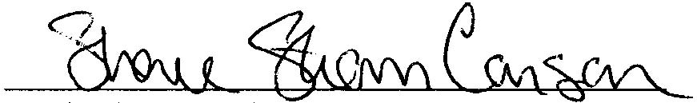  Sheree Strom Carson WSBA No. 25349  Jason T. Kuzma, WSBA No. 31830  Attorneys for Puget Sound Energy, Inc.

See Order No. 08 at ¶ 96.
See Order No. 08 at ¶ 165.
See Order No. 08 at ¶¶ 123, 126.
See Order No. 08 at ¶ 71, Table 6.
See Order No. 08 at 41 n.93.
See Exhibit No. 4C at 2; see Order No. 08, Appx. B at 2.
See PSE's Compliance Filing Cover Letter, January 9, 2007 at 3.

