

Timothy J. McCallion
President-West Region
112 Lakeview Canyon Road, CA501GA
Thousand Oaks, CA 91362
Phone 805 372-7160
Fax 805 373-1471
tim.mccallion@verizon.com
April 26, 2010

Mr. David Danner
Secretary and Executive Director
Washington Utilities and Transportation Commission
1300 S. Evergreen Park Dr. SW
Olympia, WA 98504-7250

Re: UT-090842 -- Joint Application of Verizon Communications Inc. and Frontier Communications Corporation for an Order Declining to Assert Jurisdiction Over, or, in the Alternative, Approving the Indirect Transfer of Control of Verizon Northwest Inc.; Verizon Acceptance

Dear Mr. Danner:
Verizon Communications Inc. ("Verizon") accepts the additional conditions specified as applicable to Verizon in paragraph 213 of Order 06 (dated April 16, 2010) in Docket UT-090842.

Sincerely,

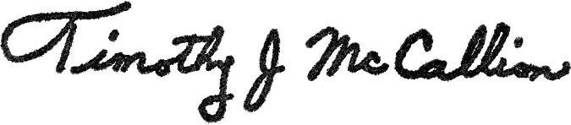

Tim McCallion
President-West Region

