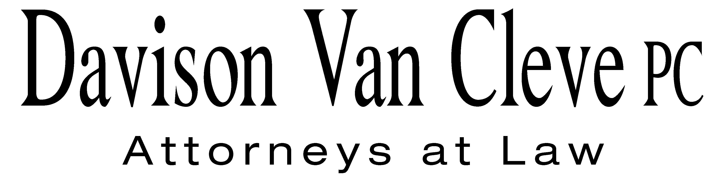
TEL (503) 241-7242 ● FAX (503) 241-8160 ● mail@dvclaw.com
Suite 400
333 SW Taylor
Portland, OR 97204

June 3, 2010

Via Email and Federal Express

Carole J. Washburn
Secretary
Washington Utilities and Transportation Commission
PO Box 47250
1300 S Evergreen Park Drive SW
Olympia, WA 98504-7250

Re: In the matter of the PacifiCorp’s general rate increase.

Docket No. UE-100749

Dear Ms. Washburn:

Enclosed please find the original and twelve (12) copies of signature pages to Protective Order No. 3 of Randall J. Falkenberg, Lauren Falkenberg, and Jeremy Hagemeyer on behalf of the Industrial Customers of Northwest Utilities in the above-referenced matter.

If you have any questions or concerns, please do not hesitate to contact our office. Thank you for your assistance.

Sincerely yours,

/s/ Martin H. Patail
Martin H. Patail

Enclosures

cc: Service List

CERTIFICATE OF SERVICE

I hereby certify that I have this day served the foregoing documents upon all parties of record in this proceeding by mailing a copy thereof in a sealed, first-class postage prepaid envelope to each individual’s last-known address, as listed below.
DATED this 3rd day of June, 2010.
Davison Van Cleve, P.C.

/s/ Martin H. Patail
Martin H. Patail

ANDREA KELLY  VICE PRESIDENT, REGULATION  PACIFICORP  825 NE MULTNOMAH, SUITE 800  PORTLAND OR 97232 | CATHIE ALLEN  PACIFIC POWER  REGULATORY AFFAIRS  825 NE MULTNOMAH STREET STE 2000  PORTLAND OR 97232  cathie.allen@pacificorp.com
KATHERINE MCDOWELL  MCDOWELL & RACKNER P.C.  520 SW 6TH AVENUE STE 830  PORTLAND OR 97204  katherine@mcd-law.com | MICHELLE R MISHOE  LEGAL COUNSEL  PACIFICORP  825 NE MULTNOMAH STE 1800  PORTLAND OR 97232  michelle.mishoe@pacificorp.com
DON TROTTER  ASSISTANT ATTORNEY GENERAL  WUTC  ATTORNEY GENERAL SECTION  PO BOX 40128  OLYMPIA, WA 98504.  dtrotter@utc.wa.gov | SIMON FFITCH  OFFICE OF THE ATTORNEY GENERAL  PUBLIC COUNSEL  800 FIFTH AVENUE STE 2000  SEATTLE WA 98104-3188  simonf@atg.wa.gov
WALMART STORES, INC. ENERGY MANAGEMENT DEPARTMENT #9638  2001 SE 10TH STREET  BENTONVILLE AR 72716-0550 | THE ENERGY PROJECT  OPPORTUNITY COUNCIL  3406 REDWOOD AVE.  BELLINGHAM WA 98225
STEVE CHRIS  ENERGY MANAGEMENT DEPARTMENT #9638  200 SE 10TH STREET  BENTONVILLE AR 72716-0550  stephan.chriss@wal-mart.com | JUDITH KIM  WALMART STORES, INC.  WALMART U.S. LEGAL, DEPARTMENT #8989  2001 SE 10TH STREET  BENTONVILLE AR 72716-0550  judith.kim@walmartlegal.com
BRAD M PURDY ATTORNEY AT LAW
2019 N. 17TH ST.
BOISE ID 83702
bmpurdy@hotmail.com

