July 13, 2015
Steven V. King
Executive Director and Secretary
Washington Utilities and Transportation Commission
1300 S. Evergreen Park Drive, SW
Olympia, WA 98504-7250
Re: T-Mobile West LLC Annual Certification: Corrected Public Redacted Version
Dear Mr. King:
Enclosed for filing is a Corrected Public Redacted version of:
- T-Mobile West LLC’s Annual Petition for Certification as an ETC, both a PDF and a Word document; and
- A PDF of T-Mobile West LLC’s Annual Petition for Certification as an ETC with REDACTED CONFIDENTIAL attachments.
We do not have Word versions of any of the Attachments.
The confidential attachments to the Annual Petition contain information that is exempt from public inspection, examination and copying pursuant to WAC 480-07-160(2) and RCW 42.56.270(11), namely proprietary data and trade secrets concerning complaints, outages, and T-Mobile's investment in its network. This competitively sensitive information would harm T-Mobile's business with respect to its competitors if disclosed.
Please feel free to contact me with any questions.
Very truly yours,
Davis Wright Tremaine LLP
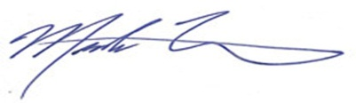
Mark P. Trinchero
Attorneys for T-Mobile West LLC
MPT/jan
Enclosures

