January 23, 2014
Dear resident,
We are pleased to announce that as of March 1, 2014, Republic Services, our trusted recycling partner, regulated under the Washington Utilities and Transportation Commission, will also begin providing trash collection service in the City of White Salmon. Under the new arrangement, residents will see lower rates and enhanced services. The decision represents a cost savings to the City, which will enable us to reallocate funding for other priorities.
Over the years, Republic Services has demonstrated that they are an experienced, dependable environmental partner. They are one of the largest providers of jobs in Klickitat County and have an excellent safety record with outstanding levels of customer service and local community engagement. We anticipate that our expanded partnership with Republic Services will be a substantial benefit to the residents of White Salmon now and in the years ahead.
For the immediate future, residents should continue to put their carts at the curb on their regularly scheduled collection day. The residents and businesses of White Salmon will begin receiving monthly invoices from Republic Services sometime after the rollout on March 1, 2014.
The City's expanded partnership with Republic Services represents significant long-term benefits to our community, our economy and our environment.
If you have questions, please refer to the new White Salmon - Republic Services website at www.RepublicServicesNW.com or call (509) 773-5825. You may also send us an email at whitesalmon@republicservices.com.
Thank you,
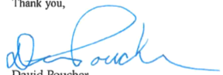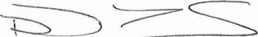

David Poucher | Don Tibbets
Mayor, City of White Salmon General Manager, Republic Services

PO Box 2139
142 E. Jewett Blvd.
White Salmon, WA 98672
Office: (509) 493-1133
Fax: (509) 493-1231
Web Site: white-salmon.net

