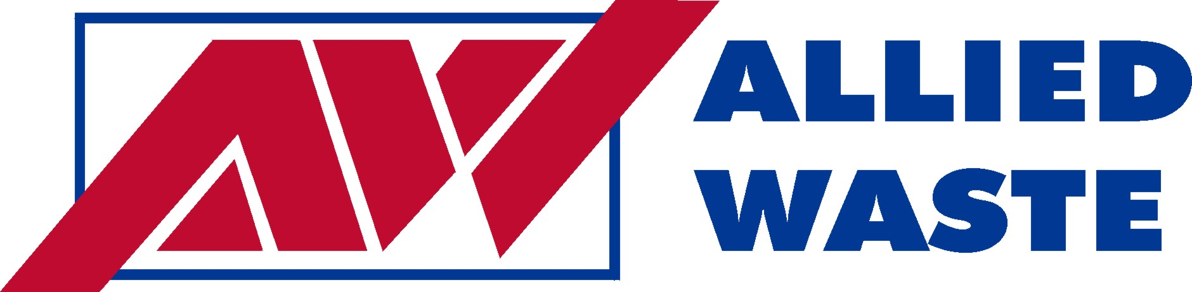
of Bellevue
1600 –127th Avenue NE
Bellevue, WA 98005 June 1, 2008

Dear Residential Customer,

This is to notify you of a proposed rate change for residential customers in the Allied Waste of Bellevue areas of King County. Should the Washington Utilities and Transportation Commission (Commission) approve our request customers will experience an overall rate increase throughout all classes of service.

The proposed rate increase is needed because the Company has incurred increased costs, primarily labor and fuel costs. If approved, the proposed rates will become effective July 1, 2008.

Monthly Monthly
Residential Service Pickup Frequency Current Rate Proposed Rate

1 Mini Can weekly 6.04 6.30
1 Can weekly 9.64 10.20
2 Cans weekly 16.52 17.50
3 Cans weekly 23.71 24.75
4 Cans weekly 31.94 33.50

The proposed rate increases for our residential services range from 0% to 27.8% and not all residential services are listed above.

If you have questions about the proposed rate increase you may contact the company at (206)-682-9730.

The commission has the authority to set final rates that may vary from the company’s request, depending on the results of its investigation. To comment on this filing, be added to the commission’s mailing list, or ask questions about the ratemaking process, please use the contact information below. You may also comment in person at the commission’s open meeting at 1300 S. Evergreen Park Dr. SW in Olympia at 9:30 a.m. on June 12, 2008, or by using the “Public Comment” feature at the commission’s web site, at http://www.utc.wa.gov/comment. The commission is scheduled to make a decision at its open meeting on June 26.

If you are unable to attend the open meeting in person, you can participate or listen by telephone. Call 360-664-1234 for instructions the day before the open meeting.

You may also comment by using the “Public Comment” feature at the commission’s web site, at http://www.utc.wa.gov or you may continue to provide your comments in the following manner:

Mail: Post Office Box 47250, Olympia, WA 98504-7250
E-mail: comments@utc.wa.gov
Telephone: 1-800-562-6150

We look forward to continued service to you.

Allied Waste of Bellevue

