 |  |  |  |  |  |  | Commission Docket No. |  |  |  |  |  |  |  | UT-060810
 |  |  |  |  |  |  | Agenda Date Assigned
BEFORE THE WASHINGTON UTILITIES AND TRANSPORTATION COMMISSION

LESS THAN REQUIRED NOTICE REQUESTED BY:

Verizon Northwest Inc. 313-013-420
(Utility Name) |  |  |  |  |  |  |  |  |  |  |  |  | (Utility UBI Number)
Utility proposes |  | Amendment No. 1 to the Service Agreement for Emergency Alerting and Conferencing Services |  |  |  |  |  |  |  |  |  |  | Number: |  | Contract No. 1401ICB
(Contract Title)
Indicate below, or attach, an explanation of the reason the company requests permission to file the proposed provisions with less than required notice.

Verizon Northwest respectfully requests this ICB contract become effective August 21, 2009. The customer’s current Agreement expires on August 20, 2009. The customer did not execute Amendment No. 1 timely which precluded the company filing it to be made effective in the normal statutory notice period of 30 days. If no effective contract is in place when the current agreement expires, the Company must disconnect service as it is not available under tariff. The Amendment 1) extends the term for sixty one days, 2) adds new language on limitation of liability and 3) deletes the section in the existing agreement related to maintenance of the service because equipment used to provide the service is manufacturer discontinued.

Timothy J. McCallion-President, West Region, Public Affairs, Policy and Communications |  |  | is authorized to make filings on behalf of |  |  |  |  |  |  |  |  |  |  | Verizon Northwest Inc.
Signature and Title of Company Officer
I request these provisions become effective on |  |  |  | August 21, 2009
 |  |  |  |  |  |  |  |  | (Date)
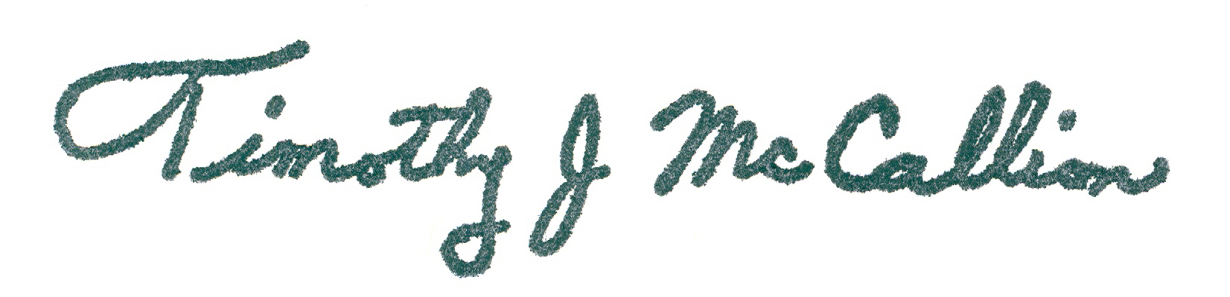 |  |  |  |  |  |  |  |  | President-West, Public Affairs, Policy and Communications
(Signature of Authorized Agent) |  |  |  |  |  |  |  |  | (Title)
Timothy J. McCallion
(Print Name)
( 805) 372-7160 |  |  |  |  | (805 ) 373-1471 |  |  |  |  |  |  | Tim.mccallion@verizon.com
(Telephone Number) |  |  |  |  | (Fax Number) |  |  |  |  |  |  | (E-Mail Address)
1800 41st St. MC: WA0105RA |  |  |  |  | Everett |  |  |  |  |  |  | WA |  |  |  | 98201
(Mailing Address) |  |  |  |  | (City) |  |  |  |  |  |  | (State) |  |  |  | (Zip Code)
WASHINGTON UTILITIES AND TRANSPORTATION COMMISSION

O R D E R
The Commissioners, having determined this order is consistent with the public interest, directed the Secretary to enter this order granting the provisions requested above.
DATED and signed at Olympia, Washington, this |  |  |  |  |  |  |  | Day of
 |  |  |  |  |  |  |  |  | (Month and Year)
 |  |  |  |  |  |  |  |  | Secretary
Util LRN Form 05/16/05

