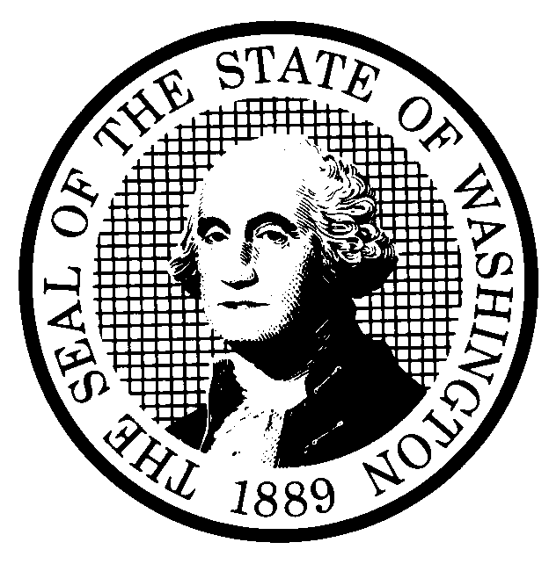 | EXPEDITED RULE MAKING  (Chapter 25, Laws of 2001) |  |  |  |  |  |  |  | CR-105 (7/22/01)  EXPEDITED RULE MAKING ONLY
Agency: Washington Utilities and Transportation Commission
(a) Title of rule: (Describe Subject): This rulemaking would revise adoption-by-reference dates in Title 480 of the Washington Administrative Code (WAC) and create a new section 480-110-999, Adoption by Reference.

Purpose: The rulemaking would revise adoption-by-reference dates in Title 480 of the WAC to incorporate the most recent versions of adopted federal rules and other adopted publications; substitute an existing national standard for railroad passenger-carrying vehicle first-aid kit requirements to replace the Commission’s adopted Washington State Labor and Industries’ rules that were repealed in 2001; create a new section in
Chapter 480-110 WAC so each chapter in Title 480 will have a common location for adoption-by-reference rules; and correct grammatical and punctuation errors.

Other identifying information: Commission Docket No. A-020379. Affected chapters of the WAC include: 480-14; 480-15; 480-30;
480-31; 480-40; 480-62; 480-70; 480-90, 480-100; and 480-110. Please refer to attachment A for a list of the specific rules affected
and the proposed changes.

(b) Statutory authority for adoption: RCW 80.01.040, RCW 80.04.160,  RCW 81.04.160 and RCW 34.05.353 |  |  |  |  |  |  |  | Statute being implemented:
(c) Summary: This proposal would revises the adoption-by-reference dates to reflect the current version of adopted material and makes other minor administrative changes in Title 480 WAC. Adopted material in the telecommunications and pipeline safety chapters of rules is not reflected in this rulemaking as those chapters are open under other docket numbers.

Reasons supporting proposal: The Commission adopts by reference several parts in Title 18, Title 40, and Title 49 of the Code of Federal Regulations and other state rules and national standards. Commission rules need to reflect the most current versions of the adopted material.

(d) Name of Agency Personnel Responsible for: |  |  |  |  | Office Location |  |  |  |  | Telephone
1. Drafting............... Kim Dobyns, Regulatory Analyst |  |  |  |  | 1300 S. Evergreen Park Drive SW, Olympia, WA 98504-7250 |  |  |  |  | (360) 664-1242
2. Implementation.... Carole J. Washburn, Secretary |  |  |  |  | 1300 S. Evergreen Park Drive SW, Olympia, WA 98504-7250 |  |  |  |  | (360) 664-1174
3. Enforcement.......... Carole J Washburn, Secretary |  |  |  |  | 1300 S. Evergreen Park Drive SW, Olympia, WA 98504-7250 |  |  |  |  | (360) 664-1174
(e) Name of proponent (person or organization):  Washington Utilities and Transportation Commission |  |  |  |  |  |  |  |  |  | Private  Public  X Governmental
(f) Agency comments or recommendations, if any, as to statutory language, implementation, enforcement and fiscal matters:
None

(g) Is rule necessary because of  Federal Law?  Federal Court Decision?  State Court Decision? |  | Yes  Yes  Yes |  | X No  X No  X No |  | If yes, ATTACH COPY OF TEXT  Citation:
NOTICE
THIS RULE IS BEING PROPOSED UNDER AN EXPEDITED RULE-MAKING PROCESS THAT WILL ELIMINATE THE NEED FOR THE AGENCY TO HOLD PUBLIC HEARINGS, PREPARE A SMALL BUSINESS ECONOMIC IMPACT STATEMENT, OR PROVIDE RESPONSES TO THE CRITERIA FOR A SIGNIFICANT LEGISLATIVE RULE. IF YOU OBJECT TO THIS USE OF THE EXPEDITED RULE-MAKING PROCESS, YOU MUST EXPRESS YOUR OBJECTIONS IN WRITING AND THEY MUST BE SENT TO
Name: Secretary, Docket No. A-020379
Agency: Washington Utilities and Transportation Commission
Address: P.O. Box 47250, Olympia, WA 98504-7250

AND RECEIVED BY: August 5, 2002 |  |  |  |  |  |  | CODE REVISER USE ONLY
NAME (TYPE OR PRINT)

CAROLE J. WASHBURN
SIGNATURE

TITLE  SECRETARY |  |  | DATE  June 5, 2002
(COMPLETE REVERSE SIDE)
(j) Short explanation of rule, its purpose, and anticipated effects:
The proposal would change adoption-by-reference dates to reflect current published versions of adopted material and make other minor administrative changes such as:

Create a new adoption-by-reference section in Chapter 480-110 (Water Companies), WAC 480-110-999, so each chapter in Title 480 will have a common location for the adoption-by-reference rules and add cross references to the newly created rule;

Correct grammatical and punctuation errors; and,

Add language to WAC 480-90-203 (Accounting System Requirements) and WAC 480-100-203 (Accounting System Requirements) that clarifies that adopting the most current version of Title 18 of the Code of Federal Regulations does not supercede prior Commission orders directing companies to treat accounting items, such as depreciation accounting, in a specific manner.

The proposal would also substitute an existing national standard (ANSI Z308.1) for railroad passenger-carrying vehicle first-aid kit requirements to replace the Commission’s adoption-by-reference of Washington State Labor and Industries’ rules
(Chapter 296-24 WAC) that were repealed in 2001.

Does proposal change existing rules? | X YES NO | If yes, describe changes:
New federal rules and national standards are incorporated into the Commission’s rules. Other administrative changes and clarifying language is added. See a detailed listing of the proposed rule changes on attachment A.

