Puget Sound Energy
2019 GRC Workpapers
AURORA Modeling Information

General information:

PSE used AURORA version 13.1.1001 for all AURORA model runs. Use of other versions may yield slightly different results

The AUROA zonal database US_Canada Data Package 2019_v1.xdb provides the baseline input assumptions for all resources, loads, and interconnections in the WECC region.
With an AURORA license, the original database is available for download at: https://epis.com/customer_support/database_updates.php
Two versions of the database with minor changes to support PSE’s use of the AURORA model are provided as workpapers in this filing and described further below.

PSE utilized two separate AURORA model runs in the calculation of rate year AURORA power costs for this filing. The first model, “AURORA WECC prices model”, calculates a market energy price for the Oregon-Washington-Idaho Zone (a proxy for the Mid C market hub) for each hour of the rate year. The prices output is then used as input in the second model, “AURORA PSE Two Zone model.” This model calculates rate year AURORA power costs given the hourly market energy price and rate year load and resource assumptions.

AURORA files utilized in the calculation of proposed rate year power costs:

PKW WP (C) AURORA WECC prices project file.apz
PKW WP (C) AURORA WECC prices US_Canada_DB_2019_v1.xdb
PKW WP (C) AURORA WECC prices model inputs.csf

PKW WP (C) AURORA Two Zone project file.apz
PKW WP (C) AURORA Two Zone US_Canada_DB_2019_v1.xdb
PKW WP (C) AURORA Two Zone model inputs.csf

AURORA model setup and run procedures
First, copy the six AURORA files listed above and save them to a location on your computer’s hard drive.

Run the AURORA WECC prices model
Load input files
Open the file PKW WP (C) AURORA WECC prices project file.apz. Navigate to the Input Tables by selecting the “Input” button in the menu ribbon at the top of the screen. From the Input Tables tab select the “Change Database” button that will now be available in the menu ribbon. The navigation pane shown below will open.

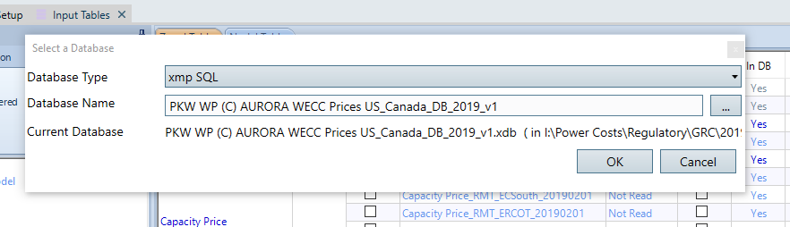

Select the button with “…” on it and then browse to the location on your computer where the AURORA files are saved. Select the input database file PKW WP (C) AURORA WECC Prices US_Canada_DB_2019_v1 and click OK. AURORA will then load the selected database (it may take a couple minutes).

When the database has finished loading return to the Input Tables tab and click the “File” tab located in the Change Set Window on the left of the screen (shown below).

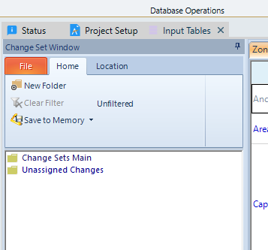

Select “Open Change Set File” and then browse again to the location on your computer where the AURORA files are saved. Select the change set file PKW WP (C) AURORA WECC prices model inputs.csf and click “Open”. AURORA will now load the change set file (again, this may take a few minutes).

After the change set file has finished loading there will be two change sets available in the “Change Sets Main” folder in the Change Set Window, “2019 GRC WECC prices model” and “80 yr average hydro”. You can now continue below to the “Model run settings” section of this document.
Alternatively, you can now view all of PSE’s changes to the default AURORA database by activating the change set “2019 GRC WECC prices model” (right click and click “Activate”). When the change set is activated, AURORA will modify the database with PSE’s rate year load and resource assumptions. Each of the database tables that has been modified will be listed in the Change Sets Window in green font as shown below.
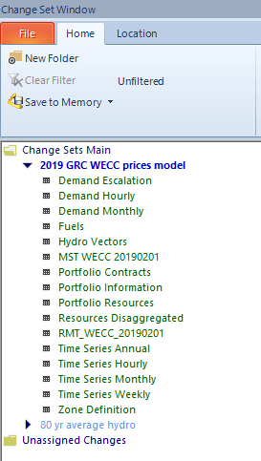

You can view all changes made to a particular table alongside the original default database values by right-clicking the table name and selecting “View/Edit Table Differences”. The screen shot below provides an example of the window that will then open.

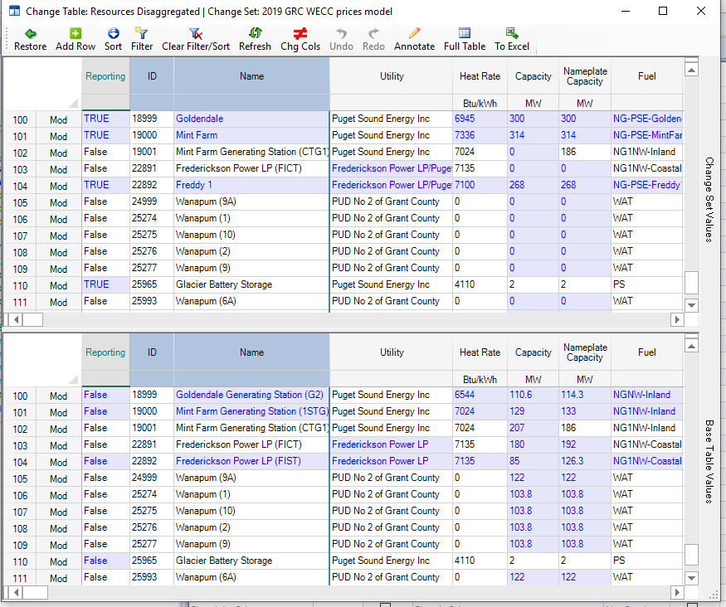

Specify model run settings
After loading the input database file and the change set file as described above open the “Project Setup” screen by clicking that button in the menu ribbon at the top of the screen. Now, in the Study Period window select the Start Date of May 2020 and End Date of April 2021 (the rate year) as shown below. Verify that the dispatch is set for Every Hour of Every Day of Every Week.

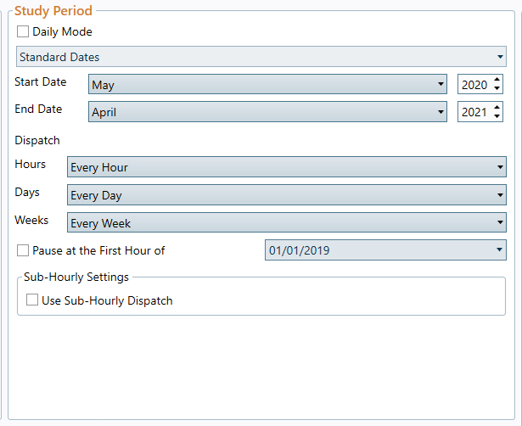

Now, In the Study Cases window, select “Run Using Study Case List”. If there are existing Available Study Cases listed in the box below, select each one and click “Delete Case” until it looks like below.

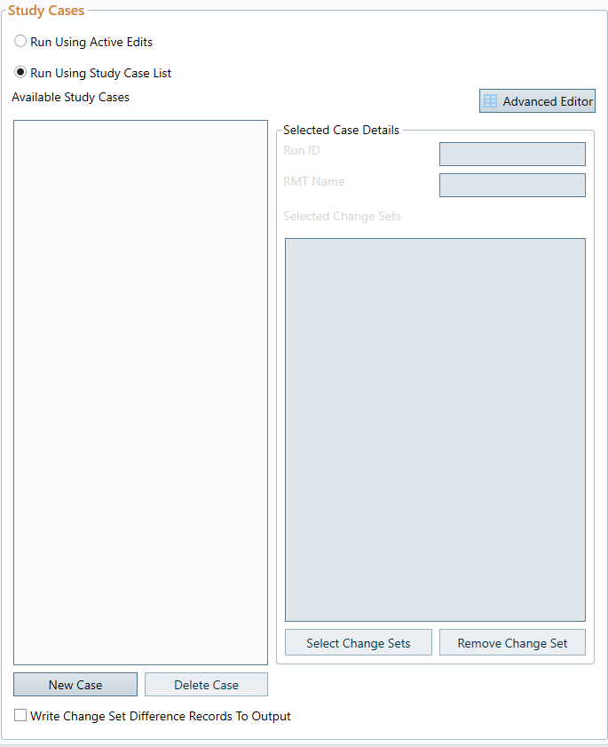

Then click “New Case”, type “WECC prices run” (or whatever you want to call it) in the Run ID input box, click “Select Change Sets”, select the two available change sets from the pop up window, and click OK. The window should now look like that shown in the screen shot below.
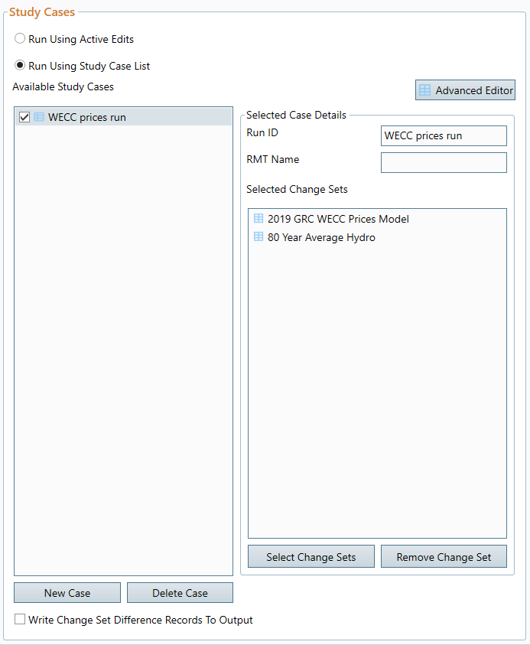

Now, in the Output window (still on the same Project Setup screen), enter the name you would like to use for the output database file and select the location you want it to be saved (typically the same location as the AURORA files we started with) by clicking the “Browse” button.
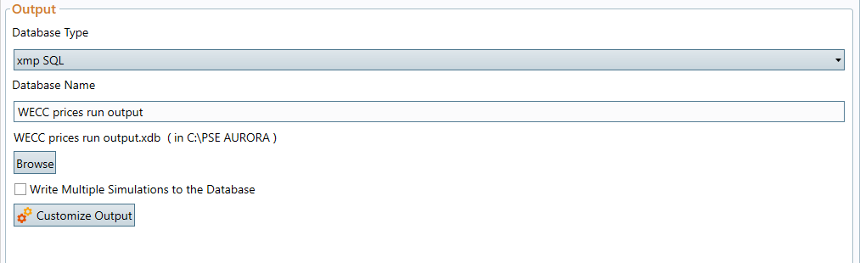

Finally, in the Active Study Type window, verify that the option “Standard Zonal” is selected. Then click the Customize Study Options button.

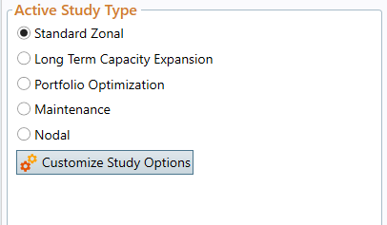

The Simulation Options tab will now be open and the menu shown below will be available on the left of the screen.

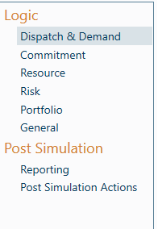

The following screen shots illustrate the settings used for each of the menu options (most are AURORA default options and will not require any changes):

Dispatch and Demand (all defaults):
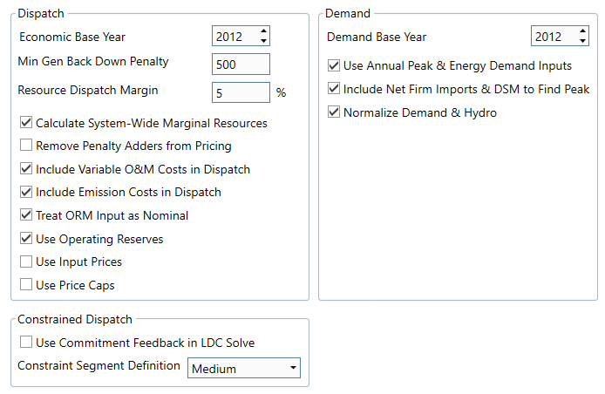
Commitment (all defaults):
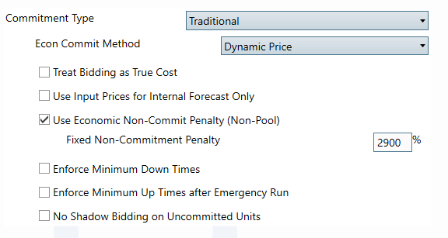

Resource (“Use Ramp Rates” is not a default selection. PSE uses them here for consistency with the Two Zone model run described below which depends on ramp rates for an accurate calculation of a resource’s ability to provide balancing and contingency reserves):
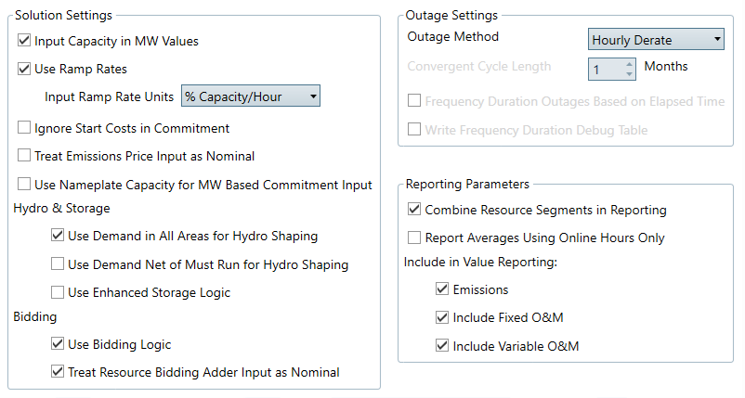
Risk (all defaults):
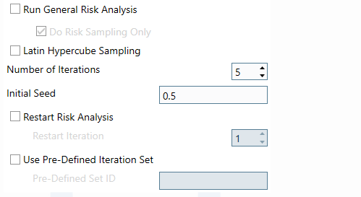

Portfolio (inputs don’t matter for this model run as we are not calculating portfolio costs, just market prices, but the below is what is used in the Two Zone model run):
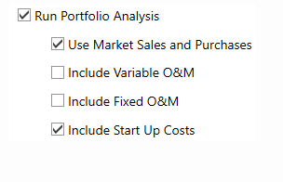
General (all defaults):
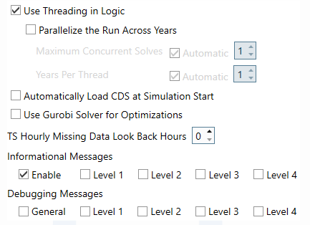

Reporting: For the WECC prices model run we only need price output. Additional data can be reported, but it will increase model run-times. The “Selected” output is just output for the Oregon-Washington-Idaho Zone (which serves as a proxy for the Mid C market hub).

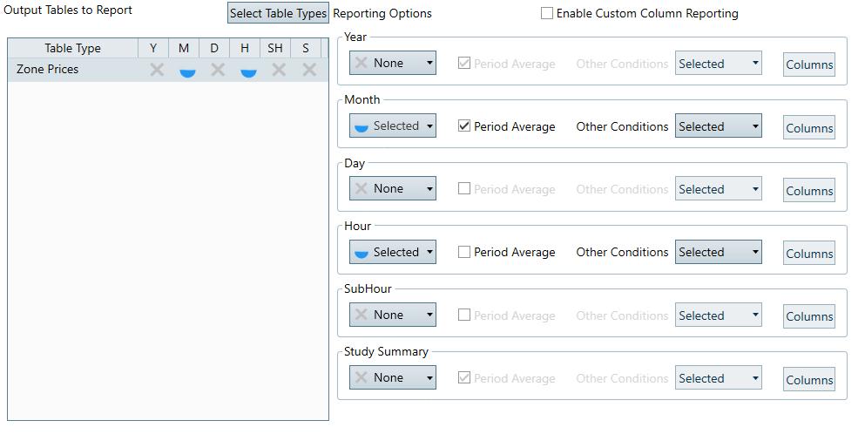

Now click the save icon at the top of the screen, close any open tabs, return to the Project Setup screen, and click “Run”.

View and process output
When the model run is complete click the “Output” button in the menu ribbon at the top of the screen. The table below should now be visible.

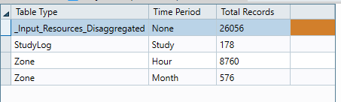
Double click in the row containing Zone and Month to view the ZoneMonth output table. The monthly on-peak, off-peak, and average prices in the “Price” column are now copied and pasted into the workpaper PKW WP (C) AURORA outputs.xlsx in column C of the “Market Price Results” tab.

Double click in the row containing Zone and Hour to view the ZoneHour output table. The hourly prices in the “Price” column are now copied and pasted into the the workpaper PKW WP (C) AURORA outputs.xlsx in column F of the “Market Price Results” tab. These are not used for subsequent calculations within the workpaper, but will be used as inputs in the AURORA PSE Two Zone Model described below.

Run the AURORA PSE Two Zone Model
Load input files
Open the file PKW WP (C) AURORA Two Zone project file.apz. Follow the same procedures described above for the WECC Prices Model to load the input database and change set files. This time use the input database PKW WP (C) AURORA Two Zone US_Canada_DB_2019_v1.xdb and the change set file PKW WP (C) AURORA Two Zone model inputs.csf.

Specify model run settings
Again, follow the same procedures described above for the WECC Prices Model but with the Two Zone change set file that is now loaded. There are, however, some changes and an additional step described below.

In the “Dispatch & Demand” run settings under Simulation Options the Use Operating Reserves box must be un-checked as shown below. We are not using AURORA’s generic zone-wide operating reserves for this run but calculating the costs of meeting PSE’s specific balancing and contingency reserve requirements (via the “Ancillary Services table”).

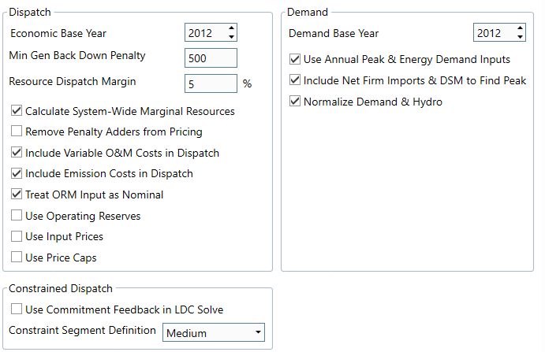

In the “Commitment” run settings under Simulation Options the Commitment Type “Commitment Optimization” must be selected as shown below.
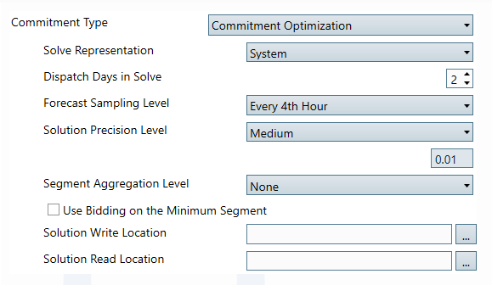

In the “Reporting” run settings under Simulation Options the specified output tables should look as shown below. We need additional output from this run in order to view and record PSE’s portfolio cost and energy included in rate year AURORA power costs.

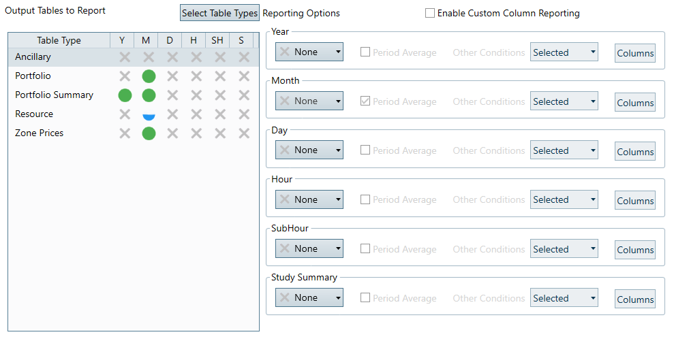

In order to run the PSE Two Zone Model prices from the WECC Prices Model must be included as an input. These are added by going to the Input Tables screen and double-clicking on the table name Time Series Generic.
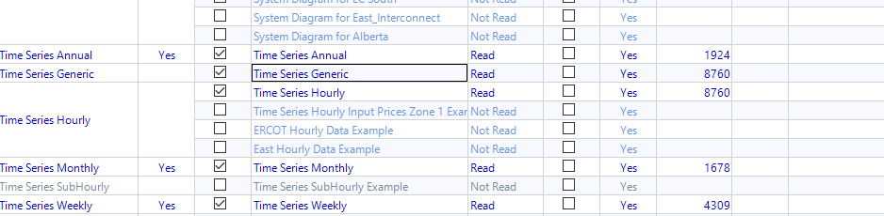

The 8760 hourly price outputs from the WECC Prices Model are now copied and pasted into the column labeled “Hrly_Mkt_price”

Finally, return to the Input Tables screen and select the Ancillary Services Table for use in the study.

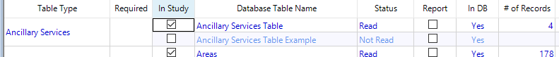

The model can be run without this selection in order to calculate PSE’s AURORA power costs without balancing and contingency reserves requirements.

Now click the save icon at the top of the screen, close any open tabs, return to the Project Setup screen, and click “Run”.

View and process output
When the model run is complete click the “Output” button in the menu ribbon at the top of the screen. The table below should now be visible.

Double click in the row containing Portfolio and Month to view the PortfolioMonth output table. The values in the columns “Energy” and “Cost” are now copied and pasted into the workpaper PKW WP (C) AURORA outputs.xlsx in columns E and F of the “Monthly portfolio results” tab. Logic within that workpaper will tranform and format the data for use in subsequent power cost calculations.

End

Note that the other change set, “80 yr average hydro”, contains only modifications to monthly hydro volume assumptions. It was added as a separate change set to accommodate variable inputs as needed, but currently only contains the 80-yr average hydro volumes assumed for calculation of rate year power costs.
This only needs to be done the first time the model is set up after changing the location of the AURORA files. If the files have not changed location since the prior run (and you are using the same change set files), then the existing study case can be used and there is no need to delete anything or create a new case.

