WN U-74 |  |  |  | Twenty-Eighth Revision of Sheet No. B
 | Canceling Twenty-Seventh Revision of Sheet No. B
PACIFIC POWER & LIGHT COMPANY
 |  |  |  |  |  |  |  |  |  |  |  | FOR COMMISSION’S RECEIPT STAMP
TARIFF INDEX

Sheet
Number

Title Page A.1
Tariff Index B-Ba
Table of Contents - General Rules and Regulations B.1-B.2
General Rules and Regulations C.1-V.1
Schedule 15* Outdoor Area Lighting Service 15.1-15.2
Schedule 16 Residential Service 16.1
Schedule 17 Low Income Bill Assistance Pilot Program - 17.1-17.2
Residential Service – Optional for Qualifying
Customers
Schedule 18 Three Phase Residential Service Rider 18.1-18.2
Schedule 24 Small General Service 24.1-24.3
Schedule 33 Partial Requirements Service - Less Than 33.1-33.2
1,000 KW
Schedule 36 Large General Service - Less Than 1,000 KW 36.1-36.3
Schedule 37 Avoided Cost Purchases from Cogeneration and 37.1-37.2
Small Power Purchases
Schedule 40 Agricultural Pumping Service 40.1-40.3
Schedule 47T Large General Service - Partial Requirements 47T.1-47T.3
Service - Metered Time of Use, 1000 KW and Over
Schedule 48T Large General Service - Metered Time of Use, 48T.1-48T.3
1,000 KW and Over
Schedule 51 High Pressure Sodium Vapor Street Lighting 51.1-51.2
Service
Schedule 52 Street Lighting Service - Company Owned System 52.1
Schedule 53 Street Lighting Service - Customer Owner System 53.1
Schedule 54 Recreational Field Lighting - Restricted 54.1-54.2
Schedule 57* Mercury Vapor Street Lighting Service 57.1-57.3
and Conservation Act
Schedule 70 Renewable Energy Rider - Optional 70.1-70.3
Schedule 71 Energy Exchange Pilot Program 71.1-71.5

(D)
(C)

Schedule 73 Renewable Energy Rider - 73.1-73.4
Optional Bulk Purchase Option
Schedule 91 Surcharge to Fund Low Income Bill Assistance 91.1
Program
Schedule 96 Deferral Amortization Surcharge 96.1
Schedule 98 Adjustment Associated with the Pacific Northwest 98.1
Electric Power Planning and Conservation Act
Schedule 101 Tax Adjustment Schedule 101.1-101.2
Schedule 102 Franchise Fee Adjustment Schedule 102.1
Schedule 107 Residential Refrigerator Recycling Program 107.1-107.2
Residential Service Option for Qualifying
Customers

NOTE: *No New Service
(Continued)
Issued |  |  |  |  |  | February 9, 2009 |  | Effective |  |  | March 11, 2009
Issued by |  |  |  |  | PACIFIC POWER & LIGHT COMPANY
By |  |  | 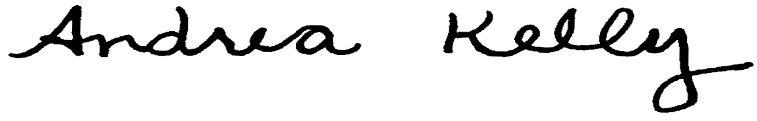  Andrea L. Kelly |  |  |  |  |  | Title | Vice President, Regulation
 |  |  | TF2 INDEX-B.REV |  |  |  | Advice No. |  |  |  |  |  | UE-
Form F

