 Verizon Northwest Inc.

1800 – 41st Street, WA0105RA
P. O. Box 1003
Everett, WA 98206-1003
Fax: 425-261-5262

August 3, 2006

Advice No. 3201

Ms. Carole J. Washburn, Executive Secretary
Washington Utilities and Transportation Commission
1300 S. Evergreen Park Drive, S. W.
Olympia, Washington 98504-7250

Dear Ms. Washburn:

Verizon Northwest Inc. filed Advice No. 3201 on July 25, 2006, a tariff filing in the Verizon Northwest Inc. General and Local Exchange Tariff, WN U-17 in compliance with Condition 2 in the Commission’s Order No. 7 in Docket No. UT-050814 dated December 23, 2005. This filing is currently pending approval with a requested effective date of August 24, 2006 under the same docket number. Please do not re-docket. Please find attached a slip sheet to this tariff filing to amend the revision number in Section 8 for Sheet 23, from 4th Revised to 5th Revised. Sheet No. 23, 4th Revised is currently pending approval in Docket No. UT-060812 with a requested effective date of August 17, 2006. Please replace the previously filed Sheet 23 under Advice No. 3201 with the attached slip sheet and contact Kathy Folsom upon receipt.

Please contact Lin Fogg at (425) 261-6380 with questions.

Very truly yours,
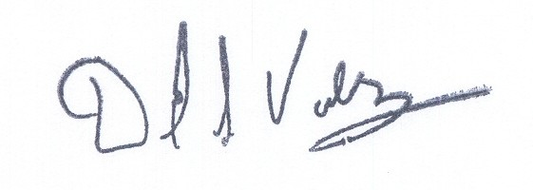

David S. Valdez
Senior Vice President - West
Public Affairs, Policy and Communications

DSV:LF:lf
Attachments
(WAIGLU-17-0245)

c: Service List

Ms. Carole J. Washburn
August 3, 2006
Advice No. 3201

Attachment A

General and Local Exchange Tariff, WN U-17

Section 8
5th Revised Sheet 23 (Slip sheet)

