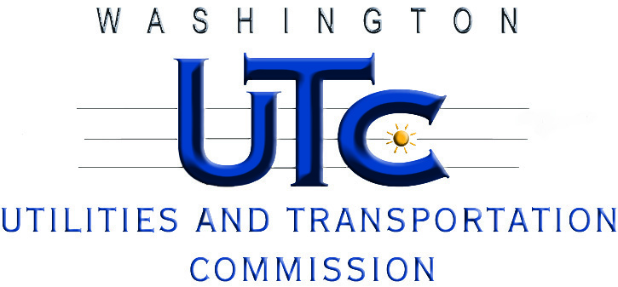

Fuel Surcharge Inquiry Workshop

Docket T-101661

AGENDA

December 7, 2010

9:00 a.m. - 9:15 a.m. Introductions

9:15 a.m. - 9:30 a.m. Background and History of Fuel Surcharges

9:30 a.m. - 11:00 a.m. General Discussion (all industries present)
(General discussion may go to noon if industry attendees do not require separate breakout session)

11:00 a.m. - Noon Commercial Ferry Breakout Session (Room 207)
(if required)

Noon - 1:00 p.m. Lunch (on your own)

1:00 p.m. - 2:00 p.m. Auto-Transportation Breakout Session (Room 207)
(if required)

2:00 p.m. - 3:00 p.m. Solid Waste Breakout Session (Room 207)
(if required)

