 | 
David S. Valdez
Vice President
Public Policy & External Affairs
WA0101RA
1800 41st Street
P.O. Box 1003
Everett, WA 98201
June 2, 2006 |  | WA0101RA  1800 41st Street  P.O. Box 1003  Everett, WA 98201
Ms. Carole Washburn, Executive Secretary
Washington Utilities and
Transportation Commission
1300 S. Evergreen Park Drive S.W.
Olympia, Washington 98504-7250

Dear Ms. Washburn:

Subject: Docket No. UT-050814

Pursuant to paragraph 171 of Order No. 7 in Docket No. UT-050814 ("Merger Order"), please take notice that on May 22, 2006, TTI National, Inc. (“TTI”), a subsidiary of MCI, LLC, filed tariffs to grandfather all of its services in the state of Washington. The grandfathering of these services will not affect existing customers (existing customers will be able to make changes to their service). These tariffs became effective on June 1, 2006.

Paragraph 171 of the Merger Order directs Verizon to provide a summary of its plans for conducting its merged operations in Washington. Verizon does not have, and likely will not have, overall plans for merged operations that can be summarized in a single document as of a particular date. But Verizon will provide filings such as this one to notify the Commission of plans of major changes impacting merged operations.

If you have any questions please call Robert Millar at (360) 236-9727.

Very truly yours,

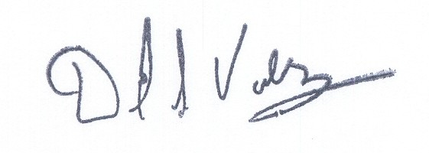

David S. Valdez

DSV:kad

c: Service List

