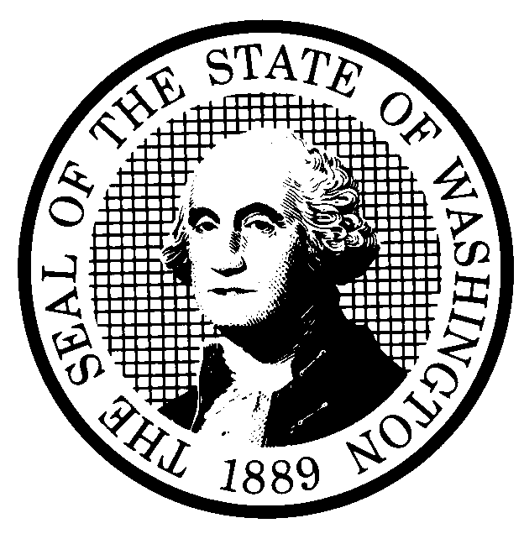 | PROPOSED RULE MAKING |  |  |  |  | CR-102 (June 2004)  (Implements RCW 34.05.320)  Do NOT use for expedited rule making
Agency: Washington Utilities and Transportation Commission
Preproposal Statement of Inquiry was filed as WSR as WSR #07-03-171; or  Expedited Rule Making--Proposed notice was filed as WSR ; or  Proposal is exempt under RCW 34.05.310(4). |  |  |  |  |  |  | Original Notice  Supplemental Notice to WSR  Continuance of WSR
Title of rule and other identifying information: Chapter 480-109 WAC: Electric Companies—Acquisition of Minimum Quantities of Conservation and Renewable Energy as Required by the Energy Independence Act (Chapter 19.285 RCW).

On November 7, 2006, Washington voters approved Initiative Measure No. I-937, now codified as RCW 19.285. This new chapter requires large utilities to acquire all cost-effective energy conservation beginning in 2010 and to serve a minimum portion of their electricity load with renewable resources beginning in 2012. The rules proposed here establish the procedures investor owned utilities must follow to demonstrate compliance with these statutory requirements (or with alternative compliance mechanisms). These regulations also establish penalty provisions, as well as reporting and public notification requirements. The rulemaking is assigned Docket UE-061895
Hearing location(s):  Commission Hearing Room 206  Second Floor, Richard Hemstad Building  1300 S. Evergreen Park Drive SW  Olympia, WA 98504-7250 |  |  |  | Submit written comments to:  Name: Washington Utilities and Transportation Commission  Address: 1300 S. Evergreen Park Drive S.W.  PO Box 47250  Olympia, WA 98504-7250  e-mail records@utc.wa.gov. Please, include: “Docket  UE-061895” in your comments.  fax (360) 586-1150 by (date) September 21, 2007
Date: October 24, 2007 Time: 1:30 PM |  |  |  | Assistance for persons with disabilities: Contact  Mary De Young by October 22, 2007  TTY (360) 586-8203 or (360) 664-1133
Date of intended adoption: October 24, 2007
(Note: This is NOT the effective date)
Purpose of the proposal and its anticipated effects, including any changes in existing rules:
The Energy Independence Act provides that the UTC “may adopt rules to ensure the proper implementation and enforcement of this chapter as it applies to investor-owned utilities.” (RCW 19.285.080) The Commission initiated an inquiry to determine whether new regulations were needed to ensure that the new renewable resource and conservation requirements were properly implemented and enforced and whether new rules would further the objectives of the Act: promote energy independence in the state and the Pacific Northwest region; stabilize electricity prices for Washington residents; provide economic benefits for Washington counties and farmers; create high-quality jobs in Washington, provide opportunities for training apprentice workers in the renewable energy field, protect clean air and water, and position Washington state as a national leader in clean energy technologies.

The UTC’s preproposal inquiry revealed that new rules would be beneficial and in the public interest because they would facilitate implementation of the Act. The proposed rules clarify the dates by which the utilities must acquire the requisite renewable resources as well as the content of reports needed to demonstrate compliance. The proposed regulations also provide guidance on how utilities may implement the conservation mandate.

Reasons supporting proposal: See above.
Statutory authority for adoption: RCW 80.01.040, RCW 80.04.160, and Chapter 19.285 RCW |  |  |  | Statute being implemented: Chapter 19.285 RCW
Is rule necessary because of a:  Federal Law?  Federal Court Decision?  State Court Decision?  If yes, CITATION: |  | Yes  Yes  Yes | No  No  No |  | Filed with the Code Reviser’s Office  August 21, 2007, 1:13 p.m.  WSR 07-17-154
DATE
August 21, 2007
NAME (type or print)
Carole J. Washburn
SIGNATURE

TITLE
Executive Secretary
(COMPLETE REVERSE SIDE)
Agency comments or recommendations, if any, as to statutory language, implementation, enforcement, and fiscal matters:

None.

Name of proponent: (person or organization) Washington Utilities and Transportation Commission |  |  | Private  Public  Governmental
Name of agency personnel responsible for:
 | Name | Office Location | Phone
Drafting............... Nicolas Garcia |  | 1300 S. Evergreen Pk Drive SW, Olympia, WA 98504 | (360) 664-1346
Implementation.... Carole J. Washburn |  | 1300 S. Evergreen Pk Drive SW, Olympia, WA 98504 | (360) 664-1174
Enforcement........Carole J. Washburn |  | 1300 S. Evergreen Pk Drive SW, Olympia, WA 98504 | (360) 664-1174
Has a small business economic impact statement been prepared under chapter 19.85 RCW?
Yes. Attach copy of small business economic impact statement.

A copy of the statement may be obtained by contacting:
Name:
Address:

phone ( )
fax ( )
e-mail
No. Explain why no statement was prepared.

The proposed rules require investor-owned utilities, none of which qualify as a small business, to acquire certain minimum amounts of renewable resources and all cost-effective, reliable and available conservation. Because the proposed rules will not increase costs to small businesses, an SBEIS is not required under RCW 19.85.030 (1).
Is a cost-benefit analysis required under RCW 34.05.328?

Yes A preliminary cost-benefit analysis may be obtained by contacting:
Name:
Address:

phone ( )
fax ( )
e-mail

No: Please explain:

The Commission is not an agency to which RCW 34.05.328 applies. The proposed rules are not significant legislative rules of the sort referenced in RCW 34.05.328 (5).

