WN U-74 |  |  | First Revision of Sheet No. 96.1
 |  |  | Canceling Original Sheet No. 96.1
PACIFIC POWER & LIGHT COMPANY
FOR COMMISSION’S RECEIPT STAMP

(C)

(C)

(C)

SCHEDULE 96
DEFERRAL AMORTIZATION SURCHARGE

PURPOSE:
The Deferral Amortization Surcharge recovers Hydro costs incurred by the Company associated with hydro conditions that occurred in 2005 and the Company’s Chehalis plant acquisition.

APPLICABLE:
All bills calculated in accordance with schedules contained in presently effective Tariff WN. No. U-74 shall have added an amount equal to the product of all kilowatt-hours of use multiplied by the following cents per kilowatt-hour.

Schedule 15 0.106 cents

Schedule 16 0.055 cents

Schedule 17 0.055 cents

Schedule 18 0.055 cents

Schedule 24 0.055 cents

Schedule 33 0.046 cents

Schedule 36 0.046 cents

Schedule 40 0.051 cents

Schedule 47T 0.038 cents

Schedule 48T 0.038 cents

Schedule 51 0.151 cents

Schedule 52 0.110 cents

Schedule 53 0.052 cents

Schedule 54 0.067 cents

Schedule 57 0.091 cents

Issued |  |  |  |  | February 9, 2009 |  | Effective |  |  | March 11, 2009
Issued by |  |  |  | PACIFIC POWER & LIGHT COMPANY
By |  | 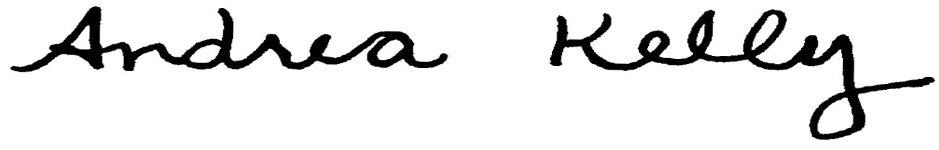  Andrea L. Kelly |  |  |  |  |  | Title | Vice President, Regulation
 |  | TF2 96.1REV |  |  |  | Advice No. |  |  |  |  |  | UE-
Form F

