 | 
David S. Valdez
Vice President
Public Policy & External Affairs
WA0101RA
1800 41st Street
P.O. Box 1003
Everett, WA 98201
March 17, 2006 |  | WA0101RA  1800 41st Street  P.O. Box 1003  Everett, WA 98201
Ms. Carole Washburn, Executive Secretary
Washington Utilities and
Transportation Commission
1300 S. Evergreen Park Drive S.W.
Olympia, Washington 98504-7250

Dear Ms. Washburn:

Subject: Docket No. UT-050814

Pursuant to paragraph 171 of Order No. 7 in Docket No. UT-050814 ("Merger Order"), please take notice that on February 13, 2006, MCI Communications Services (d/b/a “Verizon Business Services”) and MCI Metro Access Transmission Service (d/b/a “Verizon Access Transmission Services”) filed tariffs to grandfather the “Neighborhood” offerings in the Verizon Northwest Inc. ("Verizon") service territory. The grandfathering of Neighborhood service will not affect existing customers (existing customers will be able to make changes to their service). The grandfathering does not affect any customers in the Qwest ILEC service territory. These tariffs became effective on February 23, 2006.

Paragraph 171 of the Merger Order directs Verizon to provide a summary of its plans for conducting its merged operations in Washington. Verizon does not have, and likely will not have, overall plans for merged operations that can be summarized in a single document as of a particular date. But Verizon will provide filings such as this one to notify the Commission of plans of major changes impacting merged operations.

If you have any questions please call Robert Millar at (360) 236-9727.

Very truly yours,

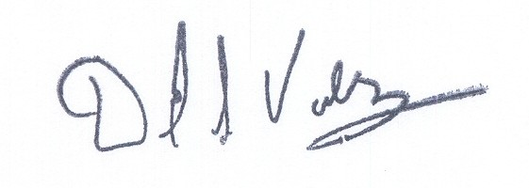

David S. Valdez

DSV:kad

c: Service List

