WN U-74 |  |  |  | Sixth Revision of Sheet No. 91
 |  |  |  | Canceling Fifth Revision of Sheet No. 91
PACIFIC POWER & LIGHT COMPANY
 |  |  |  |  |  |  |  |  |  |  | FOR COMMISSION’S RECEIPT STAMP
SCHEDULE 91
SURCHARGE TO FUND LOW INCOME BILL ASSISTANCE PROGRAM

All bills calculated in accordance with the schedules listed below shall have applied the following Surcharge.
(I)

(I)

(I)

(I)

(I)

(I)

(I)

(I)

(I)

(I)

(I)

(I)

(I)

(I)
Schedule 15 $0.09 per month

Schedule 16 $0.50 per month

Schedule 18 $0.50 per month

Schedule 24 $1.03 per month

Schedule 33 $25.10 per month

Schedule 36 $25.10 per month

Schedule 40 $10.35 per year*

Schedule 47T $171.00 per month

Schedule 48T $171.00 per month

Schedule 51 $1.43 per month

Schedule 52 $1.43 per month

Schedule 53 $1.43 per month

Schedule 54 $0.49 per month

Schedule 57 $1.43 per month

*To be included in the bill for the November billing period.

Issued |  |  |  |  | February 9, 2009 |  | Effective |  |  | March 11, 2009
Issued by |  |  | PACIFIC POWER & LIGHT COMPANY
By |  | 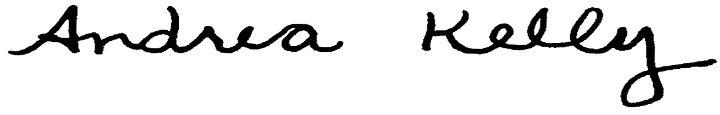  Andrea L. Kelly |  |  |  |  |  | Title | Vice President, Regulation
 |  | TF2 91LEG |  |  |  | Advice No. |  |  |  |  |  | UE-
Form F

