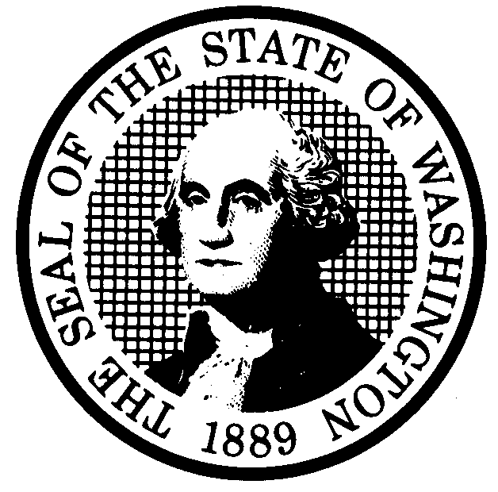  PROPOSED RULE MAKING  (RCW 34.05.320) |  |  | CR-102 (7/10/97)  Do NOT use for expedites adoption
Agency: WASHINGTON UTILITIES AND TRANSPORTATION COMMISSION |  |  | X Original Notice  □ Supplemental Notice  to WSR ___________  □ Continuance of WSR  __________________
Preproposal State of Inquiry was filed as WSR 97-22-082; or
□ Expedited Adoption--Proposed Rule Making notice was filed as
WSR____________________; or
□ Proposal is exempt under RCW 34.05.310(4).
(a) Title of rule: (Describe Subject) Motor Carriers of Household Goods.
Docket No. TV-971477
Purpose: To promote competition within the household goods industry and provide consumers with more choices by easing entry requirements, eliminating barriers to areas of operations, and providing rate flexibility. To strengthen consumer protection elements, and to review rules in accordance with Executive Order 97-02.
Other Identifying Information: Repeal all rules in Chapter 480-12 WAC, except WAC 480-12-100 and WAC 480-12-370, and establish a new chapter 480-15 WAC governing carriers of household goods.
(b) Statutory authority for adoption: RCW 80.01.040 and RCW 81.04.160 |  | Statute being implemented: None
(c) Summary: Federal preemption of most areas of transportation economic regulation has left household goods carriers, a group of approximately 250 regulated carriers, under the rules, policies, and procedures designed to regulate almost 4,000 carriers. Many of the current rules are ill-suited for the smaller group. In addition, chapter 480-12 WAC is scheduled for agency review in compliance with Executive Order 97-02. The proposed rules are drafted to apply only to the smaller transportation subset of household goods carriers. The proposed rules ease entry requirements, eliminate barriers to areas of operations, allow pricing flexibility, strengthen consumer protection elements, and clarify commission policy regarding the household goods definition.

Reasons supporting proposal: Changes are necessary to allow more carriers to provide household goods moving services and allow carriers to expand their operations. Changes are also necessary to protect consumers. It is expected these changes will promote competition within the industry, increase consumer choice, and provide stronger consumer protection elements.
(d) Name of Agency Personnel Responsible for: Office Location Telephone
1. Drafting............. Kim Dobyns, 1300 S. Evergreen Park Drive S.W., Olympia, WA 98504 360-664-1242
2. Implementation... Carole J. Washburn, Secretary, 1300 S. Evergreen Park Drive S.W., Olympia, WA 98504 360-664-1174
3. Enforcement...... Carole J. Washburn, Secretary, 1300 S. Evergreen Park Drive S.W., Olympia, WA 98504 360-664-1174
(e) Name of proponent (person or organization) □ Private
Washington Utilities and Transportation Commission □ Public
X Governmental
(f) Agency comments or recommendations, if any, as to statutory language, implementation,
enforcement, and fiscal matters: None
(g) Is rule necessary because of:
Federal Law? □ Yes X No If yes, ATTACH COPY OF TEXT
Federal Court Decision? □ Yes X No Citation:
State Court Decision? □ Yes X No
(h) HEARING LOCATION:  Commission Hearing Room  Second Floor, Chandler Plaza  1300 S. Evergreen Park Drive S.W.  Olympia, WA 98504-7250  Date: November 16, 1998 Time: 9:30 a.m.  Assistance for persons with disabilities: Contact  Pat Valentine by November 14, 1998  TDD (360) 586-8203 or (360) 664-1133 |  | Submit written comments to: Carole J. Washburn, Secretary, P.O. Box 47250, Olympia, WA 98504 or  E-mail to <records@wutc.wa.gov>. Please include Docket No. TV-971477 in your communication.  FAX (360)586-1150 By (date) October 14, 1998
DATE OF INTENDED ADOPTION:
NOVEMBER 16, 1998
CODE REVISER USE ONLY

FILED WITH THE CODE REVISER ON
SEPTEMBER 16, 1998 AT 10:31 A.M.
WSR #98-19-060

NAME (TYPE OR PRINT)
CAROLE J. WASHBURN
SIGNATURE

TITLE  SECRETARY | DATE

(COMPLETE REVERSE SIDE)

(j) Short explanation of rule, its purpose, and anticipated effects:

The proposal would make several changes to existing rules. It would ease entry requirements by changing the application process and interpreting the standards of public interest and public convenience and necessity to address the concerns of the consumer. The proposed rules allow carriers greater opportunities to operate in the state by eliminating rules which require carriers to obtain specific operating authority (local cartage and commercial zones) to provide services in specific cities and metropolitan areas of the state. These changes are necessary to allow more carriers to provide household goods moving services and allow carrier to expand their operations. It is expected these changes will increase competition and consumer choice.

Additionally, the proposed rules provide for pricing flexibility through the use of an interim rule which allows carriers to price their services within a range of the current tariff rates. This policy change is necessary to allow for service expansion in the industry and will also increase consumer choice where pricing is a determining factor.

The proposed rules strengthen consumer protection by capping the amount a carrier can charge a consumer above its estimate, providing carriers the option to issue binding estimates, clarifying credit options, reducing carrier complaint response time, and providing a more complete range of valuation options.

The proposed rules also clarify Commission policy and authority in the areas of compliance, complaint resolution and, what constitutes household goods.

Finally, the proposed rules are drafted in clear language, as directed by Executive Order 97-02.

Does proposal change existing rules? X YES □ NO If yes, describe changes:

It provides a new chapter of rules specifically for household goods carriers. The proposed rules provide a new process for new entrants to follow when seeking to enter the household goods industry and a new process for existing carriers wishing to change their operating areas.

It provides for a tariff band of rates and charges of 15% above and 35% below the existing tariff rates in effect on the effective date of the proposed rules. It puts a cap of 25% for local moves and 15% for long distance moves on the amount a carrier may charge a customer above its written estimate. It provides carriers with an option of offering customers a binding estimate.

It provides a revised set of consumer disclosure information. The proposed rules are written in language that is more clear and concise than the existing rules.

Finally, the proposed rules eliminate and/or revise unnecessary or burdensome requirements such as eliminating rules that applied to other transportation sectors and reducing certain record keeping requirements.

(k) Has a small business economic impact statement been prepared under chapter 19.85 RCW?

X Yes. Attach copy of small business economic impact statement.
A copy of the statement may be obtained by writing to:

Washington Utilities and Transportation Commission
Records Center, Docket No. TV-971477
P.O. Box 47250
Olympia, WA 98504-7250

telephoning: (360) 664-1234
faxing: (360) 586-1150

□ No. Explain why no statement was prepared.

(l) Does RCW 34.05.328 apply to this rule adoption? □ YES X NO
Please explain:

The Commission is not an agency to which RCW 34.005.328 applies and this rule is not a significant legislative rule as defined in this statute.

