WN U-74 |  |  | First Revision of Sheet No. 48T.3
 |  |  | Canceling Original Sheet No. 48T.3
PACIFIC POWER & LIGHT COMPANY
 |  |  |  |  |  |  |  |  |  |  | FOR COMMISSION’S RECEIPT STAMP
 | SCHEDULE 48T  LARGE GENERAL SERVICE - METERED TIME OF USE  1,000 KW AND OVER  ON-PEAK PERIOD BILLING DEMAND:  The On-Peak Billing Demand shall be the greater of:  (a) The measured On-Peak Period kW shown by or computed from the readings of Company's demand meter for the 15-minute period of greatest deliveries to Customer during the billing month, determined to the nearest kW, or  (b) 500 kW  TERM OF CONTRACT:  Company may require the Customer to sign a written contract which shall have a term of not less than one year.  RULES AND REGULATIONS:  Service under this schedule is subject to the General Rules and Regulations contained in the tariff of which this schedule is a part and to those prescribed by regulatory authorities. |  |  |  |  |  |  |  |  |  |  |  | (D)  (K)  to  pg.2
Issued |  |  |  |  | February 9, 2009 |  | Effective |  |  | March 11, 2009
Issued by |  |  |  | PACIFIC POWER & LIGHT COMPANY
By |  | 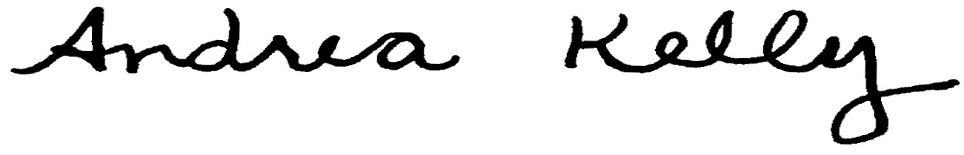  Andrea L. Kelly |  |  |  |  |  | Title | Vice President, Regulation
 |  | TF2 48T.3REV |  |  |  | Advice No. |  |  |  |  |  | UE-
Form F

